Spray Flash Evaporation (SFE) for the continuous production of high performance nanodrugs: new challenges for a new disruptive process
Denis Spitzer
NS3E (Nanomatériaux pour les Systèmes Sous Sollicitations Extrêmes), UMR3208, ISL-CNRS-UNISTRA, French-German Research Institute of Saint-Louis, 5, rue du Général Cassagnou, B.P. 70034, 68301 St Louis, France, denis.spitzer@isl.eu.

Figure: Phase Doppler Interferometry for the on-line metrology
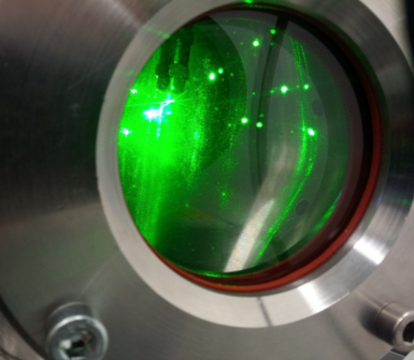
NS3E laboratory developed the Spray Flash Evaporation (SFE) for preparing drug nanoparticles at industrial scale.¹ The process was several times patented up to now. The solution is kept in a pressurized tank separated from a vacuum chamber by a hollow cone nozzle, used both to heat and spray the liquid. The instantaneous evaporation of the solvent originates from the combination of the abrupt pressure drop and the high energy stored by the overheated solvent prior to nebulisation. The flash evaporation leads to small crystallites with narrow size distribution. The nanoparticles may be composed of single compounds, mixtures of several substances or cocrystals. In the domain of medicaments, cocrystals are of critical importance as they enhance bioavailabiliy and up-take by the human body of Active Pharmaceutical Ingredients (API). Up to now, most used techniques are of batch nature and are not able to give access in big amounts to nanosized crystals or cocrystals of therapeutic interest. The SFE permits the continuous manufacturing of nano-sized cocrystals, in large amounts with a kinetic complying with the pharmaceutical industry’s requirements. The efficiency of SFE is shown by the manufacturing of pure nanomedicaments but also of nano-cocrystals such as Resveratrol/4-Amino Benzamid (1/1), Caffeine/Oxalic acid (2/1) and Caffeine/Glutaric acid (1/1), with a mean particle size of between 30 and 100 nm. After showing the possibility to continuously nanocrystallize medicaments, the presentation will focus on different main challenges to further enhance the production capacity and also to understand the SFE process itself. Among different techniques and metrologies used or specially developed such as Phase Doppler Interferometry (Figure) and AFM-TERS spectroscopies, the presentation will also focus on different crystallization configurations used.
¹D. Spitzer et al. Continuous engineering of nano-cocrystals for medical and energetic applications. Sci. Rep. 4, 6575; DOI:10.1038/srep06575 (2014).
Short Biography
Dr. Habil. Denis SPITZER received his PHD in physical chemistry in 1993 at the University Louis Pasteur of Strasbourg. He is the founding and current Director of the NS3E Research Laboratory UMR 3208 ISL/CNRS/UNISTRA. He conducts research in continuous nanoscristallization processes of organic nanomaterials such as model medicaments and energetic materials. He is the inventor of the SFE process. He is the author of more than 150 publications and scientific reports. He received in 2013 the award of strategic thinking given by the French Homeland Minister, and more recently, in 2015, the « Grand Prix Lazare Carnot » award of the French Academy of Science, for dual use research.


