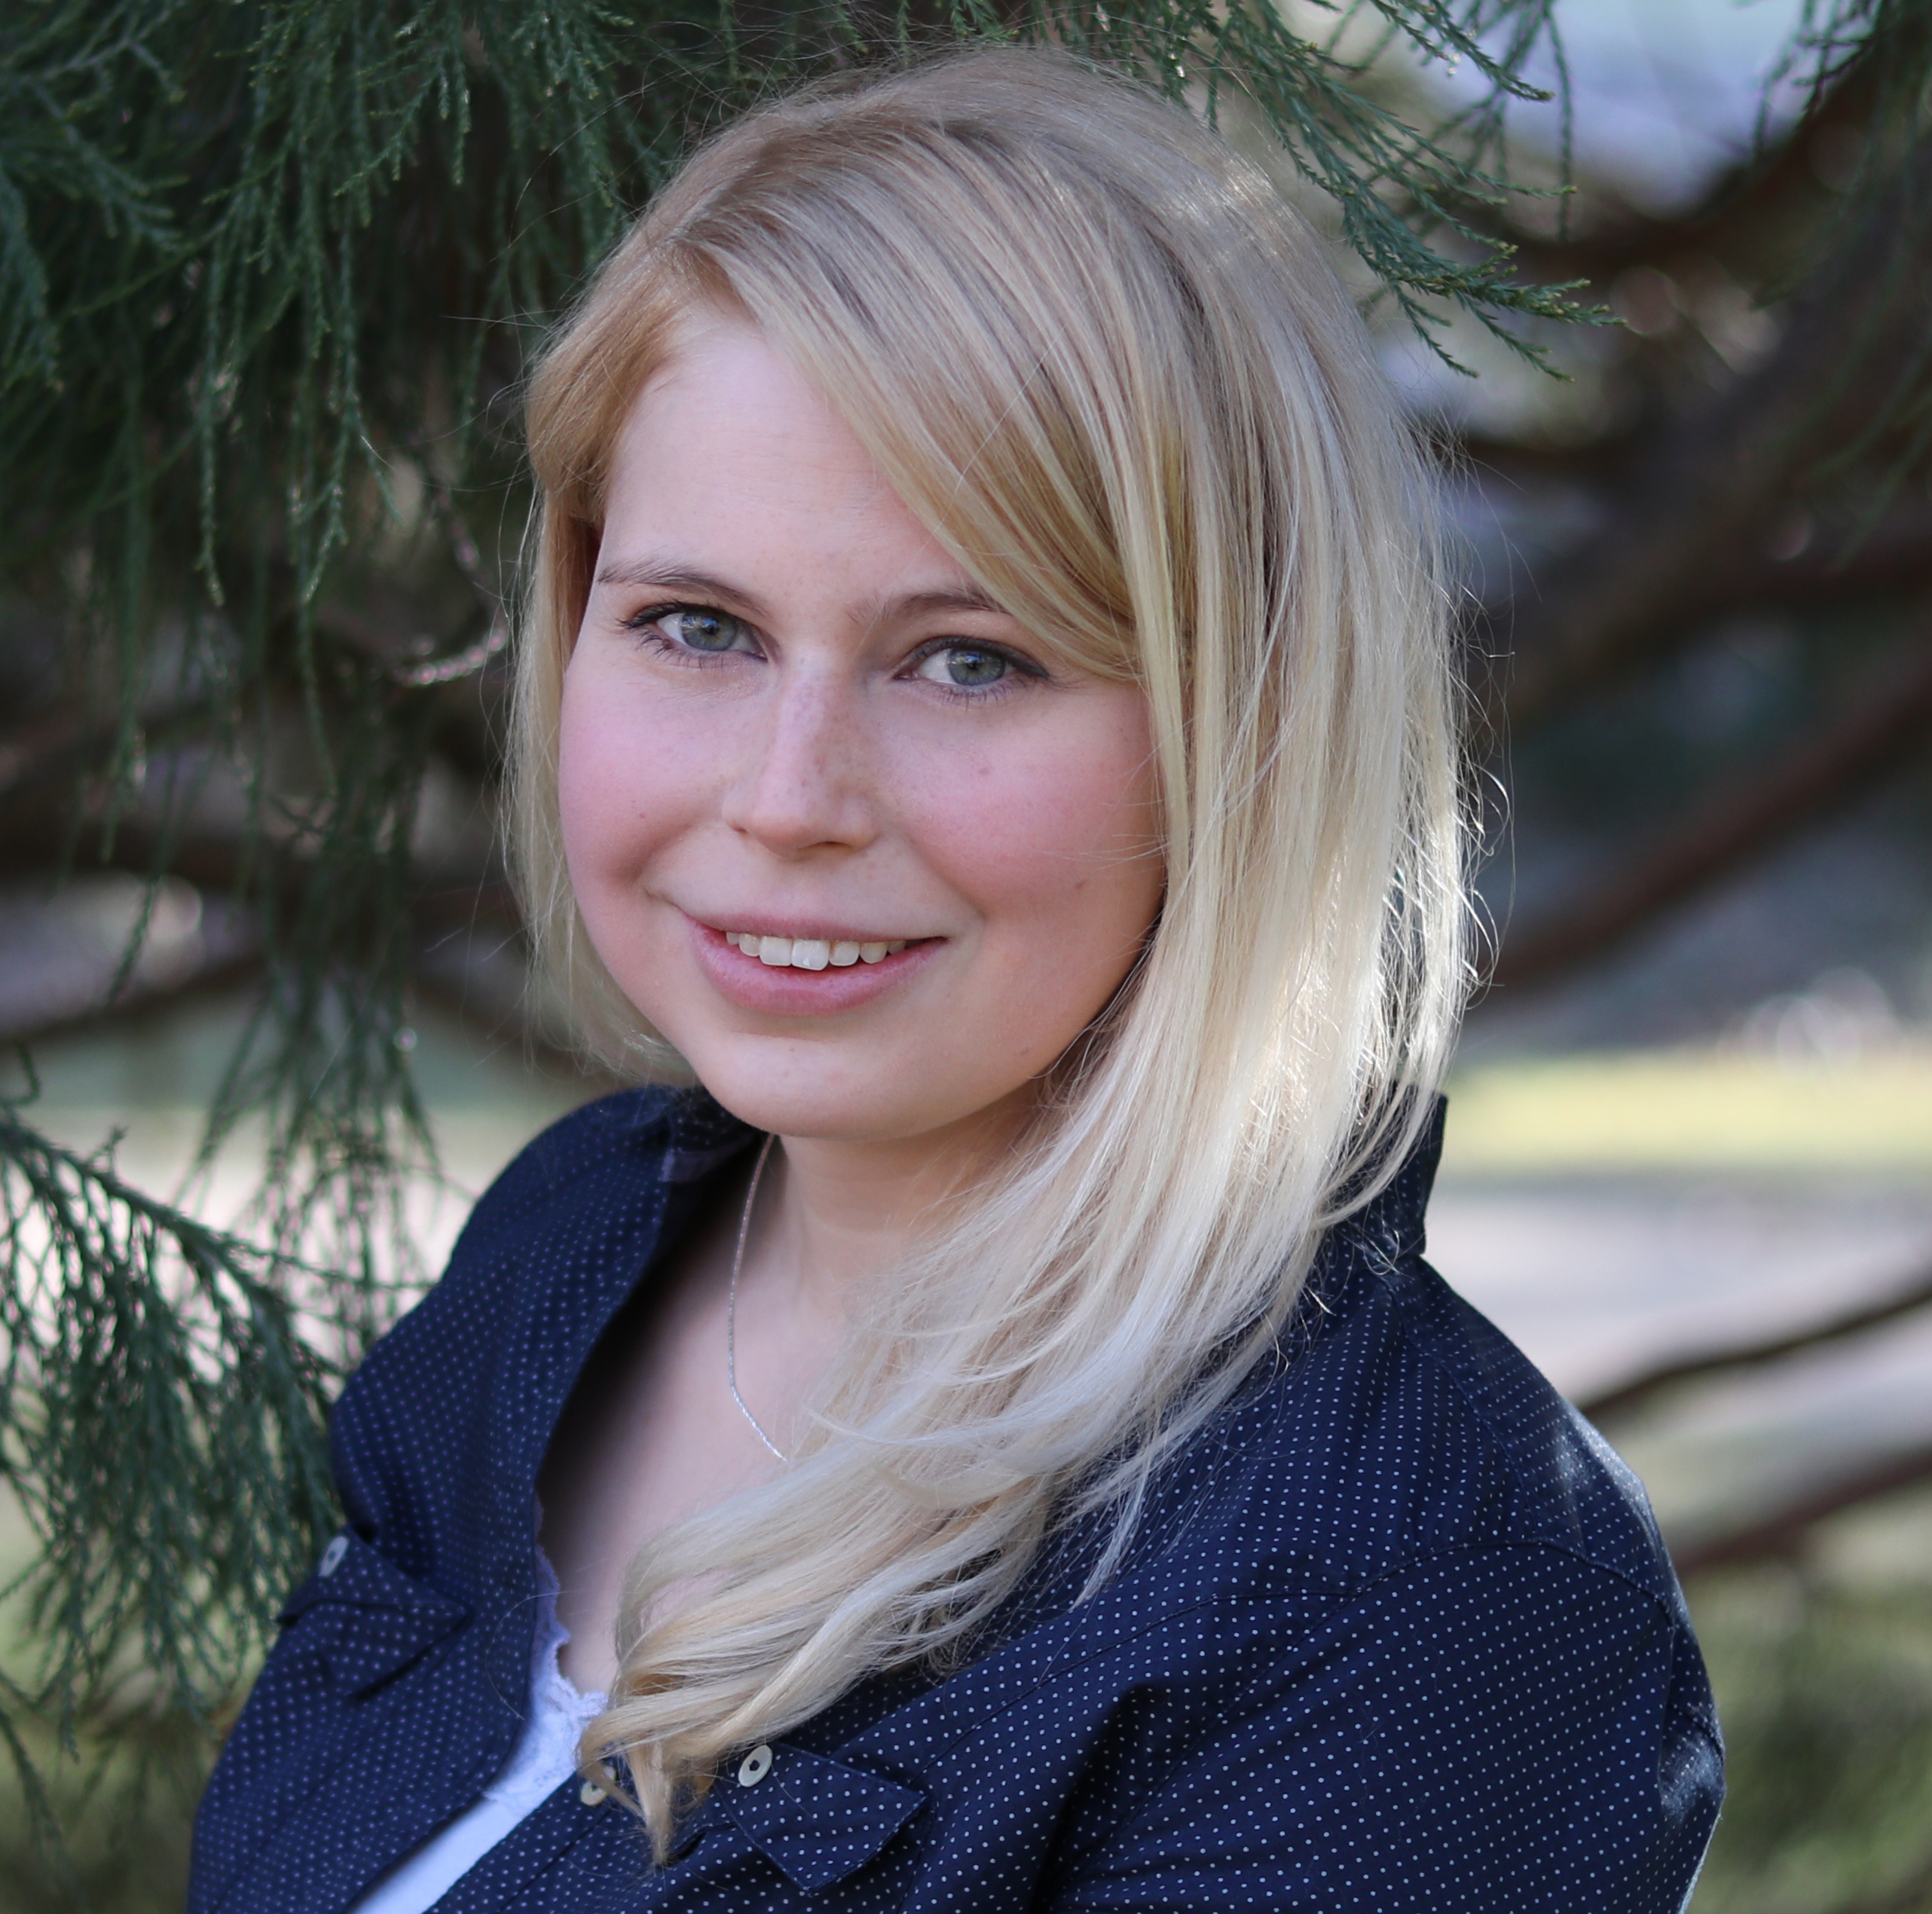

From Glycolate to Methane – A new Biofuel Production Concept

Anja Taubert¹, Prof. Dr. Christian Wilhelm¹, Dr. Torsten Jakob¹
¹ Leipzig University, Institute of Biology, Plant Physiology, Johannisallee 21-23, 04103 Leipzig, Germany

The decreasing reserves of fossil-based energy sources and the climate change enforce the usage of renewable energy and biofuels. Current microalgae-based approaches face the problem that the biological process of biomass production and the subsequent harvest and refinement of biomass strongly decrease the energetic and economic balance. A new algae-based concept aims to avoid biomass production; instead, an intermediate of algal metabolism (glycolate) is used for the methane production by anaerobic fermentation. In this way, metabolic costs and energetic costs for biomass harvest and refinement could be drastically reduced/avoided. Previous studies showed the ability of the green alga Chlamydomonas reinhardtii to produce and actively excrete glycolate under photorespiratory conditions. It was proven that a microbial consortium can be adapted to use glycolate as main carbon source for biogas production. The aim of the present study is to evaluate optimum conditions for glycolate production in a photobioreactor under simulated natural conditions and to analyse the quantum efficiency of glycolate production in comparison to biomass formation. It is further aimed to couple the photobioreactor and the anaerobic fermenter in a pilot installation to prove the technical feasibility of this approach. From the obtained results it can be concluded that a continuous production of glycolate is possible over a period of at least several days. The achieved glycolate concentration in the culture suspension is high enough to feed microbial fermentation. It was shown that the daily glycolate production (59 mg L⁻¹ d⁻¹) is equivalent to that of algal biomass (62 mg L⁻¹ d⁻¹).

Biography

Anja Taubert completed her Master of Science degree in biology with the focus on biotechnology in 2015 at the Leipzig University. Within her bachelor and master thesis she attended to environmental biotechnological questions in miniaturized wetlands, called planted fixed bed reactors, at the Helmholtz Centre for Environmental Research (UFZ Leipzig) and contributed to two publications. She is currently a Ph.D. student in the Department of Plant Physiology at the Leipzig University with the task to establish a self-contained system of autotrophic carbon allocation and heterotrophic production of biogas.

Presenting author details
Full name: Anja Taubert
Contact number: 0341-9736595
Session name/ number: Algal Biotechnology/ 13
Category: Poster presentation

