Development and validation of GC-NCI-MS method for detection and quantitation of synthetic Cathinones in plasma and urine: effect of CI reagent gas on method sensitivity.

Mohammed A. Meetani, Rashed H Alremeithi, and Anas A. Alaidros, Chemistry Department, College of Science, United Arab Emirates University, P. O. Box 15551, Al-Ain, UAE.
Adnan Lengawi and Kalid Alsumaiti, General department of forensic Science and criminology, Dubai police, Dubai, UAE.

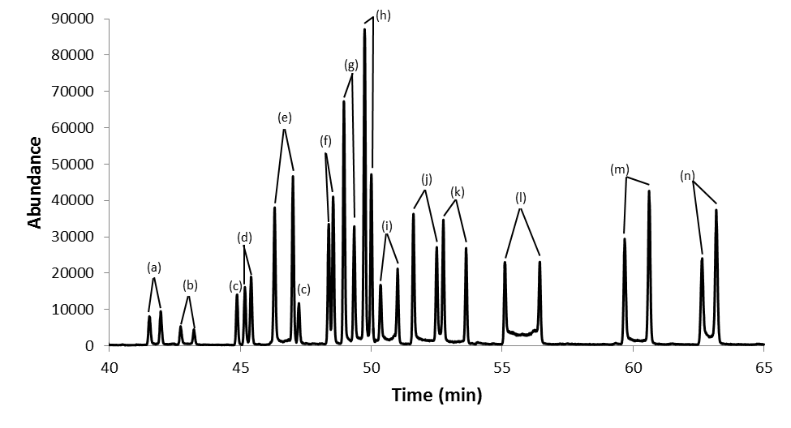
Abstract:

(f) 3-Methylbuphedrone, (g) 4-Methylbuphedrone, (h) 3-EMC, (i) 3-EEC, (j) 4-EEC, (k) 3,4-DMEC, (l) 2,3-MDMC, (m) Butylone and (n)Pentylone.
A statement of the Problem: the latest version of new designer substances (NDS) is called “bath salts” and they g spread in the drug of abuse market. Bath salts are a group of central nervous system stimulants that consists mainly of synthetic cathinone derivatives. They are chiral substances that exist as a racmic mixture. Objectives: Development and validation of sensitive and selective method for enantioseparation and quantitation of synthetic cathinones “bath salts” has been done by using GC-MS (SIM) with chemical ionization source in negative mode (NCI). Methodology: Indirect chiral separation of thirty six synthetic cathinone compounds has been conducted by using optically pure chiral derivatizing agent (CDA) called (S)-(–)-N- (trifluoroacetyl)pyrrolidine-2-carbonyl chloride (L-TPC) which converts cathinone enantiomers into diastereoisomers that can be separated on achiral GC-MS columns. Ultra inert 60 m column was used. Slow heating rate (2 ºC/min) on the GC oven has resulted an observed enhancement in enantiomer peak resolution. An internal standard, (+)-cathinone, was used for quantitation of synthetic cathinone. Conclusion & Significance: Method validation in terms of linearities, limits of detection (LOD), limits of quantitation (LOQ), recoveries and reproducibilities have been obtained for fourteen selected compounds that ran simultaneously as a mixture after being spiked in urine and plasma. Unlike the Electron Impact ion source (EI), NCI showed higher sensitivity by three orders of magnitude by comparing with the previous results.. Moreover, signal intensity improvement observation after changing the CI reagent gas from methane to isobutane, argon or methane/ammonia (95:5) will be discussed.

Image

Figure 1. enantioseparation of 14 synthic cathones, (a) 4-FMC, (b) 4-FEC, (c) Normephedrone,
(d) Buphendrone, (e) 3-MMC, (f) 3-Methylbuphedrone, (g) 4-Methylbuphedrone, (h) 3-EMC, (i) 3-EEC, (j) 4-EEC, (k) 3,4-DMEC, (l) 2,3-MDMC, (m) Butylone and (n)Pentylone.
Recent Publications:
- Fowziya Shaik Ali, b, Kezhen Qi , Bushra Al Wahaibi , Mohammed A. Meetani, et. al. “Photocatalytic degradation of bisphenol A in the presence of TiO2 nanoparticles: Effect of solvent on size control”, Desalination and Water Treatment, 79, (2017),301-307.
- Sungmook Park, Rengaraj Selvaraj; Mohammed A. Meetani, Younghun Kim, ”Enhancement of visible-light-driven photocatalytic reduction of aqueous Cr(VI) with flower-like In3+-doped SnS2”, Journal of Industrial and Engineering Chemistry, 2017, 45, 206-214 (IF 4.179).
- Rashed H. Alremeithi, Mohammed A. Meetani, Moath K. Mousa, Na’il Saleh, John Graham, Determination of p-aminohippuric acid with ß-Cyclodextrin sensitized fluorescence spectrometry, RSC advances, (2016), 6, 80576.
- Rengaraj Selvaraj, Kezhen Qi, Sathish Babu Soundra Pandian, Mohammed A. Meetani,et. al.“Morphology-Controlled Synthesis of ZnxCd1-xS Solid Solutions: An Efficient Solar Light Active Photocatalyst for the Degradation of 2,4,6-Trichlorophenol” Journal of Environmental Protection, 2016, 7, 1605-1617.
- Rashed H. Alremeithi, Mohammed A. Meetani, Saif Khalil, A validated gas chromatography mass spectrometry method for simultaneous determination of cathinone related drugs enantiomers in urine and plasma, RSC advances, 6(2016) 80576-80584.


Biography
Dr. Mohammed A. Al-Meetani has received his PhD Degree in applied analytical chemistry from Colorado School of Mines, Colorado, USA in 2003. His research encompasses various topics in the areas of pyrolysis mass spectrometry of the peptide and proteins, degradation of organic water pollutants using advanced oxidation processes, determination of human derived chemicals in ground and wastewater, and development of analytical methods for detection and determination of designer drugs of abuse. Dr. Meetani’s work has resulted over 40 articles in reputed journals and international conference proceedings. He has worked at different international universities and research institutes such as national renewable energy laboratory (NREL), CO, USA, University of Wyoming, Wy, USA, and Sam’s Nobel Foundation, OK, USA.
Email: mmeetani@uaeu.ac.ae

Notes/Comments:

