Upgrading and isolation of low molecular weight compounds from bark and softwood bio-oil through vacuum distillation
Shofiur Rahman, Robert Helleur, Stephanie MacQuarrie^{b}, Sadegh Papari, and Kelly Hawboldt
Department of Chemistry, Memorial University of Newfoundland, St. John’s, NL , A1B 3X7, Canada
^{b}Department of Chemistry, Cape Breton University, NS, B1P 6L2, Canada

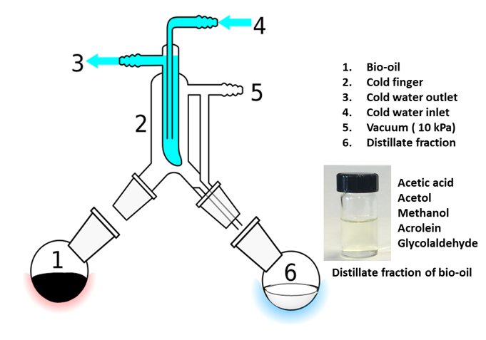
In this research an analysis of short-path vacuum distillation for the isolation of low molecular weight compounds (C1–C3) from softwood and bark bio-oils is reported. The short-path vacuum distillation was performed at 60–100 ºC under vacuum (10 kPa) for 0.5–1 h. Although methanol and acrolein distilled completely, acetic acid and hydroxyacetone failed to do so after 1 h. The acetic acid content and the total acid number of the residual oils decreased and their heating values doubled (to 19.6 kJ/g). Short-path vacuum distillation is an efficient method to both isolate low molecular weight feedstocks/fuels, and improve the quality of the residual bio-oil for blending with petroleum or biofuels.
1. Nam H, Choi J, Capareda SC. Comparative study of vacuum and fractional distillation using pyrolytic microalgae (Nannochloropsis oculata) bio-oil. Algal Res 2016;17:87–96.
2. Capunitan JA, Capareda SC. Characterization and separation of corn stover bio-oil by fractional distillation. Fuel 2013;112:60–73.
3. Boucher ME, Chaala A, Roy C. Bio-oils obtained by vacuum pyrolysis of softwood bark as a liquid fuel for gas turbines. Part I: properties of bio-oil and its blends with methanol and a pyrolytic aqueous phase. Biomass Bioenergy 2000;19:337–50.
4. Batistella, C.B., Maciel, M.R.W., Maciel Filho, R., 2000. Rigorous modeling and simulation of molecular distillators: development of a simulator under condition of non ideality of the vapor phase. Comput. Chem. Eng. 24, 1309–1315.
5. Zheng JL, Wei Q. Improving the quality of fast pyrolysis bio-oil by reduced pressure distillation. Biomass Bioenergy 2011;35:1804–1810.

Robert Helleur is a Honorary Research Professor of Chemistry at Memorial University. He has been very active in the field of analytical pyrolysis since 1986 in the area of thermochemolytic analysis of chemical markers/ profiling of carbohydrates, lignins, tannins, lipids and plant stressors in biomass and soils. A shift in research focus occurred in 2010 towards applied pyrolysis of forestry residues and municipal wastes with research funds from NSERC, NCE (BioFuelNet), and CFSI/Forestry. Pyrolysis experiments are conducted at lab- and pilot-scale and comprehensive analysis for the biochar and bio-oil products undertaken using various feedstock compositions. Biochars has been used in greenhouse studies for plant growth studies while crude bio-oils have been studied for their chemical stability and extraction of useful chemicals. Dr. Helleur has supervised over 60 graduate students and has published over 75 peer-reviewed research articles. He has been active member in a number of pyrolysis workshops and international conferences.
Email: rhelleur@mun.ca

