The study of stratification and stability of Qeshm island west coast water and Mangrove forest

Khoshkhou-Maryam,Master of Science,Department of Physics, Research center Razi Rey (Tehran),Iran
Karamipoor-Afsaneh,Master of Science, Teacher, Shiraz,Iran
Davood Eftekhary,Student Engineering Software,Azad Un.

Abstract
Statement: Persian Gulf is one of the most important bodies of water which has a very difficult and overwhelming dominant ecosystem due to severe environmental conditions such as temperature and salinity.Gheshm island has a fundamental role in the diversity of biological behavior as well as available dispersion.
The equation of condition of sea, the key gnomon of Air and Water and Quantity are the observation in International charts, and the coefficient of equation of sea is the important parameter that limit the circulation of the ocean.
At the beginning of hot days, the weather change in column of water, Thermocline layer has appeared. The existence of Thermocline layer in Summer in effect of hot water capacity and penetration hot water in Winter into the lower layers.
Ocean areas are bynatuie have a Double-diffusion converction, because of the existing salinity and temperature differences in variaus depths. As part of the ocean has a temperature inversion (temperature increasing with depth). In the Island, there are two procedures of dual diffiusion convection; including finger and diffusive regime, which have a conventional role in creating temperature inversion. Effects of bottom topography and coastline drastic changes influence the double diffusive convection.
At the beginning of hot days, due to the temperature change in column of water, Thermocline layer appears. The existence of Thermocline layer in summer is the result of hot water capacity and lock of penetration of hot water in winter into the lower layers.
Recent Publications
1 Komeyjani, fereshteh, study of seasonal changes ´ process in physical parameters such as temperature, salinity and density in chabahar gulf, Iran, thesis of Tarbiat Modaress University ,1387.
2 Nikuian, Alireza, investigation of hydrology and hydrobiology of Persian Gulf in waters of Khuzestan, Bushehr and Hormozgan, publication of Iran fisheries research institute, 1383.

3 Jokar, Kazem, investigation of changes process of some physical parameters and condition of their relation in northern area of Persian Gulf (Bushehr), Thesis of physics sea course, north Tehran Islamic Azad University, 1383.

4 Karami pour shams abadi , Afsaneh,physical parameters analysis daring Ghods tour in persian gulf in 2001 , thesis of north tehran Islamic Azad University , 1384 .

5 Kahma ´ K. K., and calkolne, C.J., 1992,reconcilling discrepancies in the observed growth of wind-generated waves: J.Phys . oceanogr ., 22 , 1389-1405.

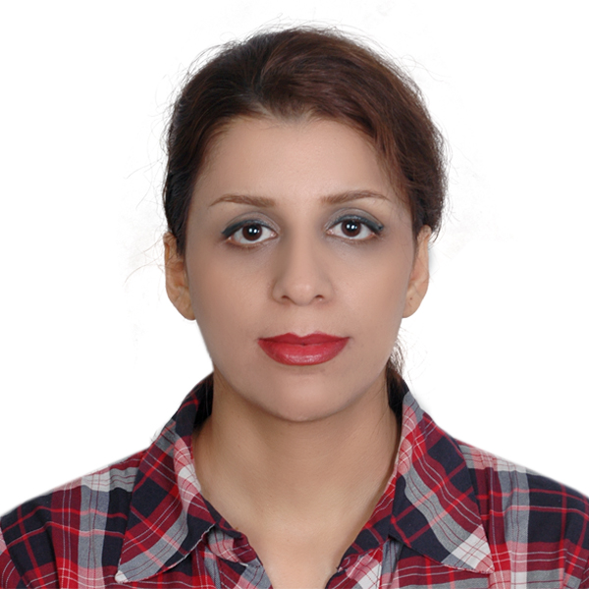 Biography
My name is Maryam Khoshkhou , I graduated form Shiraz University in BA of Nuclear Physics and received my MA from Tehran University of Science and Research in the Physical Oceanography.
I have worked as a teacher in the Education for 20 years, and also 5 years in university.
I have rendered 26 Articles in domestic conferences and one Article in domestic and overseas conferences.
At present, I work for one of the Education centers.
Email:

maryamkhoshkhou@yahoo.com

