Attenuating effects of Nigella sativa on cognitive dysfunction, hippocampal oxidative stress and neurodegeneration following status epilepticus in young male rats.
Mohammad Ahmad
College of Nursing, King Saud University, Riyadh, Saudi Arabia
Abstract
Statement of the Problem: The lithium-pilocarpine model of status epilepticus (SE) is most suitable and is frequently used for pathophysiological and management strategies in search of new, safe and effective therapeutic agents for SE. Recent studies have shown significant potential of pharmacological, prophylactic and therapeutic use of Nigella sativa (habba sauda) seed extract (NSE) for many beneficial activities in the body including neuroprotection from neurodegenerative diseases and have antioxidant property. Methodology: In the present study we investigated the effects of NSE on intensity and frequency of SE, cognitive behavioral dysfunction, hippocampal oxidative stress and histological abnormalities in the hippocampus of animals induced with SE by lithium (Li) in 3mEq/ml/kg dose, i.p. followed 20h later by pilocarpine (Pc) in 20mg/ml/kg dose, s.c. NSE was administered intraperitoneally at the doses of 100, 200, and 400 mg/mL/kg, 30 minutes before Pc injection. Mortality (if any) within 24 hours was also recorded. Ethical approval was obtained from the Ethics Committee Review Board of the College, King Saud University, Riyadh, Saudi Arabia. Results: Treatment with NSE significantly ameliorated the frequency and severity of epileptic seizures in a dose-dependent manner. The cognitive dysfunctions were improved, hippocampal oxidative stress was ameliorated and neuronal cell loss and sprouting of mossy fibers in the hippocampus were also attenuated significantly and dose-dependently by NSE. Conclusion and Significance: Possibly, therapeutic application of Nigella sativa seed as an antiepileptic and as an antioxidant for the treatment of SE has a great potential and warrants further studies.
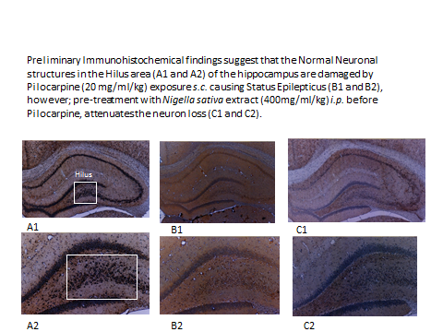

Recent Publications (minimum 5)
- Seghatoleslam M., et al. (2015) The effects of Nigella sativa on neural damage after pentylenetetrazole
induced seizures in rats. Journal of Traditional and Complementary Medicine 6:262-268.
- Hobbenaghi R., et al. (2014) Neuroprotective effects of Nigella sativa extract on cell death in hippocampal neurons following experimental global cerebral ischemia-reperfusion injury in rats. Journal of Neurological Sciences, 337:74-79.

Nourozi F., et al., (2018). Memory enhancing effect of Nigella Sativa hydro-alcoholic extract on lipopolysaccharide-induced memory impairment in rats. Drug and Chemical Toxicology, 28:1-10.
- Beheshti F, et al. (2016) Neuropharmacological effects of Nigella sativa. Avicenna Journal of Phytomedicine, 6:104-16.
- Ahmad A., et al. (2013) A review on therapeutic potential of Nigella sativa: A miracle herb. Asian
Pacific Journal of Tropical Biomedicine, 3: 337 – 352.


Biography
Dr. Mohammad Ahmad has worked with many experimental models to carry out research studies on various neurological diseases of human health importance. His particular interest lies in correlating his research findings in perspective of Nursing care and infusing more interest in Nursing research activities. After doing his Ph.D. he visited Queen's University of Belfast, UK. to persuade his Post-Doctoral studies on the ultrastructural anatomy and neurophysiology of helminth parasites of health importance. He has a vast experience of research and teaching. At present, he is an Associate Professor in Medical Surgical Department of Nursing College, King Saud University teaching courses of Anatomy and Physiology, Pathophysiology, Infectious Diseases, Infection Control and Medical Microbiology. He has published more than 60 papers and is in the Editorial and Review Boards of many international journals of repute and high impact factors.
mbadshah@ksu.edu.sa

