

Title: HPTLC Method for quantification of Celastrol from in vivo and in vitro Developed plant parts of Celastrus paniculatus Willd. – a black oil plant
Name: Illa C. Patel
Hemchandracharya North Gujarat University, Patan – 384265, Gujarat, India

ABSTRACT
Celastrus paniculatus Willd. is a medicinally important plant belongs to the family Celastraceae commonly known as “black oil plant” or “Jyotishmati”. Plant contains various phytochemicals compounds like Phenol, flavonoids, alkaloids, Saponin, glycosides, steroids, terpenoids etc. The main constituents are celastrol, malkangunin, celapanigine, celapagine and celastrine which have medicinal properties to curing the different diseases like arthritis, gout, memory loss etc. This plant is highly exploited due to use of its seed, leaves, stem and roots for obtaining many phytochemicals from it. Plant needed an ideal protocol for rapid multiplication and valid method of phytochemical analysis using techniques of High Performance thin layer chromatography (HPTLC). This study is aimed to developed a suitable protocol for production of in vitro callus and plants on MS media containing various hormones viz. 2,4-D, BAP, NAA at different concentrations for tissue culture studies. The in vitro developed plant and callus were used to find out phytochemical constituents of it along with in vivo plant parts through qualitative analysis and HPTLC quantification of Celastrol in each part. Result of Priliminary analysis shows that in vitro developed callus contain many phytochemicals and HPTLC analysis shows that both in vivo and in vitro parts are good source of Celastrol. The present work may be helpful for new avenue for production of important phyto-constituents and reduces pressure on natural medicinal plant population.

Keywords: Celastrus paniculatus Willd., Phytochemicals, Qualitative analysis, HPTLC.
Fig. 1 Tissue Culture and Phytochemical study of Celastrus paniculatus Willd.

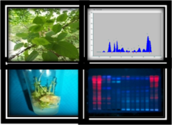
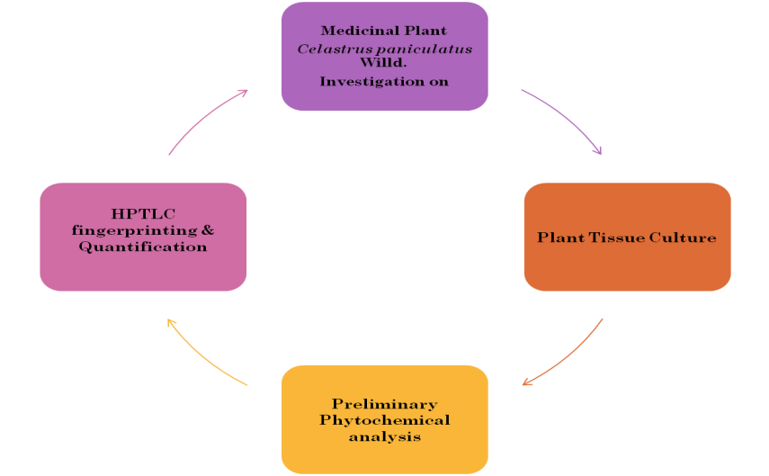
Recent five Publications
- Panigrahi J, Gantait S, Patel IC (2017) An efficient in vitro approach for direct regeneration and callogenesis of Adhatoda vasica Nees, a potential source of quinazoline alkaloids. National Academy Science Letters (Springer). Pp. 1-6. [IF 0.369].

- Panigrahi J, Gantait S*, Illa C Patel (2017). Concurrent production and relative quantification of vasicinone from in vivo and in vitro plant parts of Malabar nut (Adhatoda vasica Nees). 3 Biotech (Springer) [Pubmed] 7(5):280 [DOI: 10.1007/s13205-017-0882-7] [IF 1.361] (NAAS 6.99).

- Panigrahi J*, Gantait S, Patel I (2017). In vitro regeneration of Chlorophytum borivilianum Santapau & R.R. Fern. Medicinal plant International Journal of Phytomedicines and Related Industries, Vol.9, 76-79. [DOI: 10.5958/0975-6892.2017.00011.9]. [SCOPUS ] (NAAS 5.12).

- Rami Esha, Rami Saurabh and Patel Illa (2017). High Performance Liquid Chromatography method for quantification of Ellagic acid in in vivo and in vitro plant parts of Oroxylum indicum L. vent, Asian J Pharm Clin Res, Vol 10 (4), 2017, 56-58.

- Rathod Dipika and Patel Illa (2016). Comparative preliminary phytochemical studies of in vivo and in vitro extracts of Gloriosa superba L. International Journal of Pharma and Biosciences, 7(1): 20-23.

Biography

Dr. Illa Patel has completed her Ph. D in botany from Gujarat University, Gujarat, India. Presently she is Associate professor in botany at the Department of life sciences, Hemchandracharya North Gujarat University (Patan), Gujarat, India. She is M. phil. and Ph. D guide and has specialization in plant physiology, biochemistry, Tissue culture, medicinal plants and phytochemistry. She has more than 40 publications in the reputed journals and presented more than 35 papers in national and international conferences. She is also having some funded research projects and she is member of many specific and academic bodies and rendering her services to many scientific journals.

