Synthesis of Biopolymer Based Platinum Nanoparticles And 5-fluorouracil Loaded Platinum Nanoparticles and Evaluation of Their Anti-tumor Potential Employing Potato Tumor Bioassay Model

Godugu Deepika and B.Sashidhar Rao., India

Abstract
A facile and green synthesis of platinum nanoparticles (GKPtNP) using biopolymer, Gum Kondagogu (GK) as a reducing, capping and stabilizing agent was developed. The formation and stability of GKPtNP was confirmed by UV–visible spectroscopy, SEM-EDAX, TEM, XRD, Zeta potential analysis, FTIR, ICP-MS and stability studies. The formed GKPtNP are well dispersed, homogenous and showed a characteristic absorption peak at 201 nm, with a size of 2-4±0.50 nm and recorded negative zeta potential (−46.1 mV) indicating good stability. 5-fluorouracil (5FU), a known anticancer drug, was loaded into the synthesized GKPtNP, which leads to the development of a new combination of nanomedicine (5FU-GKPtNP). The in vitro drug release studies of 5FU-GKPtNP in pH 7.4 showed a sustained release profile over a period of 120 mins, and the hemolysis studies revealed that GKPtNP, 5FU and 5FU-GKPtNP were found to be blood compatible. A. tumefaciens induced in vitro potato tumor bioassay was employed for screening the anti-tumor potentials of GKPtNP, 5FU and 5FU-GKPtNP. The experimental results suggested, a complete tumor inhibition by 5FU-GKPtNP at a lower concentration than the GKPtNP and 5FU respectively. Further, the mechanism of antitumor activity was confirmed by their interactions with DNA using gel electrophoresis and UV-spectroscopic analysis. The electrophoresis results revealed that the 5FU-GKPtNP totally diminishes DNA and the UV-spectroscopic analysis showed hyperchromic effect with red shift indicating intercalation type of binding with DNA. Over all, the present study revealed that the combined exposure of the nanoformulation (5FU-GKPtNP) resulted in the enhanced antitumor effect on A. tumefaciens induced potato tumor bioassay.


Image
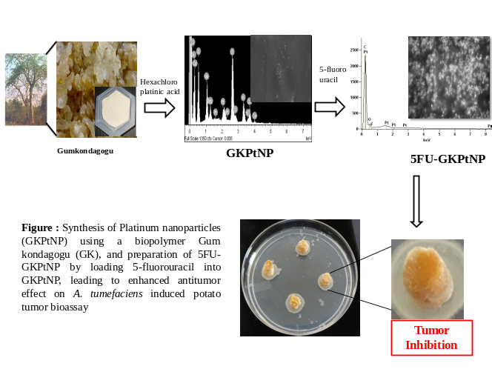

Recent Publications

- Deepika Godugu., Karuna Rupula and Sashidhar Rao Beedu (2017). Inhibitory Action of Forskolin and Its Semi-synthetic Analogues on Cyclooxygenase-2 Enzyme Activity: In silico and In vitro Studies. The Natural Products Journal. 7:1-10.
- Deepika Godugu, Karuna Rupula and Beedu Sashidhar Rao (2016). Binding Interactions of Forskolin with Human Serum Albumin: Insights from In silico and Spectroscopic Studies. Current Chemical Biology. 10:127-134.
- Deepika Godugu, Karuna Rupula and Sashidhar Rao Beedu (2016). Inhibitory Action of Andrographolide on Cyclooxygenase-2 Enzyme Activity: In Silico and In Vitro Studies. Current Bioactive Compounds. 12, 44-50.
- Velpula Suresh, D. Raju, Rupula Karuna, Godugu Deepika and Sashidhar RB (2016). Evaluation of antitumor activity of Forskolin and Andrographolide using potato disc bioassay. Clinical Cancer Drugs, 3:121-130.
- Deepika G, Khojasteh SB, Shahryari S, Seshapani P & Pramoda Kumari J (2011). Modeling and Docking Studies of Signal Transducers and Activators of Transcription 4 (STAT 4) Protein involved in cancer. International Journal of Plant, Animal and Environmental Sciences, 1, 31-44.

Godugu Deepika is pursuing PhD in Pharmacology under the supervision of Prof. B.Sashidhar Rao, Osmania University, Hyderabad, India. My present research interests are development of facile and eco-friendly method for synthesis of metallic nanoparticles using biopolymer (Gum Kondagogu) which acts as capping, stabilizing and reducing agent, and its applications as a effective carriers in sustained release/enhanced activity of drugs with nanoparticles by in vitro (mammalian cell lines) and in vivo (animal model) studies.
Email: deepikapharmaco@gmail.com

