Mycobiology

Genome Shuffling of Mangrove Endophytic Aspergillus luchuensis MERV10 for Improving the Cholesterol-Lowering Agent Lovastatin under Solid State Fermentation
Mervat Morsy Abbas Ahmed El-Gendy", Hind A.A. Al-Zahrani' and Ahmed Mohamed Ahmed El-BondLly”'
'Department of Bio/ogica/ Sciences, face/ty of Sciences, King Abdv!wiz University (W G), Jeddah 27589, 5.audi Arabia ’Chemistry of Matured anJ Microbial Products Department, National Research Centre, Dokki, Size 12622, fgypt 'Department of Biological Sciences, Foculi¿ or Sciences, jeddoh University Jeddah 802O3, Saudi Atobio

Abstract In the screening of marine mangrove derived fungi for lovastatin productivity, endophvtic 4s/›ergi//us luchuensis MERV10 exhibited the highest lovastatin productivitv (9.5 mg/Eds) in solid state fermentation (SSF) using rice bran. Aspergillus luchuensis MERV10 was used as the parental strain in which to inJuce genetic variabilities aker application of ditferent mixtures as well as doses of mutagens followed by three successive rounds of genome shuffling. Four potent mutants, UN6, UN28, NEll, and NE23, with lovastatin productivity equal to 2.0-, 2.11-, 4 .95-, and 2.11-fold higher than the parental strain, respectively, were applied for three rounds of genome shuffling as the initial mutants. Four hereditarily stable recombinants (F3/3, F3/7, F3/9, and F3/13) were obtained with lovastatin productivity equal to TO.8, 5 7.0, 49. 7, and 11.0 m@gds, respectively. Recombinant strain F3/7 yielded 57.0 mg/gels of lovastatin, which is 6-fold anJ 2.85-fr›ld higher, respectively, than the initial parental strain and the highest mutants UN28 and NE23. It was therefore selected for the optimization of lovastatin production through improvement of SSF parameters. Lovastatin procluCtivity was increased! 32-foIJ through strain improvement methoJs, incluJing mutations and three successive rounds of genome shuffling followed by optimizing SSF factors.

Keywords Aspergillus /uchuensis, Genome shuffling, Lovastatin, Mutation, Solid state fermentation

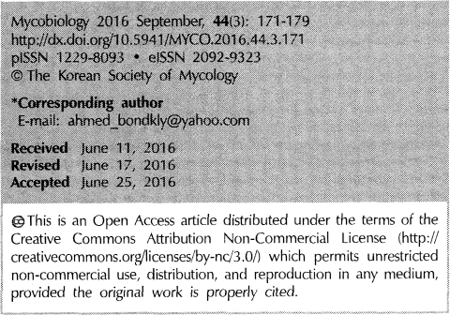
Lovastatin is a member of the statins family, a safe and effective competitive inhibitor of 3-hydroxy-3-methylg 1utaryl- coenzyme A reductase, the rate-limiting enzyme of cholesterol biosynthesis. It reduces cholesterol in the management and prevention of cardiovascular disease [I, 2]. Over the past decade, statins have been shown to have wide range of activities, such as anti—proliferative, anti—angiogenic, radio-
sensitizing, pro-apoptotic properties, anti-metastasis properties (in lymphoma, melanoma, and colon tumors), and neuro— protective ability as a probable therapeutic or preventive agent in Alzheimers disease, as well as antimitotic and antibacterial activities [3-7].
Numerous fungal genera produce lovastatin, including
Aspergillus, Penicillium, Monascus, Paecilomyces, Trichoderma, 5copulariopsis, Doratomyces, Phoma, Phythium, G[ I11i1 OOSCLI5, Hypomyces, and Pleurotu› \8 . Marine mangroves are well known to be hosts for a large community of associated endophytic fungi without inducing disease symptoms. Endophyte microbes are becoming targets of the continuing search for an economical, continuous, and manageable supply of the phar iuacologically active compounds by laboratory cultivation of the endophytic producer outside the hosts [9].
In recent years, a new breeding technique in industrial
microorganisms is induction of genetic variabilities followed by genome shuffling. The advantage of this method is that the genetic reconstruction can be achieved with the tested strains without knowing its genetic basis, making it a highly effective technique. ".Fhis introduces the advantage of

