Presentation on: My Brain and its Elasticity
Name: Colin Furphy
AUSTRALIA

Abstract

In 2000 & 2008 I had neurosurgery. I was supposed come out with a major speach impairment, poor short term memory and an impaired learning ability. Thanks the elasticity of my brain none of these side effects occurred. Doctors were amazed at how my speaking, learning and short term memory abilities shifted sides during surgery. Thanks to surgery I went from being obese, taking 36 tablets twice a day and having 60 seizures per week to being super fit, leading groups up Mt Kilimanjaro and starting my own travel company. Life has been amazing for the past 8 years all thanks to these key abilities shifting sides of the brain. (Up to 250 words)

Biography

Colin Furphy has had two rounds of neurosurgery, been heavily medicated, obese, experienced impaired learning and severe depression as a result of having 60 seizures per week since the age of 6. Thanks to neurosurgery Colin has now holds 6 qualifications, is starting his own college and also takes groups to climb Mt Kilimanjaro and Everest Base Camp. Colin is now challenging politicians in Australia too.

Email ID

Presenting author details
Full Name which you wish to be printed: Colin Furphy
Contact Tel Number: +61 422 712 717
Twitter account:
Linked In account: /colinfurphy
Session of Interest:
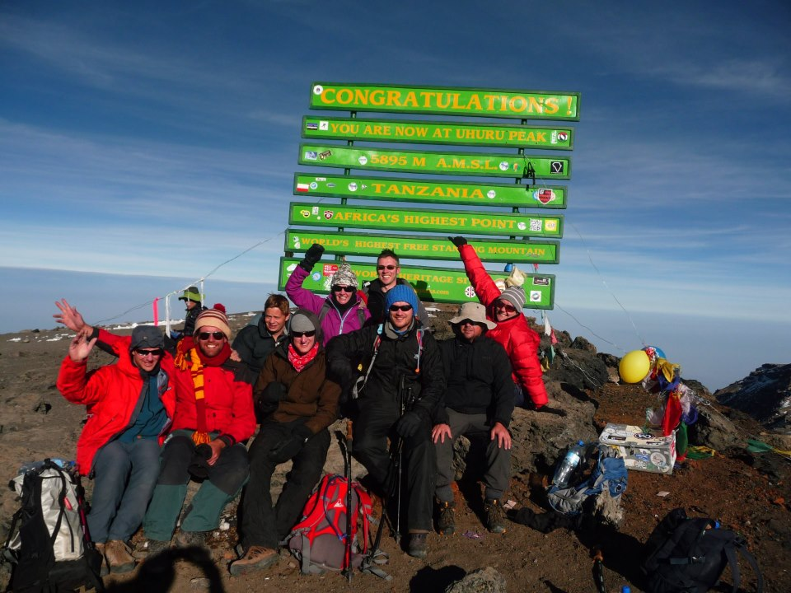
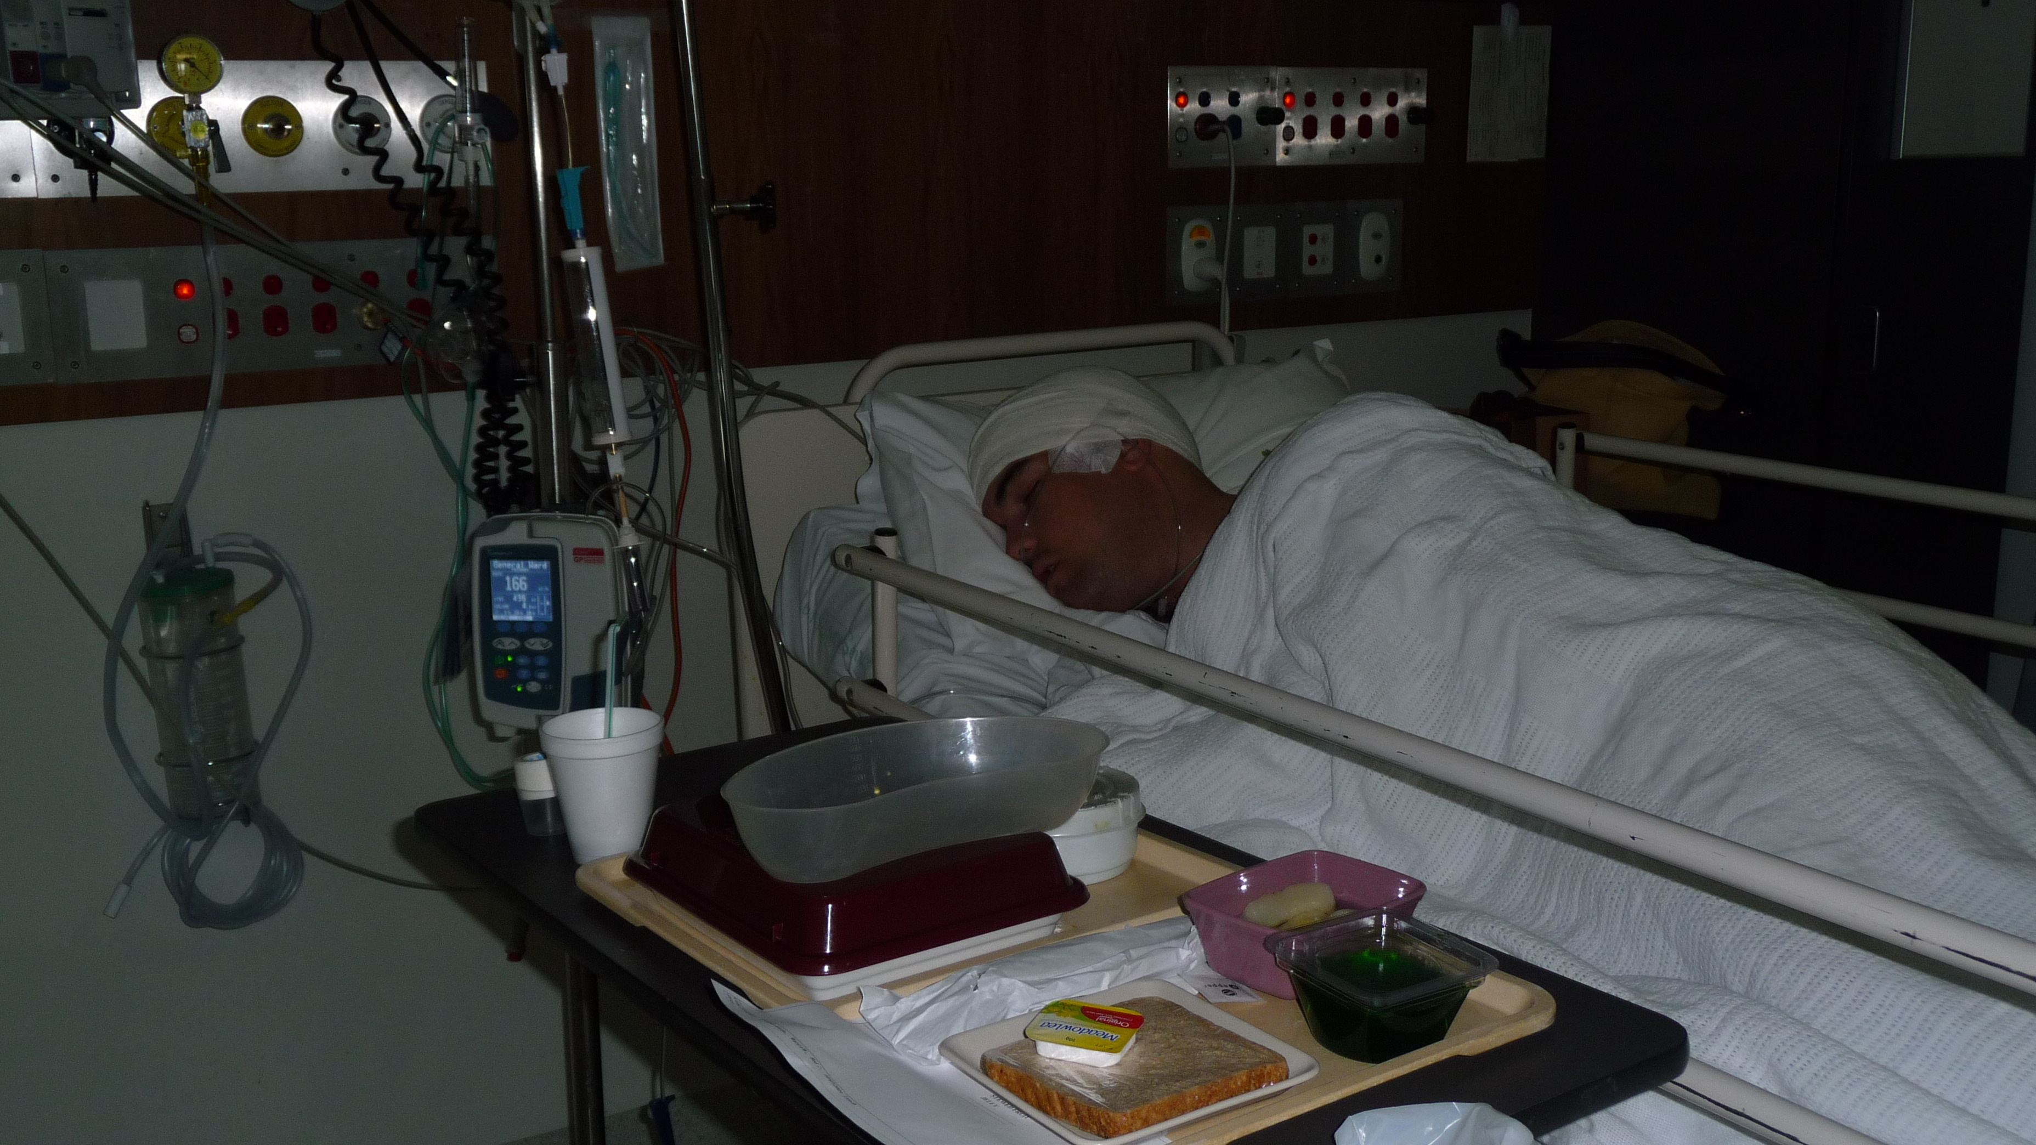

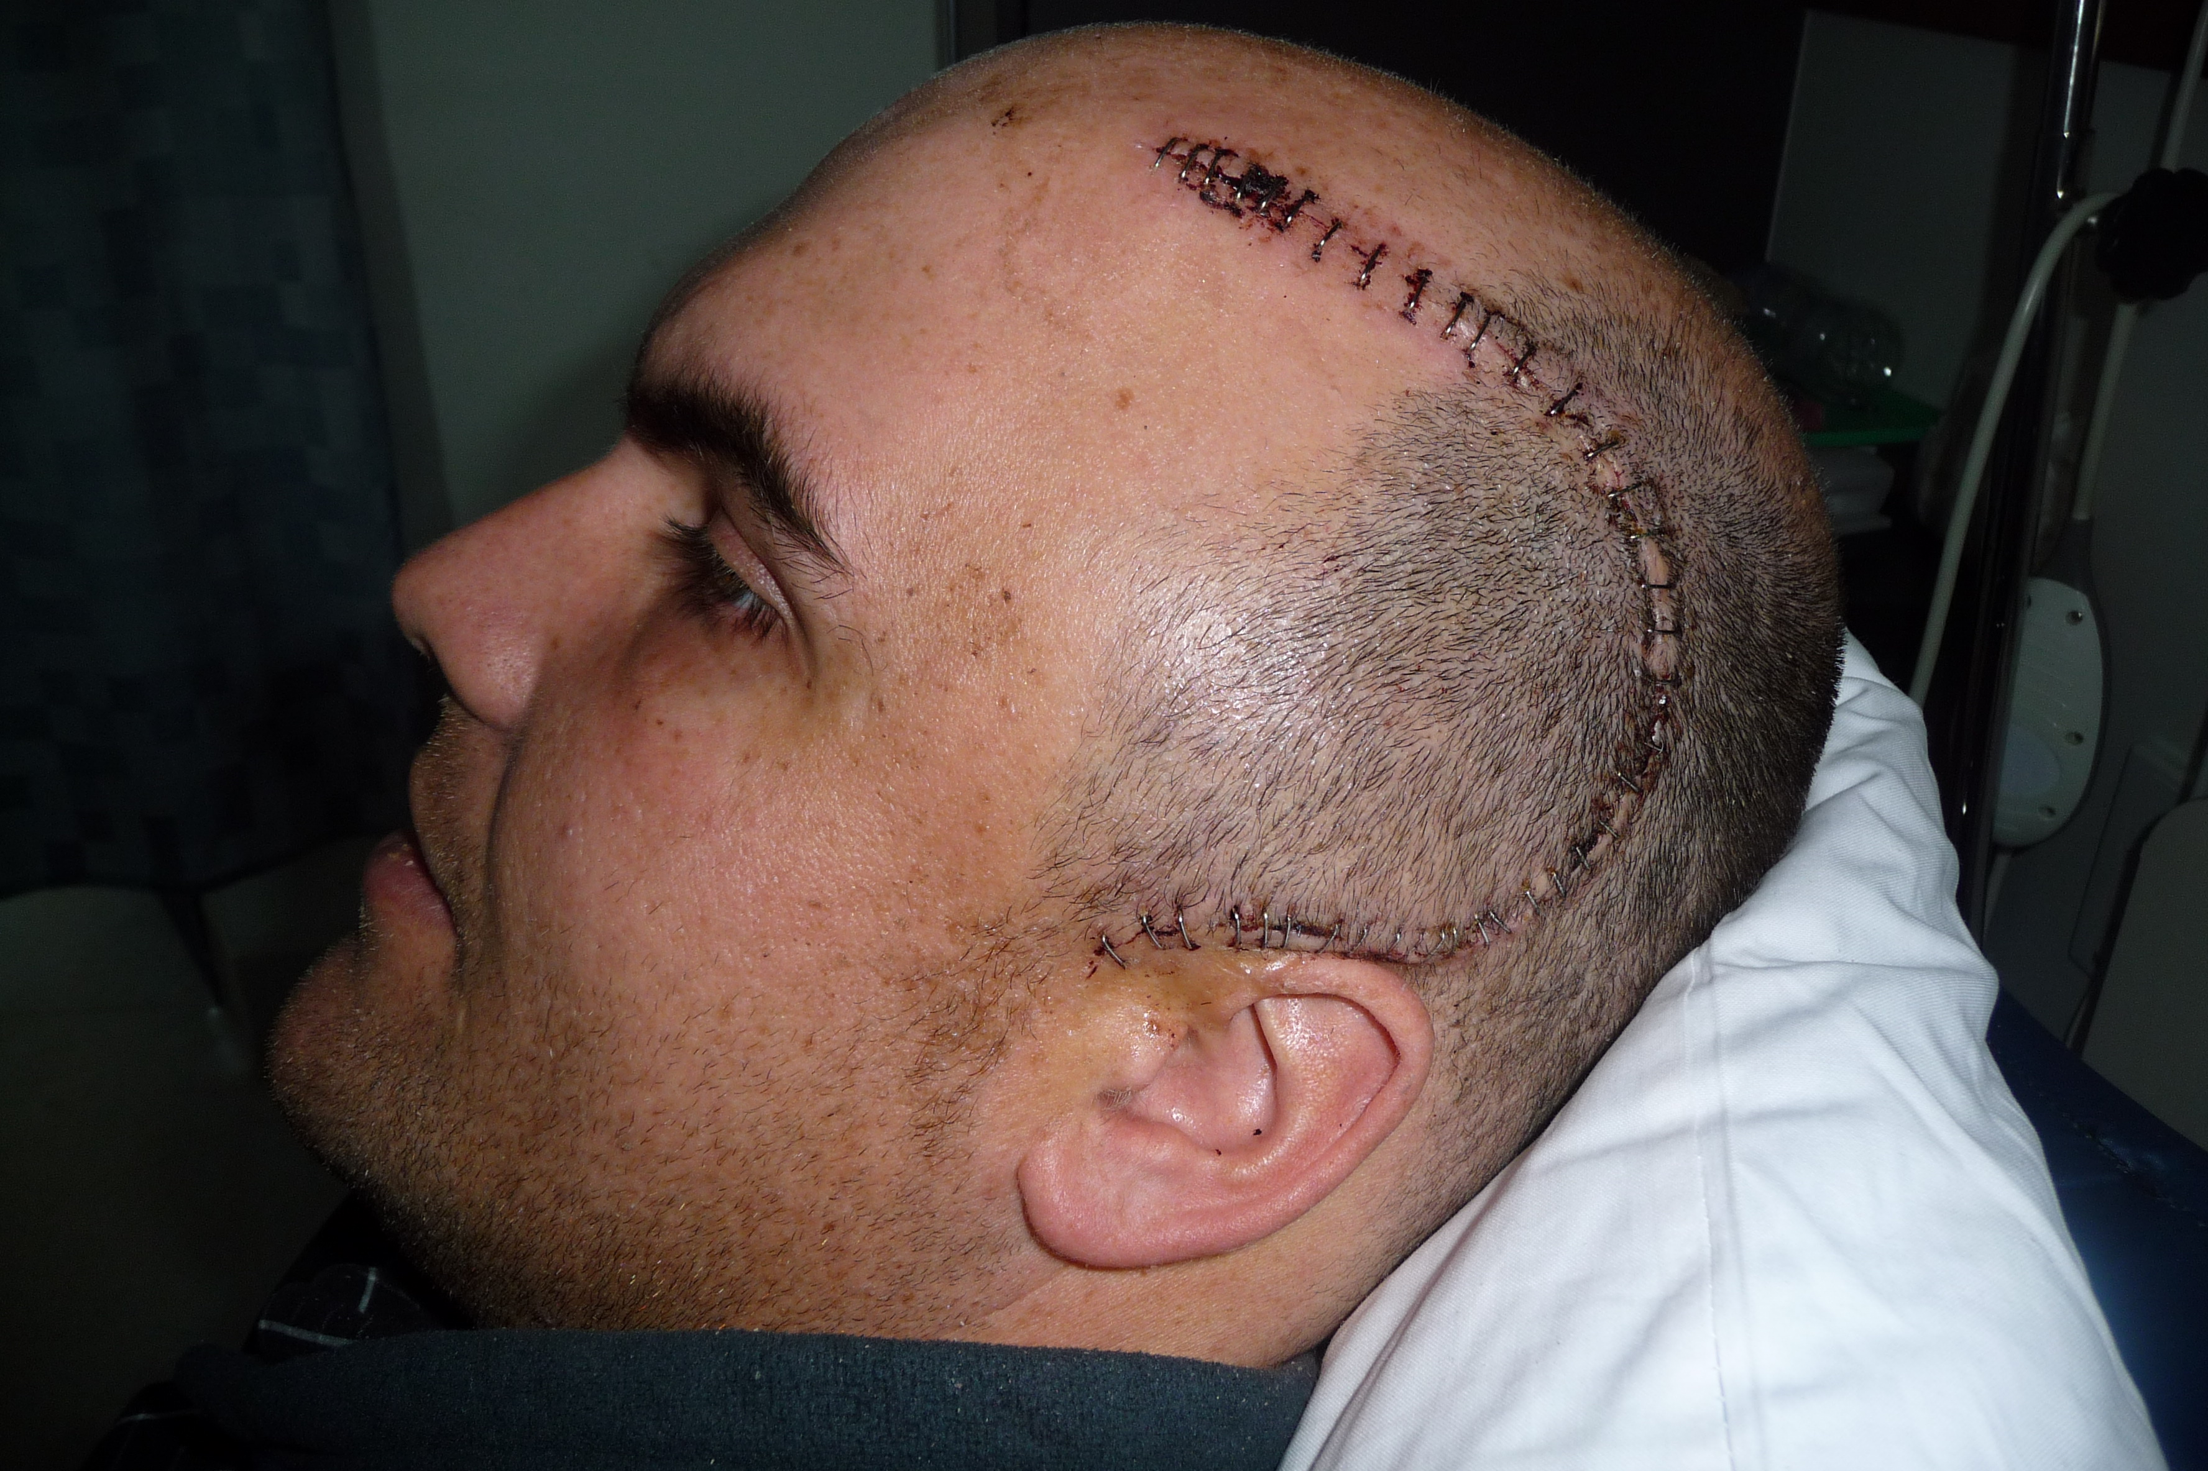

Category: Oral

