Transgenerational Epigenetic Inheritance: a Drosophila Tale
Filippo Ciabrelli PhD, CRUK Cambridge Institute, UK

Abstract

Transgenerational epigenetic inheritance is a hotly debated phenomenon whereby a non-genetically determined phenotype can be transmitted to the next generation. So far, this mode of inheritance has been described in few cases and it was suggested that chromatin components might be involved, including Polycomb group proteins, which act as repressors of key developmental genes and coordinate cell differentiation and proliferation. The molecular mechanisms linking Polycomb-mediated silencing to transgenerational epigenetic inheritance are far from being understood. Therefore, we developed an experimental system in Drosophila melanogaster to induce stable transgenerational epigenetic inheritance. After a genetic induction, I could obtain two “epilines” that either overexpressed or hyperrepressed their reporter genes and which epigenetic states could be stably inherited in the next generations, in the presence of the same DNA sequence. Starting from these highly stable epilines, I could dissect their genetic and molecular properties. The induced “epialleles” can be transmitted to the next generation from both parents in a pseudodominant manner. Moreover, the inherited epialleles display paramutagenic properties. Because of their epigenetic nature, the epialleles can be stably reset under some specific conditions as hemizygosity, but they can be only temporarily reset by environmental factors as temperature. One of the molecular signatures of the epialleles is the differential presence of the Polycomb repressive complexes and their related epigenetic marks. This different distribution is independent of the transcriptional activity of the downstream genes, at least in an early developmental stage. These results make a case for strong and stable transgenerational epigenetic inheritance in metazoan and provide a model that is amenable for the molecular dissection of this phenomenon.

Image
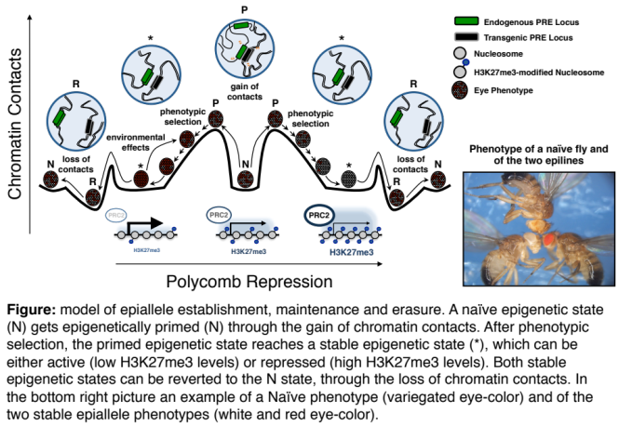
Recent Publications:
- Ciabrelli F, Comoglio F, Fellous S, Bonev B, Ninova M, Szabo Q, Xuéreb A, Klopp C, Aravin A, Paro R, Bantignies F, Cavalli G. Stable Polycombdependent transgenerational inheritance of chromatin states in Drosophila. Nat Genet. 49(6):876886 (2017).
- Miska EA, Ferguson-Smith AC. Transgenerational inheritance: Models and mechanisms of non-DNA sequence-based inheritance. Science Oct 7;354(6308):59-63. (2016).
- Heard, E. & Martienssen, R.A. Transgenerational epigenetic inheritance: myths and mechanisms. Cell 157, 95-109 (2014).
- Lim, J.P. & Brunet, A. Bridging the transgenerational gap with epigenetic memory. Trends Genet 29, 176-86 (2013).
5. Jablonka, E. & Raz, G. Transgenerational Epigenetic Inheritance: prevalence, mechanisms and implications for the study of heredity and evolution. The Quarterly Review Of Biology 84 (2009).

 Biography
Filippo Ciabrelli is a postdoc fellow at CRUK Cambridge Insitute (Cambridge,UK) in Greg Hannon lab, currently working on the interplay between noncoding RNAs and chromatin silencing in Drosophila germline. During his PhD in Giacomo Cavalli’s lab at IGH (Montpellier, France) he discovered and characterized a case of stable transgenerational epigenetic inheritance in the fruit fly Drosophila melanogaster (Ciabrelli et al., 2017). During these years, he developed his passion for epigenetic phenomena and chromatin regulation.

Email: filippo.ciabrelli@cruk.cam.ac.uk

Notes/Comments:

