Emergence of novel CpG islands and genomic imprinting in mammalian evolution
Shunsuke Suzuki, PhD, Shinshu University, Japan

Abstract

Genomic imprinting is an epigenetic regulatory mechanism which induces parent-of-origin-dependent expression to a subset of genes. In higher vertebrates, genomic imprinting has been observed only in viviparous mammals (eutherians and marsupials) and some imprinted genes have essential roles associated with fetal and placental development and control of post-natal care as well as lactation, suggesting the correlation between the evolution of genomic imprinting and these characteristics of mammals. Therefore, to study how imprinted loci arose during mammalian evolution would be of great importance to understand how these mammalian traits evolved. Parent-of-origin-dependent expression of imprinted genes is mostly controlled by parental allele-specific DNA methylation of the CpG islands called differentially methylated regions (DMRs). Although the essential role of DMRs for genomic imprinting mechanism has been well established, little is known about how they evolved. Comparative genome analysis of the SGCE-PEG10 imprinted domain revealed that PEG10, a retrotransposon-derived imprinted gene essential for placental development, was acquired in the common ancestor of marsupials and eutherians. Furthermore, in marsupials, both imprinting and differential DNA methylation were restricted to PEG10 unlike eutherians, suggesting that the insertion of PEG10 was the origin of imprinting in this imprinted domain. Also, comparative genome analyses in other imprinted domains showed that most DMRs have emerged as novel CpG islands during mammalian evolution. We presume that the emergence of novel CpG island consequent of retrotransposon insertion was key genomic change for the acquisition of DMRs that evolved imprinted loci in mammalian genomes.

Image

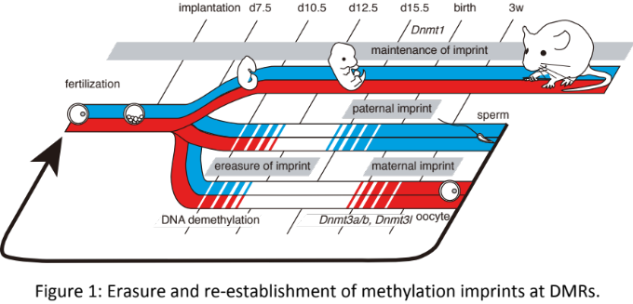
Recent Publications
- Mori S, Hayashi M, Inagaki S, Oshima T, Tateishi K, Fujii H, Suzuki S (2016) Identification of multiple forms of RNA transcripts associated with human-specific retrotransposed gene copies. Genome Biology and Evolution 8:2288-2296.
- Suzuki S, Shaw G, Renfree MB (2013) Postnatal epigenetic reprogramming in the germline of a marsupial, the tammar wallaby. Epigenetics & Chromatin 6:14.
- Renfree MB, Suzuki S, Kaneko-Ishino T (2013) The origin and evolution of genomic imprinting and viviparity in mammals. Review. Philosophical Transactions of the Royal Society B: Biological Sciences 368:20120151.
- Suzuki S, Shaw G, Kaneko-Ishino T, Ishino F, Renfree MB (2011) The evolution of mammalian genomic imprinting was accompanied by the acquisition of novel CpG islands. Genome Biology and Evolution 3:1276-1283.
- Suzuki S, Ono R, Narita T, Pask AJ, Shaw G, Wang CS, Kohda T, Alsop AE, Graves JA, Kohara Y, Ishino F, Renfree MB, Kaneko-Ishino T (2007) Retrotransposon silencing by DNA methylation can drive mammalian genomic imprinting. PLoS Genetics 3:e55.

 Biography (150 word limit)
Shunsuke Suzuki has completed his PhD from Tokyo Institute of Technology in 2006 and postdoctoral studies at Tokyo Medical and Dental University (2006-2009) and The University of Melbourne, Australia (2009-2012). He is now an Assistant Professor at Department of Agricultural and Life Sciences, Shinshu University, Japan. His work is focused on the role of retrotransposons in the evolution of gene regulatory mechanisms in mammals.
Email: ssuzuki@shinshu-u.ac.jp

Notes/Comments:

