Chromatin Reshuffling:

A Novel Biomarker for Stress-related Mental Disorders
Daniel Nätt, Linkoping University, Center for Social and Affective Neuroscience, Sweden.

Abstract (300 word limit)
Epigenetic changes have repeatedly been associated with stress resilience and susceptibility for mental disorders like major depression and post-traumatic stress disorder. This is true both in the central nervous system, as well as in peripheral cell populations. However, likely due to the heterogeneity, and the comorbidity between mental disorders and other health problems, peripheral epigenetic biomarkers for mental illness have been difficult to consistently reproduce. In a series of experiments, targeting multiple world populations, we have shown that single CpG biomarkers are only informative in special cases. Instead, building models that summarize information from multiple CpGs are more potent in predicting stress exposures and mental health. Using this strategy we have identified a stress mechanism characterized by a special pattern of chromatin reshuffling, where stress and mental illness lead to epigenetic silencing of euchromatin, accompanied by un-silencing of heterochromatin. We have also shown that poorly methylated genes and CpG-islands are protected against these effects, supporting the idea that single gene markers may be less informative biomarkers for mental illness. Here, I will summarize our exploration of this novel peripheral biomarker in projects investigating prenatal stress, childhood cortisol exposure, childhood and adult trauma exposures, and intimate/community violence, as well as in studies on major depressive, post-traumatic stress, substance use and anxiety disorders. I will show that in the majority of cases, chromatin reshuffling, more reliably predicts mental health outcomes than traditional candidate gene biomarkers.


Image
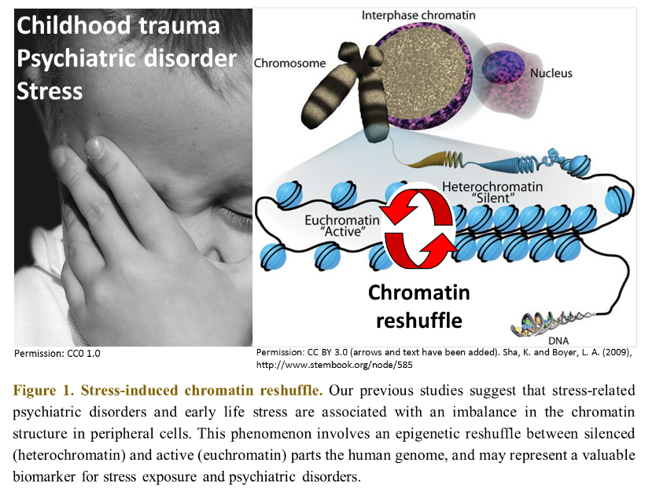
Recent Publications (minimum 5)
- Nätt, D., et al. (2015) High cortisol in 5-year-old children causes loss of DNA methylation in SINE retrotransposons: a possible role for ZNF263 in stress-related diseases. Clinical epigenetics 7, 1-13.
- Barbier, E. et al. (2016) Dependence-induced increase of alcohol self-administration and compulsive drinking mediated by the histone methyltransferase PRDM2. Molecular Psychiatry.
- Nätt, D. & Thorsell, A. (2016) Stress-induced transposon reactivation: a mediator or an estimator of allostatic load? Environmental Epigenetics 2.
- Thorsell, A. & Nätt, D. (2016). Maternal stress and diet may influence affective behavior and stress-response in offspring via epigenetic regulation of central peptidergic function. Environmental Epigenetics 2.
- Serpeloni et al. (2017) Grandmaternal stress during pregnancy and DNA methylation of the third generation: an epigenome-wide association study. Translational Psychiatry. Accepted.
- Serpeloni et al. (2017) Interplay between prenatal and community violence epigenetically shapes psychiatric resilience. Submitted.

Biography (150 word limit)
Daniel Nätt (Naett) has a long history of studying the (epi)genomic impact of stress in the brain and in peripheral cell population, both in Europe (Linkoping University, Linkoping) and in the US (Columbia University, New York). While starting off in an unorthodox model species (chickens), his research is now primarily focused on clinical and pre-clinical questions, targeting epigenetic mechanisms in human mental disorders. He aims to make ground breaking discoveries about these complex diseases by combining whole-genome molecular methods with innovative bioinformatics analyses. He has a diverse interest in the evolutionary foundation of stress and its’ consequences. This is reflected in his scientific contributions, which stretches from the very first paper reporting a quantitative genome-wide analysis of the chicken methylome, to the evidence for genome-wide heterochromatin loss following human childhood stress, and ultimately the discovery of stress-induced chromatin reshuffling in human mental disorder.
Email: daniel.natt@liu.se

Notes/Comments:

