Methylation Level of Plasminogen Activator Inhibitor-1 (PAI-1) gene in Endometriosis
Asmarinah^{1,2}, Ririn Rahmala Febri², Raden Muharam^{2,3}
¹Medical Biology Department of Faculty of Medicine, Universitas Indonesia
²Human Reproductive, Infertility, and Family Planning Cluster, Indonesian Medical Education and Research Institute (IMERI), Faculty of Medicine, Universitas Indonesia
³Department of Obstetrics and Gynecological, Faculty of Medicine, Universitas Indonesia

Introduction. Endometriosis that affects 10% women in the reproductive group is characterized by the presence of endometrium-like tissue outside of the uterine cavity, primarily in the ovaries. Endometriosis-associated pain can be caused by peritoneal inflammation, specific innervation, adhesion formation and cell invasion; whereas plasminogen activator system plays a role in this invasion. It has been known that plasminogen activator inhibitor-1 (PAI-1) level higher in endometriotic cells than normal endometrial cells. In this study, we determined the methylation level of plasminogen activator inhibitor-1 (PAI-1) in association with endometriosis. Methods. We collected 16 ovarian endometriosis samples obtained from patients, as compared to 12 normal endometrium tissues obtained from health women. Each participant gave informed consent. We used methylation specific PCR (MSP) and Image J software to analyze the methylation level of PAI-1 gene. Results: We found that the methylation level of PAI-1 in endometriotic cells was lower 37.95%, than normal endometrial cells. In addition, there was a significantly different of methylation level of PAI-1 gene between endometriosis (24.02 ± 7.22) and normal endometrium (61.97% ± 9.62) (p<0.05). Conclusion: This study showed there was a hypomethylation in the promoter region of PAI-1 gene and might contribute in the high level of PAI-1 in endometriosis tissue.

Recent Publications
1. Asmarinah, Febri RR, Rifani A, Putri AH, Muharam R. Progesterone receptor gene polymorphisms of rs1042838 and new mutation in ovarian endometriosis in Indonesian women. Advance Science Letter, July 2017 accepted.
2. Asmarinah, Febri RR, Putri AH, Rifani A, Muharam R. Association of progesterone receptor gene polymorphisms in promoter region with ovarian endometriosis in Indonesia woman. Advance Science Letter, July 2017 accepted.
3. Asmarinah, Syauqy A, Umar LA, Lestari SW, Mansyur E, Hestiantoro A, Paradowska-Dogan A. Sperm chromatin maturity and integrity correlated to zygote development in ICSI program. System Biology and Reproductive Medicine. 2016. Oct;62(5):309-16.
4. Muharam R, Harzif AK, Catherine, Asmarinah, Wiweko B. A preliminary communication: ongoing study on HOXA10 methylation profile of endometriosis patients with infertility. Journal Endometriosis and Pelvic Pain Disorders. 2016, 8(3): 106-110.
5. Asmarinah, Paradowska-Dogan A, Kodariah R, Tanuhardja B, Waliszewski P, Mochtar CA, Weidner W, Hinsch E. Expression of Bcl-2 family genes and complexes involved in the mitochondrial transport in prostate cancer cells. International Journal of Oncology. 2014. 45(4):1489-96.
6. Turana Y, Ranakusuma TA, Purba JS, Amir N, Ahmad SA, Machfoed MH, Handayani YS, Asmarinah, Wapadji S Enhancing diagnostic accuracy of aMCI in the elderly: Combination of alfactory test, pupillary response test, BDNF plasma level and APOE genotype. International Journal of Azheimers Disease. 2014:912586.

Biography

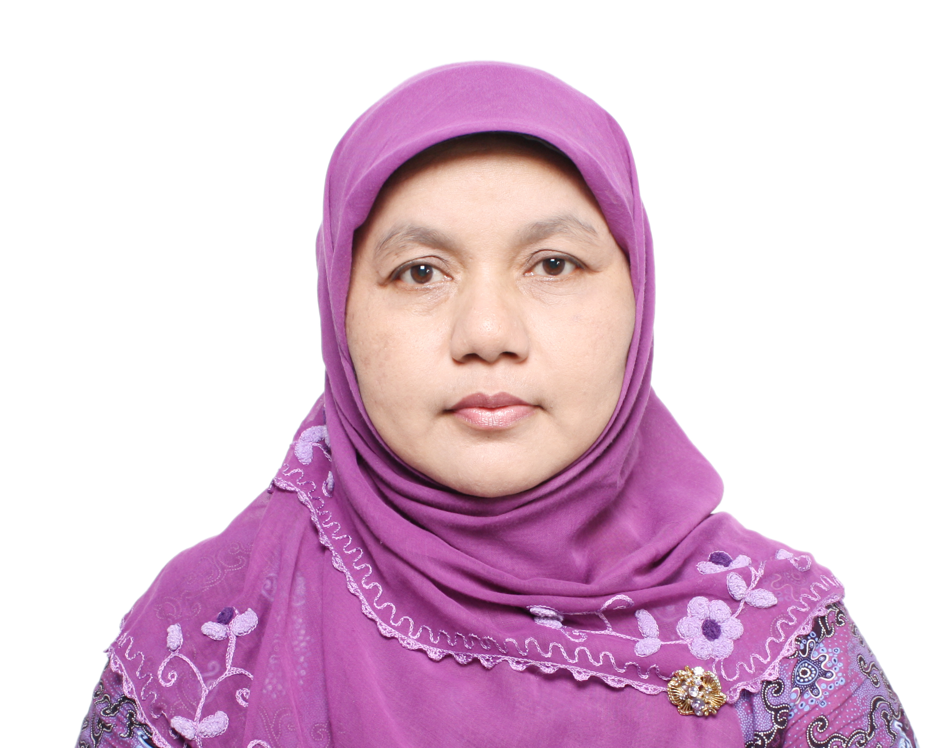
Asmarinah, born in Jakarta Indonesia, November 21th 1965, is a lecturer at Medical Biology Department, Faculty of Medicine Universitas Indonesia. She graduated from the Faculty of Mathematics and Natural Sciences, Universitas Indonesia (UI) in 1989. In 1996, she received Master of Science from Postgraduate Program in Biomedical Sciences of UI and Doctoral degree at Faculty of Biology, Chemistry, and Geo-Sciences; Justus-Liebig University of Giessen, Germany in 2003.
She received awards and grants including scholarship and research fellowship from DAAD (German Academic Exchange Service), Universitas Indonesia as well as from Indonesian Ministry for Education and Culture. Her research interests are human reproduction, human genetic and epigenetic field. Recently, she is doing research in sperm genetic and epigenetic as well as in woman reproductive disorders.

