Epigenetic strategies to treat neurodegenerative diseases
Andre Fischer, Department for Epigenetics and Systems Medicine in Neurodegenerative Diseases, German Center for Neurodegenerative Diseases (DZNE) Göttingen, von Siebold Str. 3A, 37075 Göttingen, Germany, Department of Psychiatry and Psychotherapy, University Medical Center Göttingen, Griesbachstr. 5, 37077 Göttingen, Germany

Abstract (300 word limit)
Statement of the Problem: Neuropsychiatric and neurodegenerative disease are an increasing emotional and economical burden to our societies. Recently the German government has created novel Health Center’s within the Helmholtz Society to foster translational research for the major disease such as cancer, cardiovascular diseases and also for neurodegenerative diseases. In this context the German Center for Neurodegenerative (DZNE) has been established. It consists of 9 research institutes across Germany. The site in Goettingen has a specific focus on epigenetic processes in neurodegenerative diseases, a novel research area in the neurosciences. The etiology of neurodegenerative and neuropsychiatric diseases is often complex and disease progression is due to variable combinations of genetic and environmental risk. Especially the environmental risk has been difficult to measure. Epigenetic processes are key regulators of such genome-environment interactions and have emerged as novel therapeutic targets in various brain diseases including depression, post-traumatic stress disorder or Alzheimer’s disease (AD). In addition, the analysis of epigenetic marks offers the ability to develop novel biomarker and hold great promise for patient stratification and personalized medicine. In my presentation, I will give an overview on the novel research field of neuroepigenetics and highlight specific examples for its potential in translational research. For example we have discovered that inhibitors of histone-deacetylases, which control epigenetic gene-expression at the systems level, ameliorate disease phenotypes in mouse models for AD and have now initiated the first clinical trial using an FDA approved HDAC inhibitor Vorinostat to treat AD patients. Another key area I will cover in my presentation is the use of epigenetic marks as biomarker for the stratification of patients suffering form neurological diseases. Here our central hypothesis is that the various AD risk factors eventually lead to aberrant gene-expression and loss of transcriptional control. This is based on the assumption that proper gene-expression is a core feature of cellular homeostasis and that changes occurring at various compartments of the cell (e.g. at the synapse) will eventually signal to the nucleus and cause gene-expression changes. Thus, targeting pathological gene-expression could be a suitable therapeutic approach, especially for multifactorial diseases such as AD, where it is nearly impossible to determine all of the genetic and environmental factors that eventually contribute to clinical phenotypes (Fig 1) .

Image
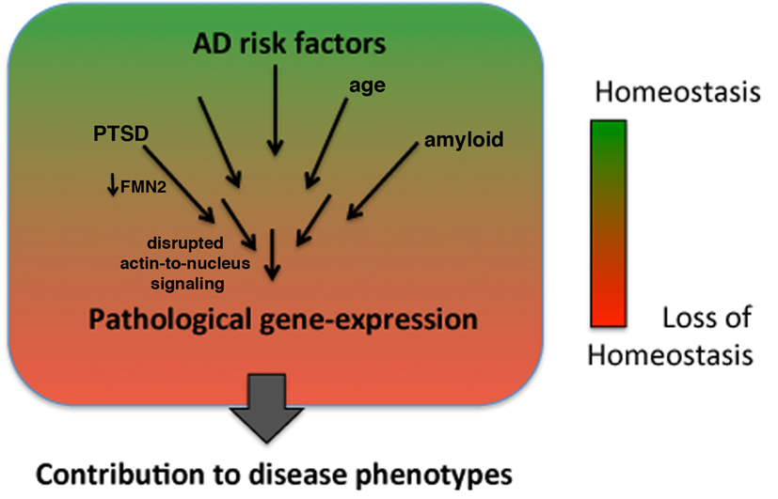
Fig. 1. An epigenetic view on the pathogenesis of Alzheimer’s disease (AD)
Recent Publications (minimum 5)
- Benito E, Ramachandran B., Schroeder H, Schmidt G, Urbanke H. Burkhardt S, Capece C, Dean C, Fischer A,. The BET/BRD inhibitor JQ1 improves brain plasticity in WT and APP mice. Translational Psychiatry, in press
- .Bahari-Javan, S., et al. Fischer, A. Hdac1 as a target for individualized therapy of schizophrenia patients. PNAS, 2017. 114(23):E4686-E469
- Kerimoglu C, Sadman SM, Jain G, Benito E, Burkhardt S, Capece V, Kaurani L, Halder R,, Agís-Balboa RC, Stilling R, Urbanke U, Kranz A, Stewart AF, Fischer A. Kmt2a and kmt2b mediate memory function by affecting distinct genomic regions. Cell Reports, 2017, 20, 3:538-548
- Halder R, et al. Fischer A*, Bonn S. DNA methylation changes in plasticity genes accompany the formation and maintenance of memory. Nat Neurosci. 2016 Jan;19(1)* shared last author
- Benito, E. et al., Fischer, A. Reinstating transcriptome plasticity and memory function in models for cognitive decline. Journal of Clinical Investigation, (2015) 125(9):3572-84

Biography (150 word limit)
After several research stays at Harvard University, Boston USA and Massachusetts Institute of technology (Cambridge, USA), Prof. Fischer was leading a junior research group funded by the EURYI Award at the European Neuroscience Institute, Goettingen. The scientific results of this group significantly contributed to the establishment of the new research field of neuroepigenetics. Since 2011, Andre Fischer is Professor at the Medical Center of the University of Goettingen, Director of the Department for Systems Medicine and Epigenetics in Neurodegenerative Diseases at the German Center foor Neurodegeneraive Diseases (DZNE) and Spokesman of the DZNE site Goettingen.
Email: andre.fischer@dzne.de
Notes/Comments:

