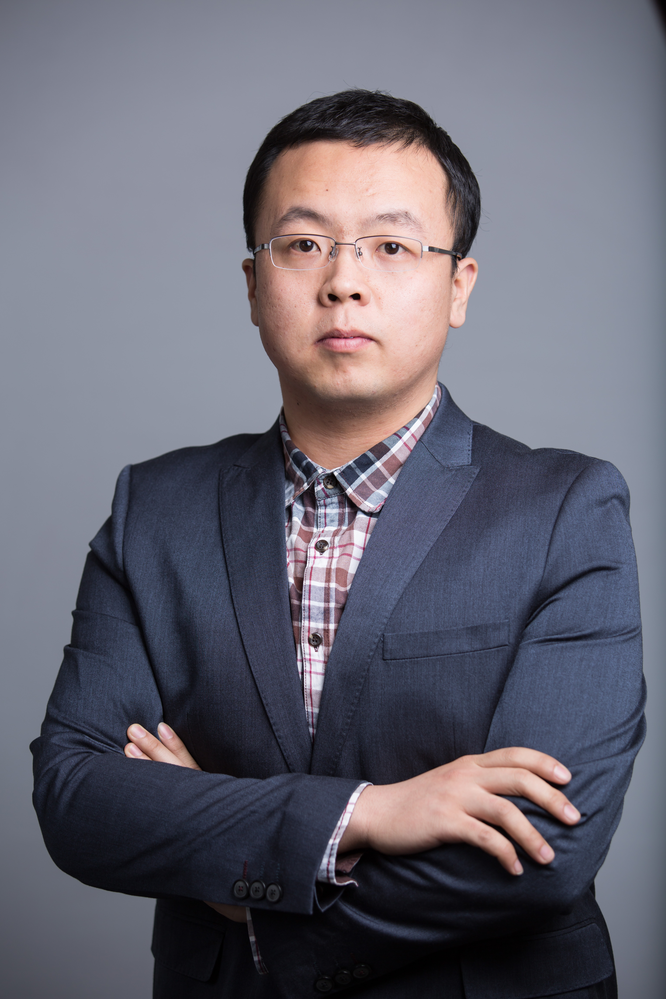

Title: Lifestyle factors and gender-specific risk of stroke in Chinese adults with hypertension: a national case-control study

Name: Jian Guo¹, Tianjia Guan¹, Ying Shen², Baohua Chao³, Mei Li⁴, Longde Wang⁵ and Yuanli Liu¹

¹School of Public Health, Peking Union Medical College, Beijing, 100006, P.R.China
²Xuanwu Hospital Capital Medical University, Beijing, 100053, P.R.China
³National Health and Family Planning Commission of the People’s Republic of China, Beijing, 100044, P.R.China
⁴China Stroke Data Center, Beijing, 100101, P.R.China
⁵School of Public Health, Peking University Health Science Center, Beijing, 100083, P.R.China

Limited studies investigated the relationship between lifestyle factors and risk of stroke in hypertensive people. Moreover, estrogen was shown to counteract the unfavorable effects of lifestyle factors on stroke in general people by several studies. Therefore, we conducted a case-control study to investigate the relationship between lifestyle factors and gender-specific risk of stroke in hypertensive people based on the China National Stroke Screening Survey. Stroke cases and types were defined by self-report and were confirmed by a neurologist using neuroimaging according to the criteria of the World Health Organization. Demographic data and information on risk factors were collected using structured questionnaires and physical examinations. Hypertensive participants who were diagnosed with ischemic stroke or hemorrhagic stroke were considered cases. The controls (1:1 frequency-matched for age and urban/rural ratio) were non-stroke subjects who were randomly selected from the hypertensive participants. A total of 7,631 ischemic stroke cases (7,769 controls) and 994 hemorrhagic stroke cases (1,015 controls) were included. Among smoking, overweight and physical inactivity, the lifestyle factor that showed the strongest association with the risk of ischemic stroke was physical inactivity (OR=1.42) in men and smoking (OR=1.46) in women. The strength of the association between physical inactivity and risk of hemorrhagic stroke was higher in men (OR=1.91) than in women (OR=1.55). In conclusion, the strength of the association between physical inactivity and both types of stroke was higher in men, but the association between smoking and risk of ischemic stroke was higher in women.

Biography:
Jian Guo is pursuing his PhD degree at School of Public Health, Peking Union Medical College. His research interest is epidemiology of chronic non-communicable diseases. Now he focused on the epidemiology and lifestyle intervention of stroke in Chinese people.

Presenting author details:
Full name: Jian Guo
Contact number: +86-18810962989
E-mail: guojian_pumc@163.com
Session name/number: Epidemiology and stroke/Track 2-11
Category: Poster presentation

