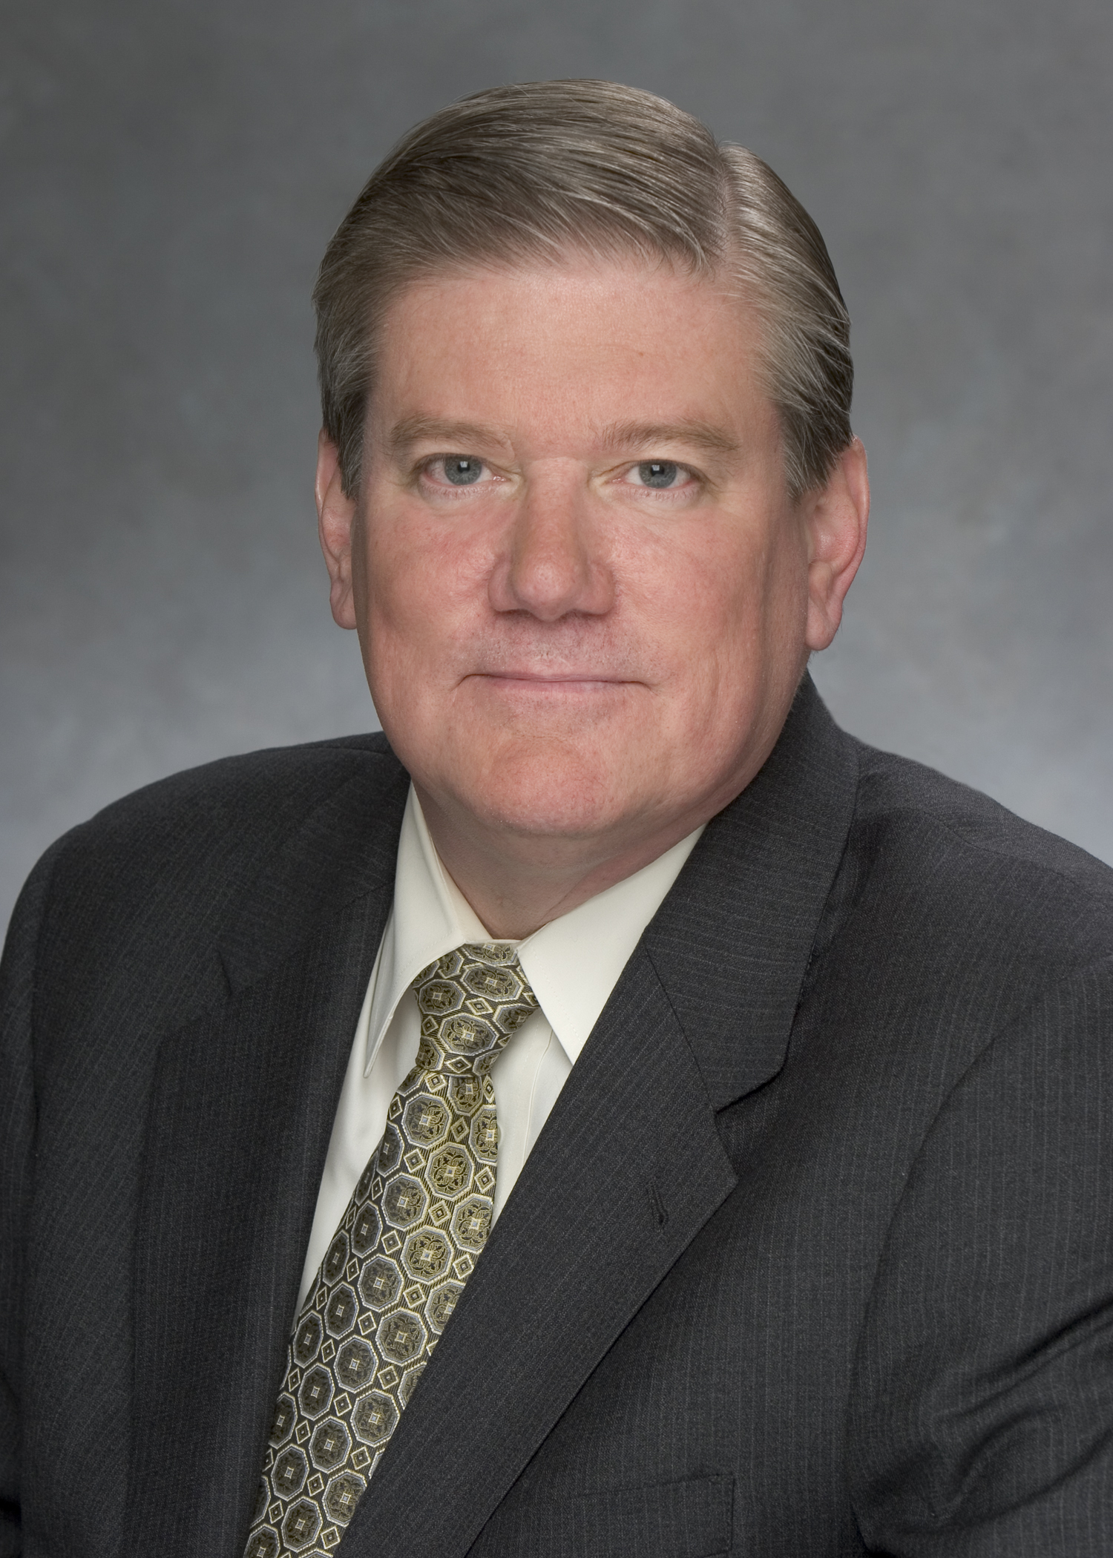

SOCIOECONOMIC DEPRIVATION IN THE CAUSAL PATHWAY OF DISEASE

Gary Stephen Young MA DrPH*

*Cooper Medical School of Rowan University, 401 Broadway, Camden, NJ, 08103

There is no widely accepted conceptual framework for incorporating social causation and the role of social factors in the biomedical physiological model that dominates contemporary epidemiology. Social epidemiology has contributed significant insights about the distribution of disease and poses fundamental questions about disease pathology. The social determinate of health literature emphasizes inequality across populations, but typically uses status measures (SES, SEP) rather than socioeconomic deprivation (SED) to account for variability in health outcomes. This paper views population vulnerability as the interaction of differential exposure and differential susceptibility related to SED. This paper reviews the sociology of SED and explores plausible mechanisms of the disease process related to SED. Two indices of SED (Townsend Index, Neighborhood Concentrated Disadvantage) are then used in three demonstrations of SED-related vulnerability: (a) differential exposure to hazardous air pollution among U.S census tracts (1999-2005); (b) differential susceptibility to cardiorespiratory hospitalization among the 566 towns in New Jersey (2000-2005) ; and (c) differential vulnerability to premature mortality among U.S counties (1999-2008). Findings include support for construct and convergent validity of SED measures, and statistically significant effects (beta coefficients) for SED after adjustment for population size and density: (a) greater environmental respiratory hazard exposure (.17) among U.S. census tracts; (b) higher respiratory (.89) and cardiovascular (1.9) hospitalization among NJ adults 25-64 years; and (c) increased premature all cause mortality (.44) among adults aged 35-64 in U.S counties. This paper demonstrates how sociological models of SED can be incorporated into epidemiology and advances understanding of social causation in the disease process.

Biography

Dr. Young graduated from the Johns Hopkins Bloomberg School of Public Health as Master and Doctor of Public Health, with specialization in Epidemiology and Social Medicine. He also took a Master’s degree in Sociology from Pennsylvania State University where he studied demography, biostatistics and quantitative research methods as a doctoral candidate. His research focuses on the distribution of air toxic exposure, neighborhood health effects, and vulnerability to chronic disease and health care disparities. He holds positions as Executive Vice President for Health Policy at Cooper University Health Care and Assistant Professor in the Department of Medicine of Cooper Medical School of Rowan University, where he is Director of the Center for Injury Epidemiology and Social Medicine.

Keywords: differential exposure, population vulnerability; socioeconomic deprivation; townsend index, neighborhood health effects; social epidemiology.

Abstract submitted for presentation at the 4th International Conference on Epidemiology and Public Health which will be held from October 03-05, 2016 London, U.K.

Desired presentation: XX_ Oral / _ Poster / _ either

Topic: Epidemiology and Sociology

Corresponding Author Details: Gary S. Young MA DrPH
young@rowan.edu
Cooper Medical School of Rowan University
10th Floor Pavilion, Executive Suite B
One Cooper Plaza
Camden, New Jersey 08103 USA
01-856-342-3002, 01-856-342-3299

