Bromoperoxidase mimicking bromination catalysts
Toshiyuki Moriuchi, Dr., Department of Applied Chemistry, Graduate School of Engineering, Osaka University, Japan

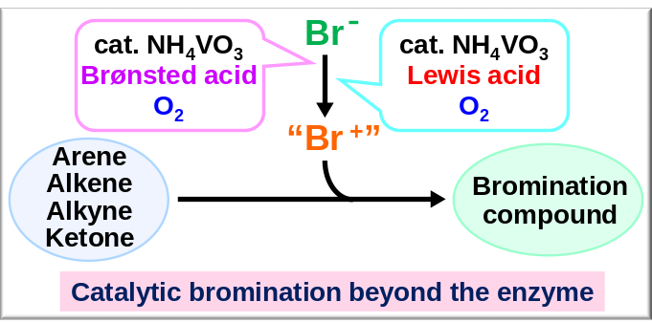
Abstract (300 word limit)
Haloperoxidases are enzymes that are able to catalyze the oxidation of halide ions by using hydrogen peroxide. Catalytic activities of haloperoxidases have received great attention because of their capability to halogenate a variety of organic compounds. Vanadium bromoperoxidase (V-BrPO), which is a naturally occurring enzyme found in marine algae, is a kind of haloperoxidase. V-BrPO catalyzes two-electron oxidation of the bromide ion in the presence of hydrogen peroxide, affording a bromonium cation-like species. V-BrPO has been demonstrated to perform the catalytic bromination of organic compounds. Bromination reaction is one of the most fundamental reactions in organic synthesis, providing important precursors and substrates in various coupling reactions. Conventional bromination reaction is performed by using hazardous and toxic elemental bromine. Considerable efforts have been focused on developing a versatile bromination method with a bromide ion as a bromide source instead of bromine. So, the V-BrPO mimicking bromination reaction systems induced by a vanadium catalyst and hydrogen peroxide have attracted much attention. These catalytic systems, however, require a stoichiometric amount of a strong oxidant to generate the bromonium-like species. A more practical catalytic bromination reaction system without use of hazardous reagents is to be developed. From the view point of green chemistry perspective, molecular oxygen is regarded as the best candidate for oxidants. We embarked upon the development of an environmentally-favorable catalytic method for selective bromination of a wide range of substrates. In this presentation, bromoperoxidase mimicking versatile and practical bromination catalytic systems by the combination of a commercially available inexpensive ligand-free vanadium catalyst and a Brønsted acid or a Lewis acid under molecular oxygen will be described.

Recent Publications
- Moriuchi T, Yamaguchi M, Kikushima K, Hirao T (2007) An Efficient Vanadium-Catalyzed Bromination Reaction. Tetrahedron Lett. 48:2667-2670.
- Kikushima K, Moriuchi T, Hirao T (2009) Vanadium-Catalyzed Oxidative Bromination Reaction under Atmospheric Oxygen. Chem. Asian. J. 4: 1213-1216.
- Kikushima K, Moriuchi T, Hirao T (2010) Oxidative Bromination Reaction Using Vanadium Catalyst and Aluminum Halide under Molecular Oxygen. Tetrahedron Lett. 51: 340-342.
- Kikushima K, Moriuchi T, Hirao T (2010) Vanadium-Catalyzed Oxidative Bromination Promoted by Brønsted Acid or Lewis Acid. Tetrahedron 66: 6906-6911.
- Moriuchi T, Fukui Y, Kato S, Kajikawa T, Hirao T (2015) Vanadium-Catalyzed Chlorination under Molecular Oxygen. J. Inorg. Biochem. 147: 177-180.


Toshiyuki Moriuchi received his bachelor’s degree in 1991 and his doctoral degree in 1995 under the supervision of Professor Toshikazu Hirao, both from Osaka University. He became Assistant Professor at Osaka University and was a postdoctoral fellow at California Institute of Technology with Professor Jacqueline K. Barton (1996–1997). Dr. Moriuchi was promoted to Associate Professor in 2004. His current research interests focus on the development of novel artificial bioconjugated systems based on self-organization of biomolecules and redox-active π-conjugated systems for functionalized catalysts and materials. He received the Inoue Research Award for Young Scientists in 1997 and HGCS Japan Award of Excellence 2011 in 2012.
Email: moriuchi@chem.eng.osaka-u.ac.jp

Notes/Comments:

