The Catalytic and Structural Roles of the Human Hexokinase 2 in Cancer
Wael M. Rabeh. PhD, New York University Abu Dhabi, UAE.

Abstract (300 word limit)
Glucose metabolism is 200 times higher in cancer in comparison to normal tissue as a strategy to support tumor growth and progression, historically known as the ‘Warburg effect’. Hexokinase is the first enzyme of the glycolytic pathway that catalyzes the phosphorylation of glucose for its activation to glucose-6-phosphate and uses ATP as high-energy source of phosphates. Four isozymes are present in human with Hexokinase 2 (HK2) is most active and specifically expressed in verity of different cancers. However, HK2 binding to the outer mitochondrial membrane not only gives it prime access to ATP generated by the mitochondrial but inhibit apoptosis.
Here, we aim to biochemically and structurally characterize interactions of HK2 with the mitochondria and the N-terminal role in catalysis and stability of the full-length enzyme. Here, we solved the crystal structure of human HK2 in complex with glucose and glucose-6-phosphate (PDB code: 2NZT), where it is a homodimer with catalytically active N- and C-terminal domains linked by a seven-turn α-helix. Different from the inactive N-terminal domains of isozymes 1 and 3, the N- domain of HK2 not only capable to catalyze a reaction but it is responsible for thermodynamic stabilizes of full-length enzyme. Deletion of first α-helix of the N-domain that binds to the mitochondria altered the stability and catalytic activity of the full-length HK2. In addition, we found the linker helix between the N- and C-terminal domains to play an important role in controlling the catalytic activity of the N-terminal domain. HK2 is a major step in the regulation of glucose metabolism in cancer making it an ideal target for the development of new anticancer therapeutics. Characterizing the structural and molecular mechanisms of human HK2 and its role in cancer metabolism will accelerate the design and development of new cancer therapeutics that are safe and cancer specific.

Image
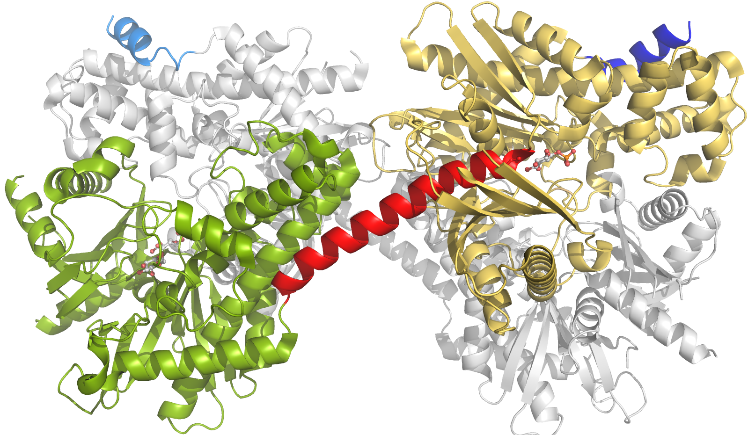
Recent Publications (minimum 5)
- Rabeh, W.M.; Bossard, F.; Xu, H.; Okiyoneda, T.; Bagdany, M.; Liu, Y.; Mulvihill, C.M.; Du, K.; Di Bernardo, S.; Konermann, L.; Roldan, A.; Lukacs, G.L. Correction of both NBD1 energetics and domain interface is required to restore ∆F508 CFTR folding and function. (2012) Cell; 148(1-2): 150-63.
- Wyatt, E.; Wu, R.; Rabeh, W.; Park, H.W.; Ghanefar, M. and Ardehali, H. Regulation and Cytoprotective Role of Hexokinase III. (2010) PLoS One. 5(11): e13823
- Okiyoneda, T.; Barrière, H.; Bagdány, M.; Rabeh, W.M.; Du, K.; Höhfeld, J.; Young, J.C. and Lukacs, G.L. Peripheral Protein Quality Control Removes Unfolded CFTR from the Plasma Membrane. (2010) Science. 329: 805-10.
- Rabeh, W.M.*, Tempel, W.*, Bogan, K.L., Belenky, P., Wojcik, M., Seidle, H.F., Nedyalkova, L., Yang, T., Sauve,A.A., Park, H.W. and Brenner,C. Nicotinamide Riboside Kinase Structures Reveal New Pathways to NAD+. (2007) PLoS Biol. 5(10): e263 *Co-first Authors.
- Rabeh, W.M.*, Chattopadhyay, A.*, Meier, M., Ivaninskii, S., Burkhard , P., Speroni, F.*, Campanini, B., Bettati, S., Mozzarelli, A., Li, L. and Cook, P.F. Structure, Mechanism, and Conformational Dynamics of O-Acetylserine Sulfhydrylase from Salmonella typhimurium: Comparison of A and B Isozymes. (2007) Biochemistry 46, 8315-30 *Co-first Authors.

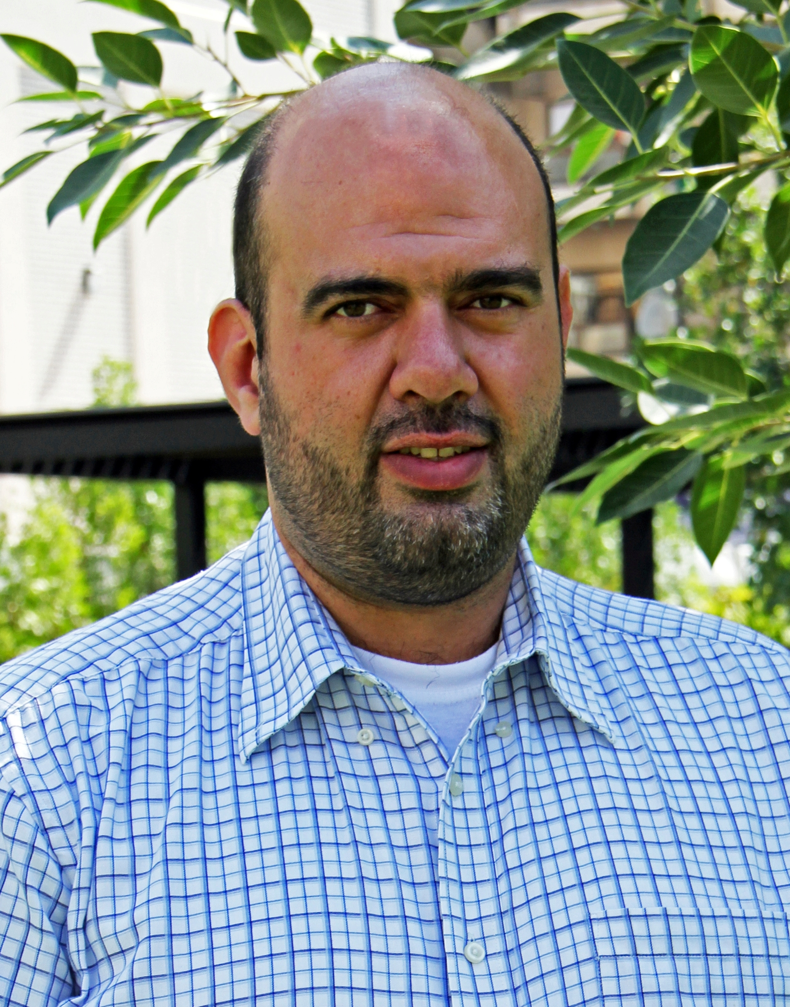Biography (150 word limit)
Dr. Wael Rabeh received his PhD in Biochemistry in the lab of Prof Paul F. Cook where he characterized the last enzymatic reaction of the cysteine biosynthetic pathway in Salmonella typhimurium. In 2005, Dr. Rabeh joined the Structural Genomic Consortium (SGC) at the University of Toronto as a post-doctoral fellow, where he characterized the 3D structure of human proteins with medical relevance using X-ray crystallography. In 2007, Dr. Rabeh joined the lab of Dr. Gergely Lukacs at McGill University for the characterization of a membrane channel that is the main cause of Cystic Fibrosis. Dr. Rabeh’s research is devoted for the characterization of proteins’ structure and mechanism to understand their biological function. Major area of his research focus is devoted for the characterization of disease-causing mechanism of proteins with medical relevance to assist in the discovery and design of new therapeutics using proteins’ structural information and computer simulation.

Email: wael.rabeh@nyu.edu

Notes/Comments:

