Toxicological assessment of acetaminophen, ibuprofen and furosemide pharmaceuticals on aquatic organisms
Soledad Chamorro, PhD, Departamento de Ciencias Básicas, Universidad Santo Tomás.
Gester Gutiérrez, Environmental Chemistry, Universidad de Concepción, Chile.
Cristina A. Villamar, PhD, Universidad Santiago de Chile, Chile.
Margarita Lopéz, MSc, Departamento de Ciencias Básicas, Universidad Santo Tomás
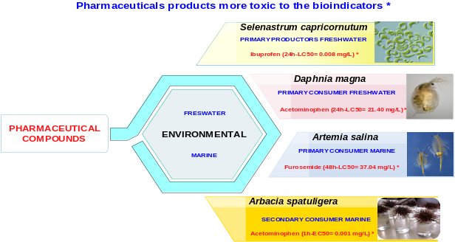
Figure 1. Environmental assessment for pharmaceuticals compounds in freshwater and marine bioindicators.

Abstract (300 word limit)
Acetaminophen, ibuprofen and furosemide effect are inside of 140 pharmaceutical products detected in water resources. The main route of entry to aquatic environments of these compounds is from municipal wastewater to concentrations under 3 μg/L. Recalcitrance to biodegradation in wastewater treatment plant and their chemical properties (solubility, coefficient octanol-water) favored the presence and potential toxicological effect on organisms of aquatic environments. Therefore, the aim of this work was to assessment of theses pharmaceutical products on freshwater organism Daphnia magna and Selenastrum capricornutum, as well as marine organisms such us Artemia salina and Arbacia spatuliera. The methodology was based on acute/chronic bioassays on D. magna (24-48 h-LC₅₀, reproductive effects), S. capricornutum (72 h-LC₅₀), A. salina (48 h-LC₅₀) and A. spatuligera (reproductive effects). Pharmaceutical concentrations were tested in values from 1.0 to 260.0 mg/L for acetaminophen and ibuprofen, while concentrations from 1.0 to 64.0 mg/L for furosemide. Results demonstrate the acute toxicity from acetaminophen reached values between 0.26 mg/L for S. capricornutum and 21.40 mg/L D. magna. Furosemide showed acute toxicity of 37.01 mg/L for A. salina and 62.31mg/L for D. magna. Finally, ibuprofen reached acute toxicity values under 0.01mg/L and 78.11mg/L for S. capricornutum and D. magna respectively. Chronic effects related with reproduction on D. magna showed values of media effective concentration (CE₅₀) of 15mg/L for furosemide and 5 mg/L for Ibuprofen. Therefore, toxicity effects on aquatic organisms of these pharmaceutical products depend on tropic level evaluated, being primary producers (S. capricornutum) more sensible than primary consumers (D. magna). Marine organisms (A. salina) are more resistant than freshwater organism (D. magna). Pharmaceutical products as acetaminophen, ibuprofen evidenced more toxicity than diuretics drug. Reproductive effects on A. spatuligera evidence that ibuprofen and acetaminophen (CE₅₀: 0.001 and 0.003 mg/L), respectively is more toxic that furosemide (CE₅₀: 0.36mg/L).


Image

Recent Publications (minimum 5)
- Chamorro S, Hernández V, Matamoros V, Domínguez C, Becerra J, Vidal G, Piña B, Bayona JM (2013). Chemical characterization of organic microcontaminant sources and biological effects in riverine sediments impacted by urban sewage and pulp mill discharges Chemosphere 90:(2) 611-619.
- Chamorro S., López D, Brito P, jarpa M, Piña B, Vidal G (2016) Sublethal Effects of Chlorine-Free Kraft Mill Effluents on Daphnia magna. Bulletin of Environmental Contamination and Toxicology 97:843–847.
- Chamorro S, Vergara JP, Jarpa M, Hernández V, Becerra J, Vidal G (2016) Removal of stigmasterol from Kraft mill effluent by aerobic biological treatment with steroidal metabolite detection. Journal of Environmental Science and Health part A: Toxic/Hazardous Substances and Environmental Engineering 51:(12) 1012-1017.
- Chamorro S, Barata C, Piña B, Casado M, Saéz K, Schwarz A, Vidal G (2017) Toxicological analysis of acid mine drainage by water quality and land use bioassays. Mine Water and the Environment DOI: 10.1007/s10230-017-0472-2.
- Xavier CR, López D, Chamorro S, Scholze A, Vidal G. (2017) Sensitivity study comparing Daphnia obtusa (Kurz 1874) and Daphnia magna (Straus 1820) exposure to treated Kraft mill effluents, diethylstilbestrol and androstenodione. BioResources 12:(3) 6558-6567.

Biography (150 word limit)
Soledad Chamorro has expertise in toxicology evaluation (lethal, sublethal, chronic and metabolic) trough bioindicators and biomarkers as algae, microcrustacean and fish. The line of expertise are the aquatic quality and environment health. In addition the evaluation of biologicals treatment (conventional and not conventional applied to industries), moreover the assess of microcontaminants in aquatic and soil matrix
Email: schamorro@santotomas.cl
Notes/Comments:

