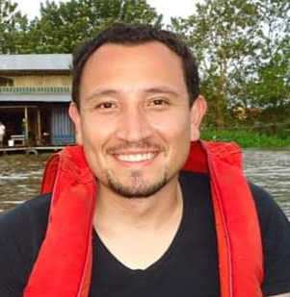
Determination the lethal concentration (LC₅₀ 96h) of herbicide Roundup Activo® on native fish (Piaractus brachypomus) and histopathological alterations in gills and Kidney

Edwin Gómez Ramírez, Camilo Andrés Riaño Quintero, Mónica Andrea Ortiz, Oscar Javier Bernal
Militar University Nueva Granada, Ecotoxicology, Evolution, Environmental and Conservation Group, and GREST Group. Colombia.
Abstract
Roundup® Activo (RA) is one of the most used herbicide in Colombia to weed control in traditional and transgenic crops, although also is used in the drying of grains, maturation of sugar cane, and control of illicit crop. The objective that research was determinate the lethal concentration (LC₅₀96h) of herbicide RA on fry and fingerling on native fish Piaractus brachypomus. During 96h an acute static toxicity tests were performed to determine the median lethal concentration of glyphosate in the commercial product RA. Eighteen concentration was evaluated (1.0, 1.7, 2.3, 3.1, 4.2, 5.6, 7.4, 10.0, 13.3, 17.7, 23.7, 31.6, 35, 42.1, 56.2, 74.9, 100, 163.3 mg/L). Ten Fry and five fingerlings were randomly introduced in aquarium of 20L. There aquariums were marked as control (not treated with RA). The dead fishes were noted and removed instantly by histopathological studies. Finally the LC₅₀96h was determinate by the probit analysis method. Gill and kidney were dissected and fixed in formaldehyde, dehydrated in alcohol, processed in paraffin and stained in H&E. In fry and fingerlings of P. brachypomus the LC₅₀96h were determinate in 7.4 mg/L and 35 mg/L respectively. The histopathological alteration enhance when increasing the concentration of glyphosate in the RA. The gill showed edema, lamellar fusion, thalangetasia, and damage in pillar cells. The kidney exhibit picnotic cells, damage in the Bowman capsule and degeneration in the tubular epithelium. The LC₅₀96h in Fry and Fingerlings were lower than previous reported to P. brachypomus for Roundup® SL, which suggests greater toxicity of RA. INV-ING2980.
Biography.
Biologist, specialist and magister in aquaculture. Professor and researcher at the Military University Nueva Granada. Group of Ecotoxicology, Evolution, Environment and Conservation (E = mc2). Meritorious thesis in fish neuroscience, about histology and morphometry of dorsal root ganglia and their neurons in a fish of indeterminate growth the White Cachama (Piaractus brachypomus). Research about effect of glyphosate and Roundup in tropical fishes. Studies in the World Fish Center (Egypt) and scholarship in recirculation aquaculture systems, in the Scientific Research Center of Baja California (CICESE, Mexico). About 27 scientific publications in national and international indexed journals. INV-ING 2980.
Presenting author details
Full name: Edwin Gómez Ramírez
Contact number: + 57 3178545231
Twitter account:
Linked In account:
Session name/ number:
Category: Poster presentation

