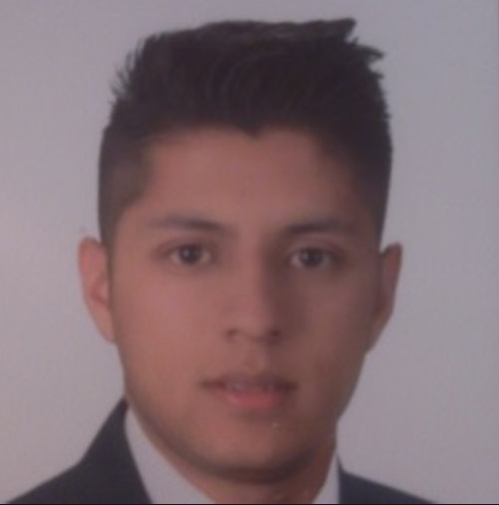

Histopathological alterations in preoptic area of tropical fish (Piaractus brachypomus) exposed to a commercial glyphosate presentation (Roundup Activo®)

Camilo Riaño, Edwin Gómez Ramírez
Ecotoxicology, evolution, environment and conservation group. Universidad Militar Nueva Granada, Colombia

The use of commercial presentations of glyphosate (IUPAC name: N-(phosphonomethyl) glycine) in Colombia has generated negative effects on human and animal health due to fumigation in both agriculture and Colombian. The application of this herbicide is carried out near the Orinoco river basins inhabited by Piaractus brachypomus which is the native fish with the highest human consumption in Colombia. An experiment was conducted with three treatments, 0, 1 and 5 mg / L of glyphosate presented in the product Roundup Activo® per quadruplicate. The fish were exposed for 30 days in 20-liter aquariums. Five individuals were sacrificed per treatment following the ethical norms for the management of fish proposed by American Veterinary Medical Association (AVMA) Guidelines for the Euthanasia of Animals (2013). The brains were processed for high-resolution microscopy and transmission electron microscopy (MET) and sectioned to 300 nm and then they were contrasted with lead citrate/uranyl acetate. The photographs were taken in a JEOL JEM-2100Plus transmission electron microscope coupled to a GATAN K3 camera. The main effect of Roundup Active® was the presence of cells similar to mast cells (MSCs) associated with the bloodstream. The appearance of MSCs is indicative of stress related to increased concentration of Roundup Active®. These cells are involved in inflammatory, immunological tasks, which shows a risk in reproductive dynamics, integration of visual, olfactory and sensory information, among other processes, which can reduce the reproductive success and survival capacity, consequently it could cause decreasing species population. In conclusion, glyphosate in sublethal concentrations causes alterations at the fish brain, which could affect the fitness of the species. ING-INV-2980.
Biography
Camilo Riaño is currently a master's student in applied biology at the New Granada Military University, with experience in fish toxicology, transmission electron microscopy, immunohistochemistry and histotechnology participating in more than six research projects in these areas.
Author details
Name: Camilo Andres Riaño Quintero, Edwin Gómez Ramírez
Contact number: +573184331160
Category: Poster presentation

