Endocrine disruption by DEHP and DBP mediated through glucocorticoid biosynthetic pathway in adrenal gland of rats
Shahzad Ahmad and Sheikh Raisuddin
Department of Medical Elementology & Toxicology
School of Chemical & Life Sciences, Jamia Hamdard, New Delhi-110062
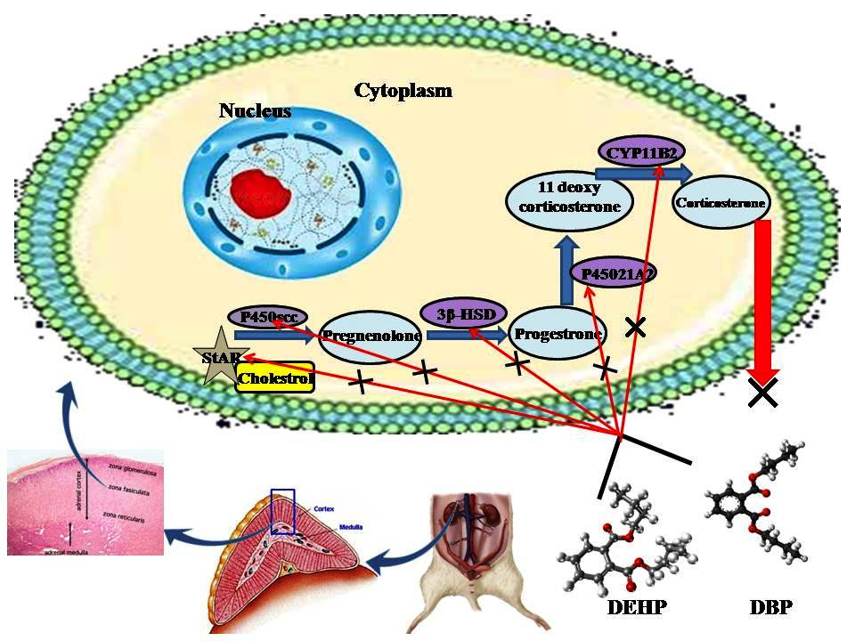
Recent Publications
Molecular docking revealed the potential of phthalate esters to inhibit the enzymes of glucocorticoid biosynthetic pathway
Ahmad S, Khan MF, Parvez S, Akhtar M and Raisuddin S.

In Silico Molecular Interaction of Bisphenol Analogues with Human Nuclear Receptors Reveals their Stronger Affinity vs. Classical Bisphenol A.
Sharma S, Ahmad S, Faraz Khan M, Parvez S, Raisuddin S.

The protective effect of α-lipoic acid against bisphenol A-induced neurobehavioral toxicity.
Khan J, Salhotra S, Ahmad S, Sharma S, Abdi SAH, Banerjee BD, Parvez S, Gupta S, Raisuddin S.

Mitochondrial dysfunction induced by Bisphenol A is a factor of its hepatotoxicity in rats.
Khan S, Beigh S, Chaudhari BP, Sharma S, Aliul Hasan Abdi S, Ahmad S, Ahmad F, Parvez S, Raisuddin S.
Abstract
Various endocrine disrupting chemicals (EDCs) target the endocrine system in different ways but adrenal is mostly a neglected endocrine gland so far to check the effects of EDCs. To elucidate the molecular mechanism of EDCs, the effects of two extensively used phthalate esters viz. DEHP and DBP on adrenal gland were observed in wistar rats. Wistar rats were divided into seven groups (n = 5) and received the exposure of DEHP and DBP for fourteen days. Group I was control and received only corn oil which is used as vehicle. Group II, III and IV received daily dose of DEHP of 250, 750 and 1500 mg/kg-BW respectively while group V, VI and VII received daily dose of DBP of 100, 500 and 1000 mg/kg-BW respectively. The molecular docking studies revealed the potential of phthalates to inhibit the key enzymes of glucocorticoid biosynthetic pathway (GBP). The histopathological comparison of different endocrine glands indicated that adrenal is most vulnerable target of DEHP and DBP. The mRNA expressions of key enzymes of GBP in adrenal were checked by RT-qPCR. The expression of StAR, 3β-HSD and Cyp21A1 has been up-regulated significantly while the expression of Cyp11B2 has been down regulated on exposure of DEHP and DBP. The enzymatic activities of some key enzymes were also altered on exposure to DEHP and DBP. The study of effects of enzymes expression is underway which may probably be finished before date of presentation. This study indicates that GBP may be the primary target of DEHP and DBP. The molecular mechanism of endocrine disruption by DEHP and DBP may further be elucidated by extensive study of these phthalates on GBP and may directly be used for the risk assessment policies.

Biography
Shahzad Ahmad pursuing his Ph.D. (Toxicology) under the supervision of Prof. S. Raisuddin in the Department of Medical Elementology and Toxicology, School of chemical and life sciences , Jamia Hamdard, New Delhi. He is the recipient of UGC-BSR (senior research fellowship) and also received best presentation (3rd) award in National Symposium on Impact of Emerging Toxic Chemicals on Humans, Plants, Diseases and Sustainable Development (IETC-2016), Jamia Hamdard, New Delhi. His research interests include molecular and endocrine toxicology, analytical toxicology and environmental toxicology. He is fluent in analytical and molecular techniques such as HPTLC, HPLC, GC-MS, LC-MS, PCR, RT-qPCR, Electrophoresis etc. Email: sahmad.sch@jamiahamdard.ac.in

Presenting author details
Full name: Shahzad Ahmad

University/Industry/Organization name: Jamia Hamdard

Designation (Director/Prof/Assistant or Associate prof/Researcher/Student): Student

Country: India

Telephone: +91 9015297491

Email: sahmad.sch@jamiahamdard.ac.in

Track name: Risk Assessment
Category (Oral presentation/ Poster presentation/Young researcher forum/E-poster): Young researcher forum

Research interest: Environmental and Molecular Toxicology

Linked In account: https://www.linkedin.com/in/shahzadforensic/

