New test panel to assess neurotoxicity levels and facilitate controls
Keith Schofield, MA PhD, University of California, Santa Barbara, USA

Neurological human disturbances are on the increase worldwide. These range from autism to Alzheimer’s. They have a broad range of variation. This is a recent occurrence now at epidemic levels. Extensive research excludes a single cause but concludes a connection to environmental and lifestyle changes. In order to affect the brain, material has to enter the body by absorption or ingestion, and cross the blood brain barrier. It also has to fit the time constraint. Although we are inundated with chemicals, both organic (pharmaceuticals, insecticides, pesticides) and inorganic (chemicals of the periodic table) few exist in a normal diet at levels to be of concern and generally are more poisonous or carcinogenic than neurological. Suspected materials have to be globally available and widespread. Considerations reduce possibilities to six neurotoxic elements and their compounds. These are aluminum (in cookware, food, vaccines), arsenic (water, and some fish), lead (old paint, solder, some gasoline, leaded glass), mercury (some vaccines, fish, dentistry), manganese (teas), selenium (food such as nuts, eggs, fish). No one element has emerged but synergism with their combinations is noted. In the US, mercury from fish, and aluminum or mercury from vaccines are sufficient to exceed minimum risk levels especially for pregnancy. In other parts of the world arsenic and lead are dangerous. Numerous blood testing studies are available and indicate everyone has these elements in their blood. Broad distributions show some eliminate these toxins while others not. We now need to know the state of our bodies. The levels of these toxins in our blood appears important for all people and especially young women of childbearing age. A new blood test is being marketed to monitor these six elements from a very small blood sample. In this way, risk levels will become apparent and are necessary long before any pregnancy.
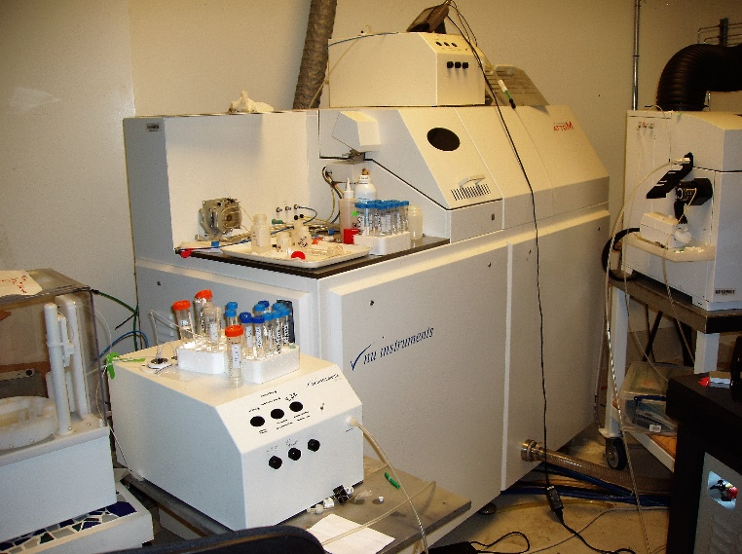
Recent Publications

Autism, Chemicals, Probable Cause and Mitigation: A New Examination, Autism-Open Access 6: (3) 184, 27 pp., 2016.

The Metal Neurotoxins: An Important Role in Current Neural Epidemics? Int. Journal Environmental Research and Public Health 14, 1511, 23 pp., 2017. Open Access.

A Test Panel to Measure Blood Neurotoxin Levels in Prematernal Women and for the General Public in Relation to Mental Disorders of the Aging. US Patent Assigned to K.Schofield, Pat. No. 9,928,346, Issued March 27, 2018, International Applications Pending.

Mercury Emission Control: Phase II. Let’s Go Passive. Energy 122, 311-318, 2017



Dr. Schofield was a Major Scholar, educated at the University of Cambridge. In the U.S., he has worked at the National Center for Atmospheric Research, Cornell Aeronautical Laboratory, General Motors Defense Research Laboratories and the University of California in its Physics, Chemistry and School of Engineering Departments. He has been a Consultant for the U.S. Department of the Air Force and the British Coal Research Establishment. Email: KSHome@ucsb.edu

Dr. Keith Schofield
University of California, Santa Barbara CA, USA
Professor Emeritus
USA
805 966-6589
KSHome@ucsb.edu
Human Neurological Testing; A New Blood Test Panel for Doctors to Prescribe and Analyze.
Oral Presentation
Neurological Toxicity

