Aquatic Toxicological Assessment of Surfactant (Shampoo Wash Residue) On African Catfish (Clarias gariepinus)
¹Adebayo, G.B, ²Iyiola, I.O, ¹Aiyedun, I.O and ¹Bolakale, M.O
1 Department of Industrial Chemistry, University of Ilorin
2 Department of Zoology, University of Ilorin

Abstract (300 word limit)
Toxicological effects of Shampoo and its wash residue on African catfish (Clarias gariepinus) were carried out to assess their environmental effects. The physico-chemical properties of the effluent and shampoo solution were determined. A range finding test was conducted, followed by the determination of median lethal concentration (LC50) values of acute and chronic bioassay in a static renewal bioassay procedure by exposing the fishes to lethal concentrations 0%, 0.4%, 0.8%, 1.2%, 1.6% and 2.0% of the effluent and 0.030%, 0.035%, 0.040%, 0.045% and 0.050% of shampoo solution for 96hrs and sub lethal concentrations 0.025%, 0.050% and 0.070% of the effluent and 0.0125%, 0.0150% and 0.0170% of shampoo solution for 30days. Biochemical and histopathological studies were also carried on fishes exposed to the sub lethal concentrations. The median lethal concentration (LC50) values were 0.158% and 0.024% respectively for acute toxicity bioassay and 0.102% and 0.019% respectively for chronic toxicity bioassay. Histological and biochemical degradation of anti-oxidative stress enzymes even at low concentrations (0.025% of effluent and 0.0125% of shampoo solution) were observed. Erratic swimming pattern, respiratory disturbance, lethargies, loss of equilibrium and sudden death were observed when fishes were exposed to varying concentration of the toxicant. Significant (p<0.001) increased in mortality of C. gariepinus as the concentration increases. The overall results indicated that the shampoo and its wash residue can be toxic to the African catfish (Clarias gariepinus) and hence making it a good biomarker in the assessment of the effects of the shampoo and its wash residue.
Keywords: Toxicology, surfactant, shampoo, residue, acute toxicity, chronic toxicity, biomarkers.

Image

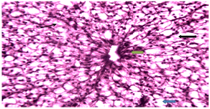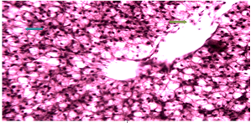
Figure: a (0.0125% M ×250) Figure: b (0.0150%M ×250)
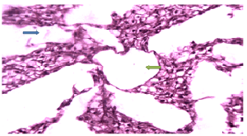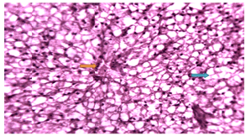
Figure: c (0.0170%M ×250) Figure: d (0.025% M ×250)
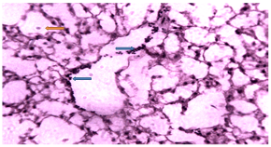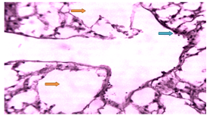
Figure: e (0.050%M ×250) Figure: f (0.070% M ×250)
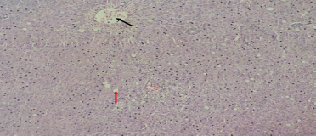

Figure: g (Control 0.00% M × 64)
Figures a-g: Histological alterations of the liver tissues of fishes exposed to varying concentrations of shampoo solutions and the control.
Recent Publications (minimum 5)
REFERENCES
Farombi, E., Adelowo, O. and Ajimoko, Y. (2007). Biomarkers of oxidative stress and heavy metal levels as indicators of environmental pollution in African cat fish (Clarias gariepinus) from Nigeria Ogun River. Int. J. Environ. Res. Public Health, 4, 15.
Ogundiran, M., Fawole, O., Adewoye, S., and Ayandiran, T. (2010). Toxicological impact of detergent effluent on juvenile of African catfish (Clariasgariepinus) (Buchell 1822). Agric Biol J N Am, 1, 330-342.
Ogundiran, M., Fawole, O., S.O, A., and Ayandiran, T. (2009). Pathologic Lesions in the Gills Structures of Clariasgariepinus on exposure to sub lethal concentrations of soap and detergent effluents. (5, Ed.) J Cell and Animal Biol, 3, 078-082.
Otitoloju, A. A. and Olagoke, O. (2011). Lipid peroxidation and antioxidant defense enzymes in Clarias gariepinus as useful biomarkers for monitoring exposure to polycyclic aromatic hydrocarbons. Environmental Monitoring and Assessment, 30, 340–346.
Vieira, L. S., Frasco, M., Lirna, I., Morgado, F. and Guilhermino, L. (2008). Acute effects of Benzo[a]pyrene, anthracene and a fuel oil on biomarkers of the common goby Pomatoschistus microps (Teleostei, Gobiidae). Sci. Total Environ, 395, 87-100.

 BIOGRAPHY
ADEBAYO GANIYU BABATUNDE is an Associate Professor in the Department of Industrial Chemistry, University of Ilorin, Ilorin, Nigeria. His major research interests are in the area of Industrial, Analytical and Environmental Chemistry with specific interest in the Toxicological effect and Risk Assessment of the Effluents from Industries which include oil and gas and food beverages. He is also into:(i) Synthesis, Characterization and application of nanoparticle/composites in solving, Toxicological and Eco-toxicological problems arising from Oil spilled Environment, Municipal Waste and Industrial effluents.(ii) Synthesis, Characterization, Application and Assessment of Toxicological effect of Dyes.
He is Currently supervising Ph.D. Students on:
- Bioremediatiation and production of Pigments from industrial Effluents.
- Preparation, Characterization application of Adsorbents from Agricultural, Domestic and Industrial Wastes.
- Physicochemical Characterization, Toxicological Assessment and Bioremediation of Municipal waste dumping sites in Ilorin Metropolis.
- Extraction, Preparation, Characterization and Application of Natural and Synthetic dyes in Dyes Sensitized Solar Cells

adebayochem@yahoo.com, adebayochem@gmail.com, adebayo.bg@unilorin.edu.ng

Notes/Comments:

Presenting author details
Full name: ADEBAYO Ganiyu Babatunde
University/Industry/Organization name: University of Ilorin, Ilorin, Nigeria
Designation (Director/Prof/Assistant or Associate prof/Researcher/Student): Associate prof
Country: Nigeria
Telephone: +2348033851631
Email: adebayo.bg@unilorin.edu.ng
Track name: Adebayo G. B
Category (Oral presentation/ Poster presentation/Young researcher forum/E-poster): Oral presentation
Research interest: Aquatic toxicology and Risk Assessment
Linked In account:

Note: Please fill up the Red mark fields so that it would be easier for us to cite your details in the conference particulars. (Please do not forget to fix your photo above the title)

