Size partitioned particulate matter with potential sources and threats of total and bioavailable metals inside varied residences of Northern India
Ajay Taneja
Department of Chemistry, Dr. B.R. Ambedkar University, Agra, India

To assess the extent of air quality within residential environments in Northern India, size fractionatedparticulate matter (PM) pollutant in coarse (>2.5 µm) and fine (quasi-accumulation ranges) (2.5-1.0, 1.0-0.5, 0.5-0.25 µm) have been analysed during heating season of 2016 in domestic homes of Agra, India. PM samples were collected on PTFE filters with Sioutas cascade impactor at urban and roadside sites and used in tandem with a health risk assessment model to study the impact of size segregation of PM on the extend of metal bound risk in both adults and children residing in varied residences; that were further stratified through their ‘socio-economic strata’. The study presented that indoor activities and discrepancy in lifestyle affected indoor particle mass concentration level dependent upon the source and house characteristics. Results revealed increased exposure (26-41%) in low income groups with elevated loading for smaller size particulates (PM_{0.5-0.25}= 54.08 μg/m³). Size partitioning trend of elements allowed the recognition of three main behavioural groups (a) elements: Fe, Ca, Cr, Cu concentrated in coarser particles (b) elements distributed mainly within fine particle ranges: Zn, K, Al, Pb, Ni and (c) elements: Mn and Mg exhibiting indefinite partitioning pattern. Higher non-carcinogenic and carcinogenic risk were found within Mn (HQ= 12.1) and Cr(VI) (ELCR= 1.21*10⁻³ (adults); 3.63*10⁻⁴ (child)) in fine (PM_{2.5-1.0}) and coarser (PM_{>2.5}) fractions respectively. In addition, the ‘ammonium acetate’ extraction of bioavailable elements accounted lower risks relative to total metal concentration thus implying its application in further health toxicology studies. Besides, bioavailability varied with element (highest for Pb (21%)) with stronger dependency for particle size (PM_{0.5-0.25}) which also supported the construal of observed increase in aerosol enrichment to finest particle. Results of this work provide insight into size segregated particulate monitoring and address need for inclusive investigation to study its toxicity and control measures in establishing safer indoor environment.

Image
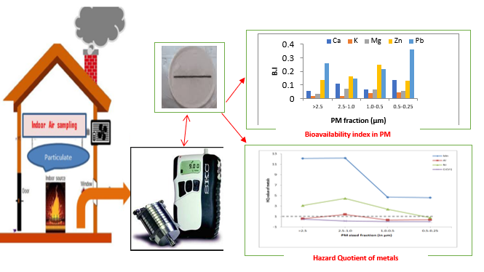

Publications:
- Kulshreshtha, P. and Khare, M. (2011) Indoor explanatory analysis of gaseous pollutants and respirable particulate matter at residential homes of Delhi, India. Atmos Poll Res, 2, 337-50
- Kulshrestha A., Massey D.D., Masih J. and Taneja A. (2014) Source characterization of trace elements in indoor environments at urban, rural and roadsite sites in a semi-arid region of India, Aerosol Air Qual Res, 14, 1738-51
- Pant P., Baker S.J., Goel R., Guttikunda S., Goel A., Shukla A. and Harrison R.M. (2016) Analysis of size segregated winter season aerosol data from New Delhi, India, Atmos Poll Res, 7, 100-09
- Taneja, A., Saini, R. and Masih, A. (2008). Indoor air quality of houses located in the urban environment of Agra, India. Ann N.Y. Acad Sci, 1140, 228–45
- Taner, S., Pekey B., and Pekey H. (2013) Fine particulate matter in the indoor air of barbeque restaurants: Elemental compositions, sources and health risks, Sci Total Environ, 454-455, 79-87
- Varshney P, Saini R. and Taneja A. (2015) Trace element concentration in fine particulate matter (PM2.5) and their bioavailability in different microenvironments in Agra, India: a case study, Environ Geochem Health,
- Voutsa D., Anthemidis A., Giakiskli G., Mitani K., Besis A., Tsolakidou A. and Samara C. (2015) Size distribution of total and water-soluble fractions of particle-bound elements-assessment of possible risks via inhalation, Environ Sci Pollut Res, 22, 13412-26

Biography
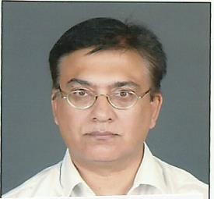
Dr Ajay Taneja is presently working as Professor in Department of Chemistry, Dr B. R. Ambedkar University Agra, India. He has more than 24 years of teaching and research experience. His expertise is in Environmental Chemistry and Air pollution. He has guided more than 15 Ph.D. and 19 M. Phil students. He has coauthored more than 105 research articles, 5 books, 3 book chapters and 3 research reports. He is life member/Fellow of many professional bodies including post of Joint Secretary, Indian Council of Chemists India. He was also awarded Father Rev. T. A. Mathias “National award for Innovative College Teachers for the year 2001” by All India association for Christian higher
education. He is also a consultant to the task force set up by Central Pollution Control board to set up standards and SOPs for Indoor air pollution in India and have participated in many national and international conferences and workshops.
Email: ataneja5@hotmail.com

Presenting author details
Full name: AJAY TANEJA
University/Industry/Organization name: Dr. B.R. AMBEDKAR UNIVERSITY, AGRA, INDIA
Designation (Director/Prof/Assistant or Associate prof/Researcher/Student): PROFESSOR
Country: INDIA
Telephone: 9897476288
Email:ataneja5@hotmail.com

Track name: ENVIRONMENTAL MONITORING (ENVIRONMENTAL CONTAMINANTS)
Category (Oral presentation/ Poster presentation/Young researcher forum/E-poster): SPEAKER/ORAL PRESENTATION

Research interest: ENVIRONMENTAL CHEMISTRY AND AIR POLLUTION

