Brain Tumors and Radiofrequency Electromagnetic Fields
E. Arribas, R. Ramirez-Vazquez. Applied Physics Department, University of Castilla-La Mancha, Albacete, Spain.
J. Gonzalez-Rubio, A. Najera. Department of Medical Sciences, UCLM

Abstract

Simultaneously with the increase of Radiofrequency Electromagnetic Fields (RF-EMF) in recent decades, there has been increasing concern about their potential relation with the etiology of several tumors. At this time, the techniques of spatial data analysis jointly with the study of the personal exposure to these fields offer a new approach to the problem.

This paper presents the results of an epidemiological study, combining Epidemiology, Statistics and Geographical Information Systems (GIS), in which we analyzed the correlation between exposure to RF-EMF in the city of Albacete (166,000 inhabitants, southeast Spain) and the incidence of several cancers with unspecific causes.

We used statistical tools to analyze the spatial point patterns and aggregate data with the aim to study the spatial randomness and to determine the zones with the highest incidence from 95 tumors studied (65 lymphomas, 12 gliomas and 18 meningiomas). We also perform a correlation (Spearman) study between the personal exposure to RF-EMF in 14 frequency bands, recorded by an EME Spy 140 (Satimo) exposimeter in the city's administrative regions, and the incidence of the tumors registered from January 2012 to May 2015.

Based on the two performed analyses, we conclude that the studied cancer cases have a random spatial distribution inside the city. On the other hand, the exposure to RF-EMF registered in the city of Albacete shows little correlation with the incidence of the studied tumors (gliomas (0.15), meningiomas (0.19) and lymphomas (-0.03)).

Both the spatial point patterns study and the aggregate data analysis clearly show the spatial randomness of the studied tumors (meningiomas, gliomas and lymphomas) in the city of Albacete. Likewise, comparing the Figure 1, we can observe that for both the different tumors and their groups, that that the zones with the highest incidence inside the city are similar independently of the type of analysis used.


The proposed methodology inaugurates an unexplored analysis path in this field.
Figure 1
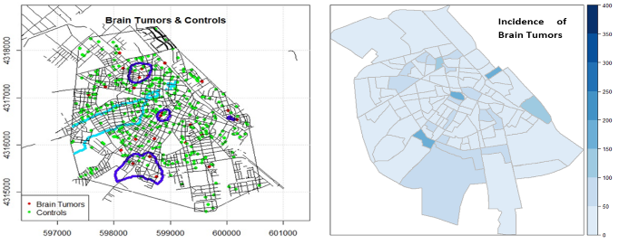
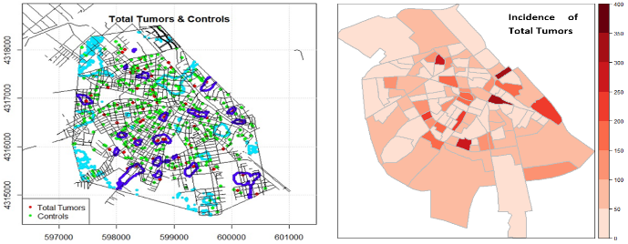
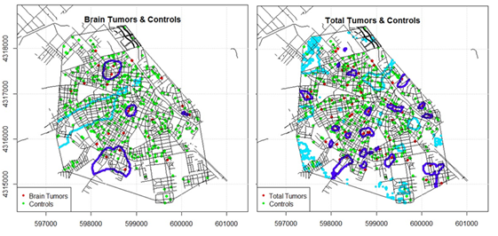

Recent Publications

J.F.B. Bolte, and T. Eikelboom. Personal radiofrequency electromagnetic field measurements in the Netherlands: Exposure level and variability for everyday activities, times of day and types of area. Environ. Int. 48 (2012) 133–142.

Gonzalez-Rubio, A. Najera, and E. Arribas. Comprehensive personal RF-EMF exposure map and its potential use in epidemiological studies. Environ. Res. 149 (2016) 105–112.

J. Gonzalez-Rubio, E. Arribas, R. Ramirez-Vazquez, y A. Najera, «Radiofrequency electromagnetic fields and some cancers of unknown etiology: An ecological study», Sci. Total Environ., vol. 599–600, pp. 834-843, dic. 2017.

J.F.B. Bolte. Lessons learnt on biases and uncertainties in personal exposure measurement surveys of radiofrequency electromagnetic fields with exposimeters. Environ. Int. (2016a).

W. Joseph, S. Aerts, M. Vandenbossche, A. Thielens, and L. Martens. Drone based measurement system for radiofrequency exposure assessment Bioelectromagnetics. (2016).

Prof. Enrique Arribas, his expertise in Radiofrequency Waves, Mathematical and Computer Physics and Chemistry, Non Linear Systems, Science Education and Active Learning Physics. He is associated professor at University of Castilla-La Mancha, Albacete, Spain. Also, he is referee of various international journals.

Email: enrique.arribas@uclm.es

Notes/Comments:
his expertise in Radiofrequency Waves, Mathematical and Computer Physics and Chemistry, Non Linear Systems, Science Education and Active Learning Physics.

Presenting author details
Full name: Enrique Arribas Garde
University/Industry/Organization name: University of Castilla-La Mancha
Designation (Director/Prof/Assistant or Associate prof/Researcher/Student): Associate Professor
Country: Albacete, Spain
Telephone: 967 599 200 | Ext: 2460
Email: enrique.arribas@uclm.es
Track name: Brain Tumors and Radiofrequency Electromagnetic Fields
Category (Oral presentation/ Poster presentation/Young researcher forum/E-poster): Oral presentation
Research interest: Radiofrequency waves, Unstable Systems, Mathematical and Computer Physics and Chemistry, Non Linear Systems, Science Education, Active Learning Physics.

