Effects of simultaneous exposure to aluminum at low pH, fluoranthene, and ultraviolet radiation on antioxidant mechanisms in Japanese Medaka (Oryzias latipes)

Wilson F. Ramírez-Duarte, BVM, PhD, Tomofumi Kurobe, PhD, Swee Teh, PhD
University of California-Davis, USA

Abstract

Aquatic organisms are continuously exposed to multiple stressors that originate from various anthropogenic activities. Here, we investigated the effects of multiple stressors (the photo-active polycyclic aromatic hydrocarbon: fluoranthene (Fl), aluminum (Al), low pH, and ultraviolet (UV) radiation on fish health using responses of antioxidant mechanisms and indicators of oxidative damage as biomarkers. Toxicity of Fl as well as of other PAHs is enhanced in presence of UV light by promoting production of reactive oxygen species. Furthermore, in acidified aquatic ecosystems (e.g. Orinoco and Amazon basins in South America) fish are simultaneously exposed to low pH and elevated concentrations of Al as well as to PAHs derived from oil exploitation and other sources. Juvenile Medaka (Oryzias latipes) were exposed to a 2 x 3 factorial treatment structure (0 and 100 μg L⁻¹ of total Al and 0, 1, and 5 μg L⁻¹ of Fl) at pH 5.3 in the presence of ultraviolet radiation (UVA: 360.1 ± 18.4 μW cm⁻² and UVB: 6.3 ± 0.5 μW cm⁻²) for 7 days. Effects on enzymatic and non-enzymatic antioxidants, and the expression of oxidative stress-related genes were evaluated after 3 and 7 days of exposure. Fl inhibited the enzymatic activity of glutathione peroxidase, and enhanced the glutathione reductase activity, however significant changes in gene expression were not found. Moreover, glutathione concentration decreased after exposure to either Fl and Al. The proposed hypothesis that Al at low pH enhances Fl-photoinduced oxidative stress in Japanese Medaka was not supported by this study. However, it was shown that both compounds have deleterious effects on the glutathione-related antioxidant system which may increase fish susceptibility to oxidative stress caused by adverse environmental conditions and other pollutants.
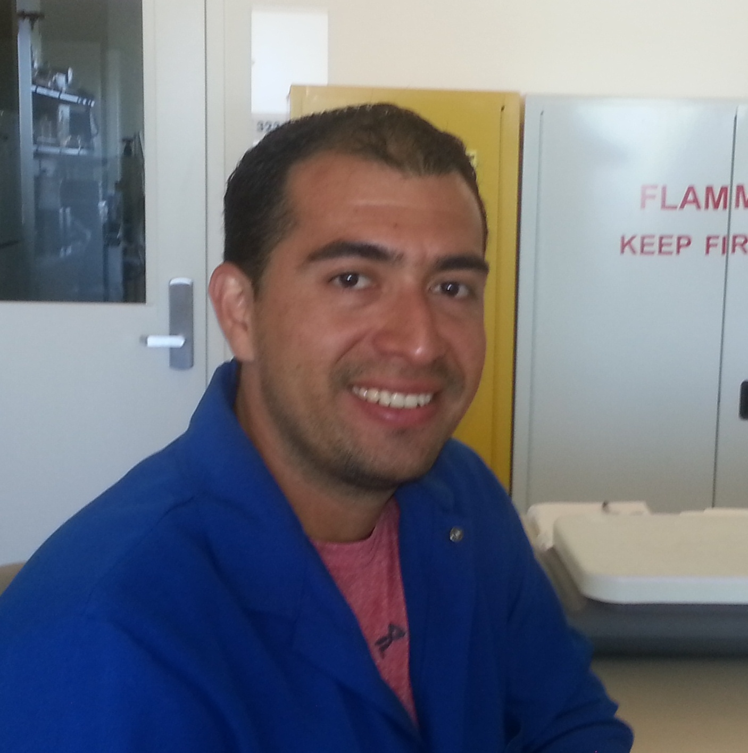
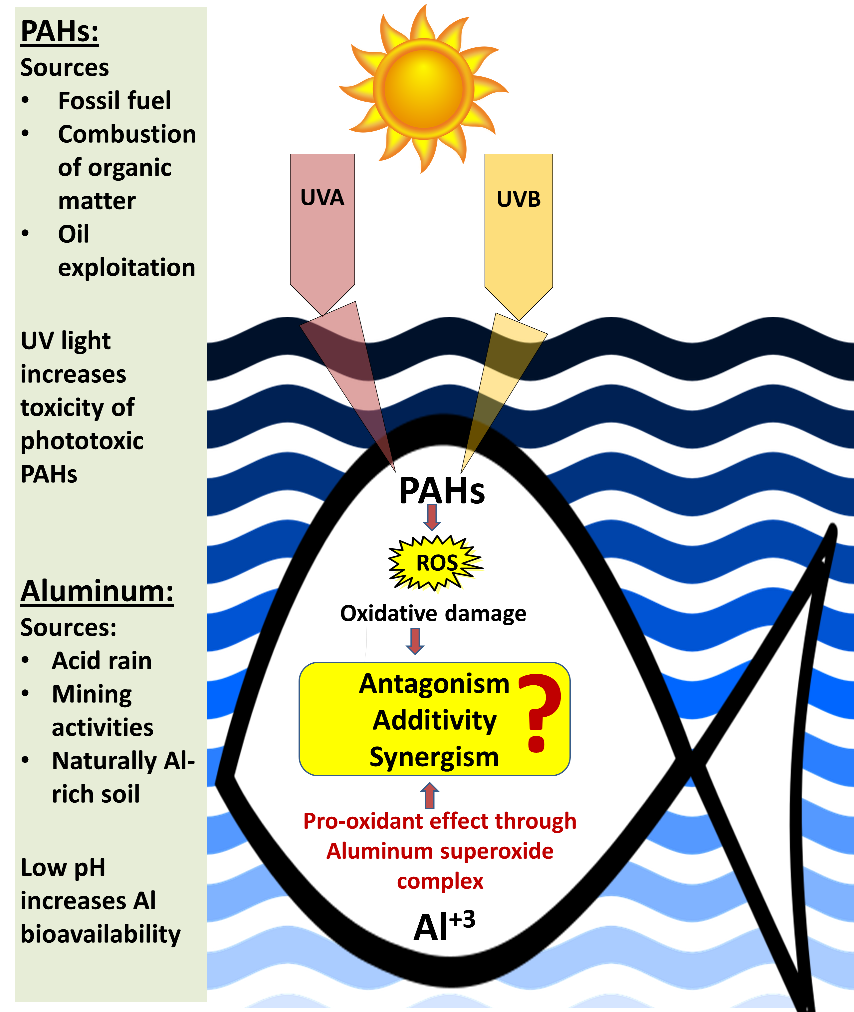

Publications

- Ramírez-Duarte WF, Kurobe T, Teh SJ. Effects of low levels of ultraviolet radiation on antioxidant mechanisms of Japanese Medaka (Oryzias latipes). Chemosphere 181 (2017) 304-312

- Wilson F. Ramírez-Duarte, Jin J, Kurobe T, Teh SJ. Effects of prolonged exposure to low pH on enzymatic and non-enzymatic antioxidants in Japanese Medaka (Oryzias latipes). Science of the Total Environment 568 (2016) 26–32

- Ramírez-Duarte WF, Rondón-Barragán IS, Eslava-Mocha PR. Acute toxicity and histopathological alterations of Roundup® herbicide on “cachama blanca” (Piaractus brachypomus). Pesquisa Veterinaria Brasileira 28 (2008) 547-554.

Biography
Wilson F. Ramírez-Duarte has his expertise in aquatic toxicology and oxidative stress. He completed his PhD in pharmacology and toxicology from the University of California-Davis. He is postdoctoral scholar in the Aquatic Health Program at the University of California-Davis and focuses his research on underground water pollution, effects of herbicides on fish health, and water pollution in the San Francisco Bay Delta.
Email: wframirezduarte@ucdavis.edu, wramirezduarte@gmail.com
Presenting author details
Full name: Wilson F. Ramírez-Duarte
University/Industry/Organization name: University of California-Davis
Designation (Director/Prof/Assistant or Associate prof/Researcher/Student): Postdoctoral scholar
Country: Colombia
Telephone: +1 (530) 304-1417
Email: wframirezduarte@ucdavis.edu, wramirezduarte@gmail.com
Track name: Aquatic toxicology
Category (Oral presentation/ Poster presentation): Oral presentation
Research interest: Biochemical and physiological responses of fish to toxicants with a special focus on enzymatic and non-enzymatic antioxidants and oxidative damage; toxicology of fish; ecotoxicology; aquatic pollution; veterinary toxicology.

