Appraisal of Heavy Metal Contamination in Sediments at the Shitalakhya river of Bangladesh using Pollution Indices

Md. Humayun Kabir, MS, ESRM, MBSTU, Bangladesh
Md. Sirajul Islam, PhD, ESRM, MBSTU, Bangladesh
Md. Enamul Hoq, PhD, BFRI, Bangladesh
Tanmoy Roy Tusher, MS, ESRM, MBSTU, Bangladesh

Abstract

The study was conducted to investigate the heavy metal contamination in sediments using geo-accumulation index (Igeo), contamination factor (CF), contamination degree (CD), pollution load index (PLI), enrichment factors (EF) and potential ecological risk factor (RI) of the Shitalakhya river. Results of the study showed that significant positive correlations between the heavy metals and the concentrations were followed the order of Zn>Cr>Cu>Pb>Cd, while the concentration of Cu, Cr and Cd were higher and the Pb and Zn were lower than the Toxicity Reference Value (TRV). Mean I_{geo} values of the metals were followed the order of Cd>Zn>Pb>Cu>Cr indicated unpolluted to moderately polluted. Mean CF values for metals were found contaminated with the following order Cd>Zn>Pb>Cu>Cr, whereas CD values for all metals indicated moderate contaminations. The PLI ranged from 0.334-1.209 stated sediments were moderately polluted. Mean EF values were in the order of Cd>Zn>Pb>Cu>Cr and depicted moderately to moderately severe enriched level. The RI of heavy metals were in the order of Cd>Cu>Pb>Cr>Zn with low ecological risk. As per sediment quality guidelines, the results also showed that sediments were not polluted with Pb, Cu, Zn, and Cd, whereas moderately polluted with Cr. Study concluded that the quality of the Shitalakhya river sediments was lower to moderately contaminated and the river is needed to manage properly by regular monitoring and assessment.

Image

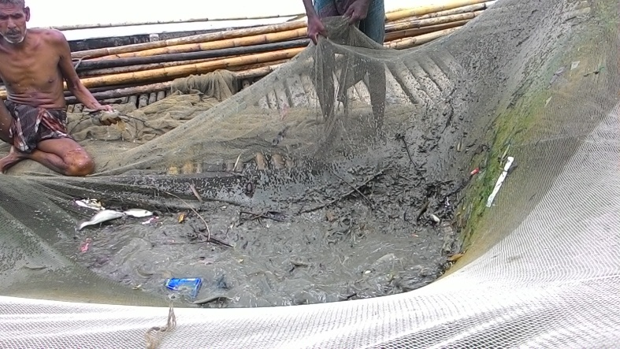

Recent Publications

1. Investigation of heavy metal contamination in fishes from Passur river near the Sundarbans Mangroves of Bangladesh.
M.S. Islam, S.C. Shil, M.H. Kabir and M.E. Hoq

2. Heavy metal contamination in water and fishes from the Shitalakhya river at Narayanganj, Bangladesh.
A. Irin, M.S. Islam, M.H. Kabir and M.E. Hoq

3. Assessment of aquatic faunal diversity in the Ratargul Swamp Forest at Sylhet in Bangladesh.
M.S. Islam, M.A. Islam, N.A. Sweety, M.A. R. Hossain and M.H. Kabir

4. Quality assessment of water in different sources at Tangail municipality of Bangladesh.
T. Datta, M.S. Islam, T.R. Tusher, M. Rehnuma and M.H. Kabir

5. Heavy metal exploration in water and fish from Bangshi river at Mirzapur area under Tangail district of Bangladesh.
M. Rehnuma, M.S. Islam, N.T. Meghla and M.H. Kabir

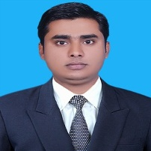
Md. Humayun Kabir has accomplished Master of Science (MS) in Environmental Science from Mawlana Bhashani Science and Technology University. He has conductecd MS thesis on “Investigation of Seasonal Variation of Heavy Metal Contamination in Water, Fish and Sediments of the Shitalakhya River, Bangladesh”. His research interset include environmental pollution monitoring and risk assessment.
Email: kabirmh07@gmail.com

Notes/Comments:
Dear Sir,
Greetings, I am very glad to know that the “12th International Conference on Environmental Toxicology and Ecological Risk Assessment” will be held on October 19-20, 2017 Atlanta, Georgia, USA. I have enclosed herewith my abstract manuscript entitled “Appraisal of Heavy Metal Contamination in Sediments at the Shitalakhya river of Bangladesh using Pollution Indices” for your kind consideration. I would be grateful if you kindly consider my abstract as well as take necessary action towards its publication in your conference. Please acknowledge the receipt of my manuscript.
Presenting author details
Full name: Md. Humayun Kabir
University name: Mawlana Bhashani Science and Technology University
Designation (Director/Prof/Assistant or Associate prof/Researcher/Student): Researcher
Country: Bangladesh
Telephone: +8801717126173
Email: kabirmh07@gmail.com
Track name: Track 1: Environmental Toxicology (Track 1-4: Environmental Contamination and Toxicology)
Category (Oral presentation/ Poster presentation/Young researcher forum/E-poster): Oral Presentation
Research interest: Environmental pollution monitoring and risk assessment.

