Health risks associated with heavy metals in the drinking water of Swat, northern Pakistan
Kifayatullah Khan, RCEES, CAS, China

Abstract (300-word limit)

The concentrations of heavy metals such as Cd, Cr, Cu, Mn, Ni, Pb and Zn were investigated in drinking water sources (surface and groundwater) collected from Swat valley, Khyber Pakhtunkhwa, Pakistan. The potential health risks of heavy metals to the local population and their possible source apportionment were also studied. Heavy metal concentrations were analysed using atomic absorption spectrometer and compared with permissible limits set by Pakistan Environmental Protection Agency and World Health Organization. The concentrations of Cd, Cr, Ni and Pb were higher than their respective permissible limits, while Cu, Mn and Zn concentrations were observed within their respective limits. Health risk indicators such as chronic daily intake (CDI) and health risk index (HRI) were calculated for adults and children separately. CDIs and HRIs of heavy metals were found in the order of Cr > Mn > Ni > Zn > Cd > Cu > Pb and Cd > Ni > Mn > Cr > Cu > Pb > Zn, respectively. HRIs of selected heavy metals in the drinking water were less than 1, indicating no health risk to the local people. Multivariate and univariate statistical analyses showed that geologic and anthropogenic activities were the possible sources of water contamination with heavy metals in the study area.

Key words: daily intake; drinking water; health risk; heavy metals; multivariate analysis

Graphical Abstract
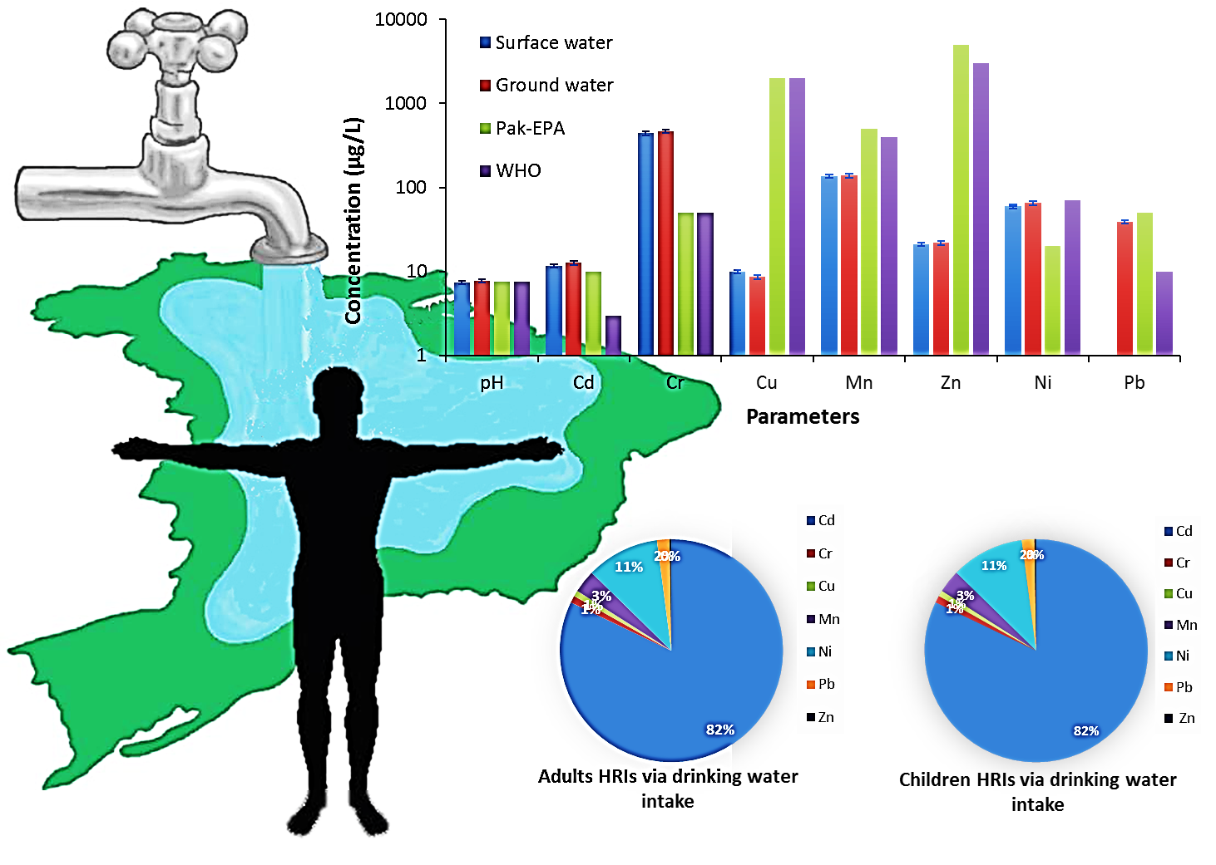
Recent publications (minimum 5)
- Crop bioaccumulation and human exposure of perfluoroalkyl acids through multi-media transport from a mega fluorochemical industrial park, China. Z. Liu, Y. Lu, Y. Shia, P. Wang, K. Jones, A.J. Sweetman, A.C. Johnson, M. Zhang, Y. Zhou, X. Lu, C. Su, S. Sarvajayakesavaluc and K. Khan.
- Kinetic and mechanism investigation on the gamma irradiation induced degradation of endosulfan sulfate. N.S. Shah, J.A. Khan, S. Nawaz, M. Ismail, K. Khan and H.M. Khan.
- Evaluation of toxicological risk of foodstuffs contaminated with heavy metals in Swat, Pakistan. K. Khan, Y. Lu, H. Khan, Ihsanullah, S. Khan, J. Nawab and I. Shamshad.
- Quantification of PAHs and health risk via ingestion of vegetable in Khyber Pakhtunkhwa Province, Pakistan. M. Waqas, S. Khan, C. Chao, I. Shamshad, Z. Qamar and K. Khan.
- Heavy metals in agricultural soils and crops and their health risks in Swat District, northern Pakistan. K. Khan, Y. Lu, H. Khan, M. Ishtiaq, S. Khan, M. Waqas, L. Wei and T. Wang.

Biography (150-word limit)
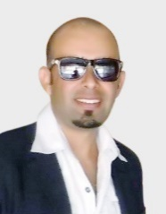
Dr. Kifayatullah Khan is Research Professor (assistant) at the Department of Environmental and Conservation Sciences, University of Swat, Khyber Pakhtunkhwa, Pakistan. Currently, he working as a CAS- PIFI Postdoctoral Fellow at the State Key Lab of Urban and Regional Ecology, Research Center for Eco-Environmental Sciences (RCEES), Chinese Academy of Sciences (CAS), Beijing, China. He did his PhD in the discipline of Environmental Sciences from the University of Peshawar, Pakistan as a TWAS-CAS Fellow (2013). As an active environmental ecologist, he has published good papers in the international peer reviewed journals such as, Environment International, Food and Chemical Toxicology, Ecotoxicology and Environmental Safety, Journal of Environmental Sciences, Science of the Total Environment, Chemosphere, International Journal of phytoremediation, Clean-Air, Soil and Water, Environmental Monitoring and Assessment, Earth Science & Climatic Change, LAMBERT. Email: kk.environ@yahoo.com

Notes/Comments:
Presenting author details
Full name: Kifayatullah Khan (PhD)
University/Industry/Organization name: University of Swat, Pakistan/ Research Center for Eco-Environmental Sciences, CAS, China
Designation: Assistant professor
Country: Pakistan but now a day at Beijing, China
Telephone:008613120111535
Email: kk.environ@yahoo.com
Track name: KK
Category: Oral presentation
Research interest: Research interests are briefly focusing on; Ecological health impacts and risk assessment of conventional and emerging pollutants, urban ecological planning and assessment; and environmental management and policy.
Linked In account: https://www.linkedin.com/in/kifayatullah-khan-phd-a57b9931/
Note: Please fill up the Red mark fields so that it would be easier for us to cite your details in the conference particulars. (Please do not forget to fix your photo above the title)

