Prioritising climate change adaptation for housing in Wales, UK
Prof. Carolyn Hayles, Cardiff Metropolitan University, UK

Abstract
Statement of the Problem: In recent years, the severity and potential impact of climate change has been rigorously assessed by scientists, the results of which are now widely published in academic literature regularly reported in the mainstream media.
According to the Intergovernmental Panel on Climate Change’s (IPCC) Fifth Assessment report published in 2014, the increase of global surface temperature by the end of the 21st century is expected to exceed 2.6–4.8 ◦C compared to 1986–2005, in the most pessimistic scenario.
The [UKCP18] projections for Wales show an increased chance of milder, wetter winters and hotter, drier summers, rising sea levels and an increase in the frequency and intensity of extreme weather events. In responding to climate change the key focus has been on the need to reduce greenhouse gas emissions. But this paradigm shift must also be accompanied by climate adaptation measures, if we are to both reduce our carbon dependence and increase our resilience to the now unavoidable impacts of climate change in the short-medium term.
During this plenary session an adaptation framework is introduced, to show the variety and scale of adaptations required, to ensure an aging Welsh housing stock will be resilient to climate change impacts in the coming decades. Both building fabric vulnerabilities and occupant health impacts were considered.
Climate modelling results were used to inform the framework which can be used to produce a prioritisation index that includes retrofit measures, repair and maintenance, and behaviour change, for a range of dwelling typologies, considering their age, construction, and topography.
Image
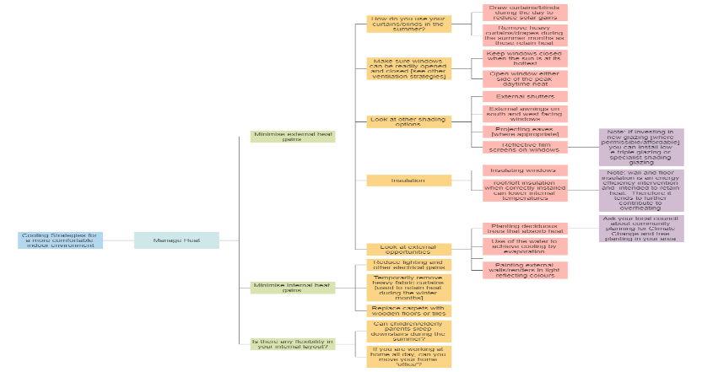
Recent Publications
- Hayles, C.; Huddleston, M.; Chinowsky, P.; Helman, J. (2022), Quantifying the Effects of Projected Climate Change on the Durability and Service Life of Housing in Wales, UK. Buildings 2022, 12, 184. https://doi.org/10.3390/ buildings12020184
- Whitehill, S.; Hayles, C.S.; Jenkins, S.; Taylour, J. Engagement with Higher Education Surface Pattern Design Students as a Catalyst for Circular Economy Action. Sustainability 2022, 14, 1146. https://doi.org/10.3390/su14031146
- Heracleous C., Michael A, Savvides A., Hayles C. (2021). Climate change resilience of schools in Cyprus: An examination of retrofit approaches and their implications on thermal and energy performance, Journal of Building Engineering, Vol. 4, December 2021, 103358.
- Price, E., White, R., Mori, K., Longhurst, J., Baughan, P., Hayles, C., Gough, G., Preist, C., (2021). Supporting the role of universities in leading individual and societal transformation through education for sustainable development, Discover Sustainability, 2, 49 (2021). https://doi.org/10.1007/s43621-021-00058-3
- Price, E., Longhurst, J., White, R., Preist, C., Mori, K., Robinson, Z., Baughan, P., Gough, G., Hayles, C., Higgins, P., Molthan-Hill, P., Hack, C., and S. Kemp (2020). Education for sustainable development in higher education. Environmental Scientist, November 2020, pp. 39-455.



Biography
Professor Carolyn Hayles is Chair of Environmental and Sustainable Design for the Built Environment in Cardiff School of Art and Design at Cardiff Metropolitan University. Carolyn has 25 years’ post-doctoral experience working in design and construction. Carolyn completed her PhD on the weathering and conservation of historic building stone, a project funded by the Getty Foundation USA, at the University of Glasgow between 1992-5. She subsequently spent eight years at BRE Scotland, specialising in Built Heritage research. Since 2004, Carolyn has been employed in academia, working in Australia, Mediterranean Europe, Hong Kong, Singapore, the USA, as well as the UK. She has a particular research interest in education for sustainability and the development and delivery of sustainable decision-making approaches and frameworks, including the sustainable refurbishment of existing buildings, design that promotes occupant health and wellbeing, and approaches to climate change mitigation and adaptation.
Email: cshayles@cardiffmet.ac.uk

Notes/Comments:

