Greening Urban Areas with Decentralized Wastewater Treatment and Reuse: A Case Study of Ecoparque in Tijuana, Mexico
Gabriela Munoz-Melendez, PhD, El Colegio de la Frontera Norte, Mexico
Lina Ojeda-Revah, PhD, El Colegio de la Frontera Norte, Mexico

Abstract (300 word limit)
Statement of the Problem: In rapidly growing urban areas, the presence of Urban green spaces (UGS) can help control soil erosion and flooding, improve infiltration, slow runoff, reduce air pollution, and mitigate climate change. However, water scarcity may pose a challenge to preserving or adding UGS to urban areas. Recycled water from centralized water reclamation facilities, has long been used for landscape irrigation. However, in the global south the high capital costs of centralized wastewater treatment systems and challenges associated with operations, and maintenance have resulted in failures of such systems. Decentralized wastewater treatment systems (DEWATS) still require substantial maintenance, but offer many advantages over centralized treatment systems, and are increasingly providing water for non-potable purposes, including landscape irrigation. The purpose of this study is to present the treatment efficiency of Ecoparque a low-energy DEWATS, which collects and treats residential sewage for landscape irrigation on site in Tijuana, northern Mexico. In addition, Ecoparque is an experimental, demonstration and education public park model, where urban resilience strategies are studied. Methodology & Theoretical Orientation: The treatment efficiency of the DEWATS, in trickling filter, clarifier, and wetland processes, was evaluated using water quality analysis over a five-year period. Findings: Results showed a <2-log reduction of total coliform and E. coli and a <20% decrease in ammonia from influent to final effluent. These results indicate that effluent concentrations are suitable for landscape irrigation under Mexican regulations. However, effluent concentrations are not yet meeting desired standards for irrigation of native plants and agricultural crops. Conclusion & Significance: The results of this study have important implications for future decentralized wastewater treatment technologies necessary to meet effluent recycle standards and provide irrigation for UGS at arid cities of the global south.

Image
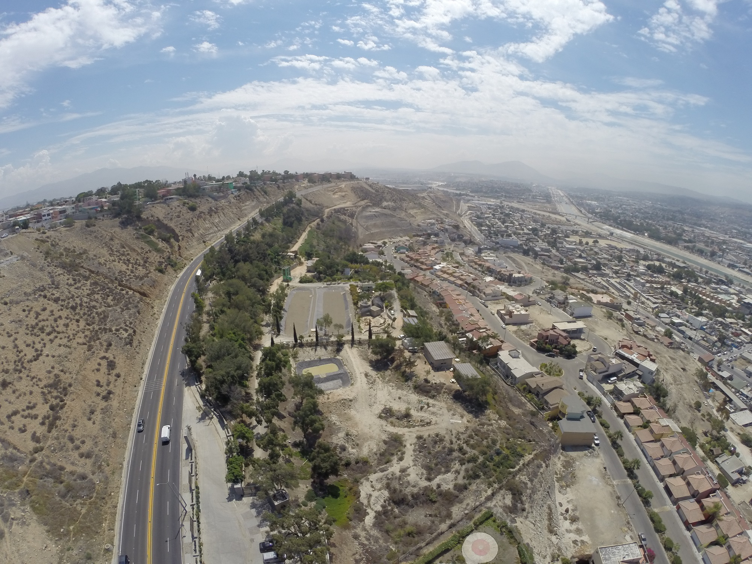
Figure 1. Ecoparque, Tijuana; Mexico
Recent Publications (minimum 5)
- Garcia, D.; Muñoz Meléndez, G.; Arteaga, A.; Ojeda-Revah, L.; Mladenov, N. (2022) “Greening Urban Areas with Decentralized Wastewater Treatment and Reuse: A Case Study of Ecoparque in Tijuana, Mexico”. Water, 14, 596. https://doi.org/10.3390/w14040596.
- Munoz-Melendez G. and Martinez-Pellegrini S. E. (2022). “Environmental Governance at an Asymmetric Border, the Case of the U.S.–Mexico Border Region”. Sustainability, 14(3): 1712-1725. https://doi.org/10.3390/su14031712.
- González Ornelas I. & Muñoz Meléndez G. (2021). “Adaptive Capacity to Climate Variability in Three Rural Communities at Sierra de San Pedro Martir”. Frontera Norte, 33. https://doi.org/10.33679/rtn.vlil.2114 10.1111/lamp.12148.
- Muñoz Meléndez G., Delgado Ramos G. and Diaz Chavez R. A. (2021). Chapter 16. Circular economy in Mexico in Ghosh S. K. and Ghosh S. K. Circular Economy: Recent Trends in Global Perspective. Springer Singapore. 497-523. Print ISBN: 978-981-16-0912-1. Electronic ISBN: 978-981-16-0913-8
5. Muñoz Meléndez G. y Sanchez Cano J. E. (2021). “Capítulo 1. Los derechos indígenas ante el agotamiento extractivista en América Latina” en Muñoz Meléndez, G., Sánchez Cano J. E. y Ríos Bolívar H. (comps.). (2021). “Territorios, neoextractivismo y derechos indígenas en Latinoamérica”. Durango: Universidad Juárez del Estado de Durango. 17-40. ISBN: 978-607-479-042-9.



Biography (150 word limit)
Gabriela Munoz-Melendez is head of the Department of Urban and Environmental Studies in the College of the Northern Border (El Colegio de la Frontera Norte) in Tijuana, Mexico. She is a chemical engineer and holds a PhD (and Diploma) in Environmental Sciences by Imperial College London. From 1992 to 1996, Gabriela Munoz worked for the General Directorate of Ecology in Mexico City. From 2000 to 2008, she was an associate researcher at the Department of Earth Sciences and Engineering - Imperial College London. She has published articles in peer-reviewed papers in journals such as Environmental Science and Technology, Journal of the Cleaner Production and Journal of Borderlands Studies. From 2016 to 2017 Gabriela Munoz spent her sabbatical leave at Stanford University researching the water-energy nexus.
.
Email:gmunoz@colef.mx

Lina Ojeda-Revah is a professor and researcher of the Department of Urban and Environmental Studies in the College of the Northern Border (El Colef) in Tijuana, Mexico. She is a biologist, with a PhD in Environment and Development of the Baja California Autonomous State University. She worked as a Director of Natural Resources of the Ministry of Environment in México City (2002-2005), Director of Scientific dissemination (2007-2012), and Director of Postgraduate Studies (2017-2019) at El Colef. Lina Ojeda-Revah has published articles in the Journal of Urban Planning and Development, Cities, and Land use policy. She was a fellow of the Leadership for Environment and Development Program (LEAD- México) of El Colegio de México and at the Center for U.S- Mexican Studies, University of California. Her main research interests are urban green spaces and green infrastructure.

Email:lojeda@colef.mx

Notes/Comments:
I decided to include Dr. Ojeda -Revah, because she has been involved in Ecoparque’s development from its origen.

