Oral bioaccessibility and Mutagenicity of Benzo[a]pyrene- and Phenazine-amended soil
^{ab}Emmanuel A. Awulu., ^{b}Graeme I. Paton., ^{b}Jeremy M. Sternberg.
ªDepartment of Biological Sciences, Federal University Lokoja, Kogi State. Nigeria
^{b}School of Biological Sciences, University of Aberdeen, Scotland. UK

Abstract
The research on oral bioaccessibility and biological consequences of polycyclic aromatic hydrocarbons (PAHs) and nitro-polycyclic aromatic hydrocarbons (NPAHs) in polluted soil is critical sequel to the hand-to-mouth behaviours in children. Most of the research focused on PAHs and NPAHs bioaccessibility exclusively without considering the potential biological effects. This study evaluated the bioaccessibility of benzo[a]pyrene and phenazine, as well as specific biological effects on modelled enteric cells following in vitro sequential human digestion of amended soil. The biological effects screened include cell viability (as shown by the MTT experiment on Caco-2 cells) and mutagenicity (via Ames Salmonella assay and Comet assay using the Caco-2 cells). The soil was amended with benzo[a]pyrene (a PAH)/phenazine (NPAH) at 10, 100, and 300 mg/kg, respectively. Benzo[a]pyrene and phenazine had bioaccessibility values of 1.45 ± 0.01 and 26.33 ± 3.54 % (^{w}/_{w}), respectively. Phenazine was more bioaccessible than benzo[a]pyrene due to their difference in hydrophobicity and insolubility. In the presence and absence of S9 mix, bioaccessible benzo[a]pyrene and phenazine produced frameshift mutations (in S. typhimurium TA98) and bases-pair mutations (in S. typhimurium TA100). Similarly, in the presence and absence of S9 mix, bioaccessible

benzo[a]pyrene and phenazine induced considerable (p < 0.05) DNA damage without affecting the viability of Caco-2 cells. These findings emphasise the critical importance of biological effects parallel chemical characteristics when assessing the risk of exposure to benzo[a]pyrene and phenazine, due to the potential of causing mutation, a biological process necessary for the occurrence of numerous physiological changes in living systems.
Image
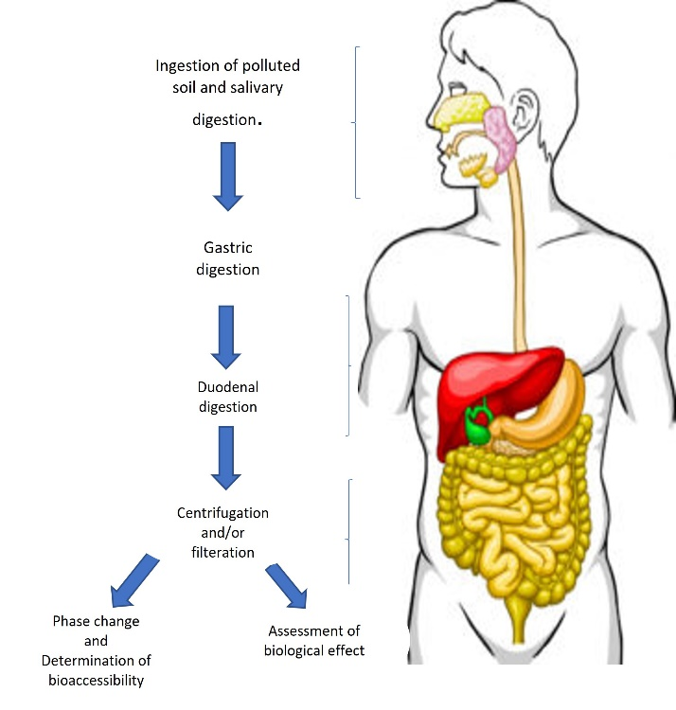
Fig 1. In vitro sequential human digestion model adopted in determination of bioaccessibility of Benzo[a]pyrene and Phenazine

References
Békaert, C., Rast, C., Ferrier, V., Bispo, A., Jourdain, M. J., & Vasseur, P. (1999). Use of in vitro (Ames and Mutatox tests) assays to assess the genotoxicity of leachates from contaminated soil. Organic Geochemistry, 30, 953–962
Calabrese, E. J., Stanek, E. J., Pekow, P., & Barnes, R. M. (Invalid date). Soil ingestion estimates for children residing on a superfund site doi:https://doi.org/10.1006/eesa.1996.1511
Juřica, J., Dovrtělová, G., Nosková, K., & Zendulka, O. (2016). Bile acids, nuclear receptors and cytochrome P450. Physiological research, 65(Suppl 4), S427–S440. https://doi.org/10.33549/physiolres.933512
Oomen, A. G., Rompelberg, C. J., Van de Kamp, E., Pereboom, D. P., De Zwart, L. L., & Sips, A. J. (2004). Effect of bile type on the bioaccessibility of soil contaminants in an in vitro digestion model. . Arch Environ Contam Toxicol., 46(2), 183-188. doi:https://www.ncbi.nlm.nih.gov/pubmed/15106668
Umeh, A. C., Duan, L., Naidu, R., Esposito, M., & Semple, K. T. (Invalid date). In vitro gastrointestinal mobilization and oral bioaccessibility of PAHs in contrasting soils and associated cancer risks: Focus on PAH nonextractable residues. Environment International, 133, 105186. doi:https://doi.org/10.1016/j.envint.2019.105186

