Examining the streets of Kabalagala’s CBD Using Crime Prevention through Environmental Design (CPTED)
Songole Shiverenje Hillary

Abstract (300 word limit)
Developing countries should explore other avenues apart from the traditional approaches of crime prevention mainly involving the criminal justice and social approaches of crime prevention that may assist in arresting crime amid resource constraints and predicted increase in population. This paper evaluates the streets of Kabalagala township Located in Kampala City, Uganda using a Defensible Space checklist and assess the perceptions of property/business owners concerning property crimes at the street level. The findings indicated that the streets of Muyenga, Gaba and Kikubamutwe were impacted by the existence of isolated areas and concealment opportunities and presented signs of poor maintenance and management of street elements which may have adversely affected effective natural surveillance and attracted criminal activity.

Image
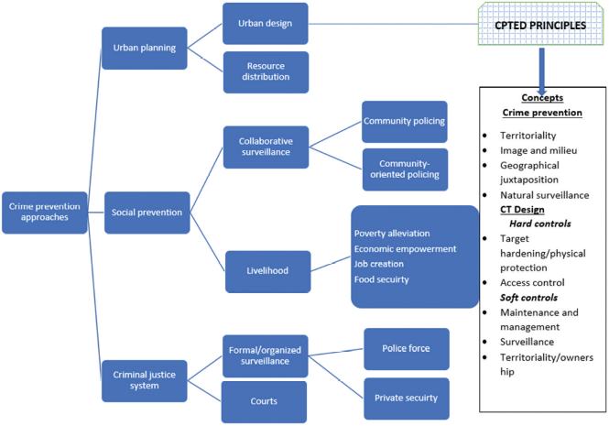
Recent Publications (minimum 5)
- Songole, H. S. (2021). "The Role of Geographical Juxtaposition in Kabalagala". Urban, Planning and Transport Research, 39. doi:10.1080/21650020.2021.1873175.

Biography (150 word limit)
Paste your Logo here
Hillary Shiverenje has her expertise in urban planning and design and is a research consultant within the built environment. He has passion in improving the safety concerns of society by advocating for place-based crime prevention approaches. His interests are particularly in Crime Prevention through Environmental Design (CPTED) and radical ways of improving clarity in CPTED research and application. He also has some experience as a peer reviewer in academic journals.
Email: Shivahilla@gmail.com

Notes/Comments:

Presenting author details
Full name: Songole Shiverenje Hillary
Contact number: +254703167185
Twitter account:
Linked In account: Hillary Shiverenje Songole
Session name/ number:
Category: (Oral presentation/ Poster presentation)

