Caatinga Albedo Preserved and Replaced by Pasture in
Northeast Brazil
Alcindo M Souza, PhD, IFRN, Brazil.
Cláudio Moisés Santos e Silva, PhD, UFRN, Brazil.
Bergson Guedes Bezerra, PhD, UFRN, Brazil.

Abstract (300 word limit)
Statement of the Problem: The caatinga is considered South America’s largest seasonally dry tropical forest (SDTF) and one of the most vulnerable endemic biomes in relation to climate change. The surface albedo in caatinga is relevant to understanding the role of this biome in the climate of the Northeast region of Brazil. Thus, a comparative analysis was conducted between the albedos of preserved and anthropized caatinga (pasture). Data were collected using CNR4-type net radiometers during the dry and rainy seasons. The mean albedo values were higher in the Pasture both in the dry and rainy season, with values of 0.181 and 0.177, respectively. In the caatinga, the mean albedo values were 0.137 in the dry season and 0.146 in the rainy season. The hourly average values for albedo, taken between 6:30 am and 4 pm, with intervals of 30 min, were also higher in the pasture. For convenience, this study uses local standard time (LST), which is 3 h behind from coordinated universal time (UTC). The greatest dispersions in the frequencies of the mean hourly albedo values occurred in the early morning and late afternoon. Some of the consequences of this study is the confirmation that there is an increase in albedo in caatinga replaced by pasture and this causes a reduction in the net radiation and also the finding that a region where there is adequate pasture management also enables albedo management and from solar radiation. And that further studies can indicate the impacts on temperature and precipitation, especially in warmer periods during the dry season.

Image
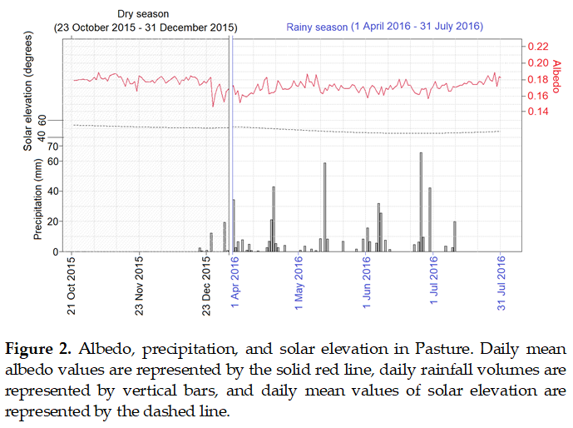
Recent Publications (minimum 5)
- Campos, S.; Mendes, K.R.; Da Silva, L.L.; Mutti, P.R.; Medeiros, S.S.; Amorim, L.B.; Dos Santos, C.A.; Perez-Marin, A.M.; Ramos, T.M.; Marques, T.V.; et al. Closure and partitioning of the energy balance in a preserved area of Brazilian seasonally dry tropical forest. Agric. For. Meteorol. 2019, 271, 398–412.
- Da Silva, M.V.; Pandorfi, H.; Lopes, P.M.O.; da Silva, J.L.B.; de Almeida, G.L.P.; de Oliveira Silva, D.A.; dos Santos, A.; de Moraes Rodrigues, J.A.; Batista, P.H.D.; Jardim, A.M.D.R.F. Pilot monitoring of caatinga spatial-temporal dynamics through the action of agriculture and livestock in the brazilian semiarid. Remote Sens. Appl. Soc. Environ. 2020, 19, 100353.
- Cunha, J.; Nóbrega, R.L.B.; Rufino, I.; Erasmi, S.; Galvão, C.; Valente, F. Surface albedo as a proxy for land-cover clearing in seasonally dry forests: Evidence from the Brazilian Caatinga. Remote Sens. Environ. 2020, 238, 111250.
- Mendes, K.R.; Campos, S.; Mutti, P.R.; Ferreira, R.R.; Ramos, T.M.; Marques, T.V.; Reis, J.S.; Vieira, M.M.D.L.; Silva, A.C.N.; Marques, A.M.S.; et al. Assessment of SITE for CO₂ and Energy Fluxes Simulations in a Seasonally Dry Tropical Forest (Caatinga Ecosystem). Forests 2021, 12, 86.
5. Marques, T.V.; Mendes, K.R.; Mutti, P.R.; Medeiros, S.S.; Da Silva, L.L.; Perez-Marin, A.M.; Campos, S.; Lúcio, P.S.; Lima, K.; Reis, J.S.; et al. Environmental and biophysical controls of evapotranspiration from Seasonally Dry Tropical Forests (Caatinga) in the Brazilian Semiarid. Agric. For. Meteorol. 2020, 287, 107957.



Biography (150 word limit)
Alcindo Souza has a degree in Physics from the Federal University of Rio Grande do Norte, a master's degree in science education from the same institution and a doctorate in climate science. He has experience in research in the area of ​​albedo and radiation balance in dry forests, specifically in the caatinga in Northeastern Brazil. Also has experience in environmental education with an emphasis on Science, Technology, Society and Environment (STSE).
Email: alcindo.souza@ifrn.edu.br

Notes/Comments:

