Photoperiod and CO₂ elevation influence morphological and physiological responses to drought in trembling aspen: implications for climate change-induced migration
Sahari Inoue, Research Associate, Centre for Boreal Research, Northern Alberta Institute of Technology, Canada
Qing-Lai Dang, Professor, Lakehead University, Ontario, Canada
Rongzhou Man, Research Scientist, Ontario Ministry of Natural Resources and Forestry, Canada
Binyam Tedla, Research Associate, Centre for Boreal Research, Northern Alberta Institute of Technology, Canada

Abstract (300 word limit)
In response to global warming, climate envelopes for most tree species are moving to higher latitudes, and trees are expected to shift their distributions to keep track of their climatic niche. However, successful migration is likely to be affected by factors other than the climate, such as photoperiod and its interaction with other environmental factors. Here, we investigated the interactive effects of CO₂ concentrations ([CO₂]), photoperiod, and soil moisture on the morphological and physiological traits of Populus tremuloides Michx. We grew seedlings under two levels of [CO₂] (Ambient (AC) 400 vs. Elevated (EC) 1000 μmol mol⁻¹), four photoperiod regimes (48 (seed origin), 52, 55 and 58°N latitude) and two soil moisture regimes (high (HSM) vs. low (LSM) soil moisture) for two growing seasons in greenhouses. Both morphological and physiological responses were observed. LSM reduced leaf size, total leaf area, and height growth by 33, 46, and 12%, respectively, and increased root/shoot ratio by 20%. The smaller leaf area and increased root/shoot ratio allowed the seedlings in LSM to maintain higher the maximum rate of Rubisco carboxylation (Vcmax) and the maximum rate of electron transport for RuBP regeneration (Jmax) than control seedlings. Photoperiod and [CO₂] modified responses to LSM and LSM altered responses to photoperiod and [CO₂], e.g., the August photosynthetic rate was 44% higher in LSM than in HSM under EC, but no such a difference existed under AC. The increase in Vcmax and Jmax in response to LSM varied with photoperiod. Stomatal conductance and its reduction in response to LSM declined with increasing photoperiod, which can have significant implications for soil moisture effect on northward migration. This study highlights the need to consider the complex interactions of [CO₂], photoperiod, and soil moisture when planning assisted migration or predicting the natural migration of boreal forests in the future.

Image
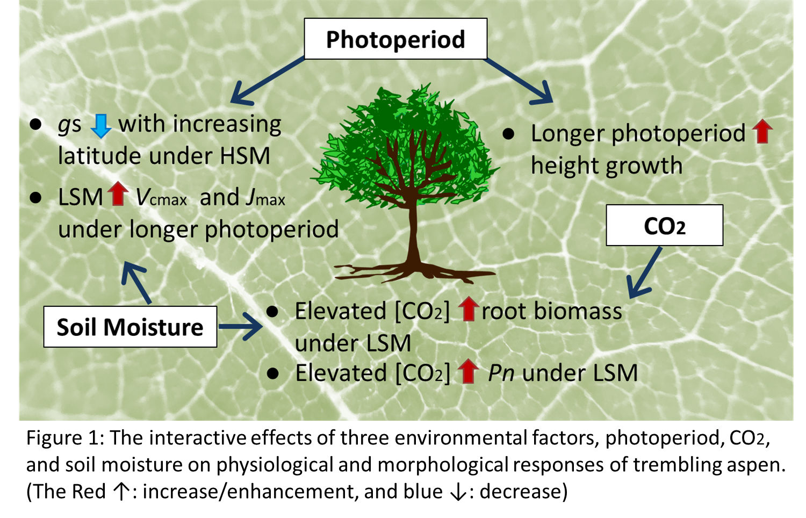
Recent Publications (minimum 5)
- Dang Q-L, Marfo J, Du F, Man R, Inoue S (2021) CO₂ stimulation and response mechanisms vary with light supply in boreal conifers. J Plant Ecol.14:291–300.
- Inoue S, Dang Q-L, Man R, Tedla B (2020) Photoperiod, [CO₂] and soil moisture interactively affect phenology in trembling aspen: Implications to climate change-induced migration. Environmental and Experimental Botany 180:104269.
- Inoue S, Dang Q-L, Man R, Tedla B (2020) Photoperiod and CO₂ elevation influence morphological and physiological responses to drought in trembling aspen: implications for climate change-induced migration. Tree Physiology 40:917–927.
- Tedla B, Dang Q-L, Inoue S (2020) CO₂ Elevation and Photoperiods North of Seed Origin Change Autumn and Spring Phenology as Well as Cold Hardiness in Boreal White Birch. Front Plant Sci 11:506.
- Tedla B, QL Dang and S Inoue (2020) Longer photoperiods negate the CO₂ stimulation of photosynthesis in Betula papyrifera Marsh: implications to climate-change-induced migration. Physiologia Plantarum 106-115.


Biography (150 word limit)
Sahari Inoue is currently a Research Associate at Centre for Boreal Research, Northern Alberta Institute of Technology. Her research seeks to advance our understanding of pre-sowing techniques to overcome seed dormancy, improve seed germination, and get a better understanding of the traits that contribute to salinity and drought tolerance in native boreal species. She completed her Ph.D. in Forest Science (Plant Eco-physiology) from Lakehead University, Ontario. In her thesis work, she investigated the impact of climate-change-associated abiotic stress on boreal tree species.
Email: sinoue@lakeheadu.ca

Notes/Comments:

