ABSTRACT
Statement of the Problem: Globally, air pollution is responsible for around 7 million deaths, with 91% of the world’s population living in areas that exceed WHO air quality guidelines. Dhaka City is ranked the most polluted city in the world, posing a major threat to the health of the population. Researchers have reported that the yearly costs of health maintenance due to air pollution in Dhaka city have been estimated to be in excess of US $100 million and cause more than 8000 excess deaths in the city. The purpose of this poster is to provide an overview and brief analysis of the causes and consequences of air pollution on population health in Dhaka City, and to evaluate current and future recommendations for policy. Methodology: Using a literature search strategy and additional methods such as snowball searching, available literature was gathered for review. Findings: Air pollution originating from industrial emissions, vehicular emissions, and household air pollution (HAP) release various types of pollutants and particulate matter (PM) that have both short and long-term effects on population health, especially to vulnerable groups such as children and the elderly. Particularly concerning is the consequences of PM2.5 and lead poisoning on children’s development, and the risks posed by solid fuel to cardiovascular mortality and morbidity. Social determinants of health (SDoH) such as living and working conditions and education and income are also heavily impacted. Conclusion & Recommendations: There is a high burden of respiratory illnesses, high risks to long term developmental problems in children and heavy impacts of SDoH in Dhaka. Current policies have the potential to be effective but need to be more coordinated and targeted. The lack of awareness about HAP needs to be tackled through policy in order to reach all people at risk in the city.
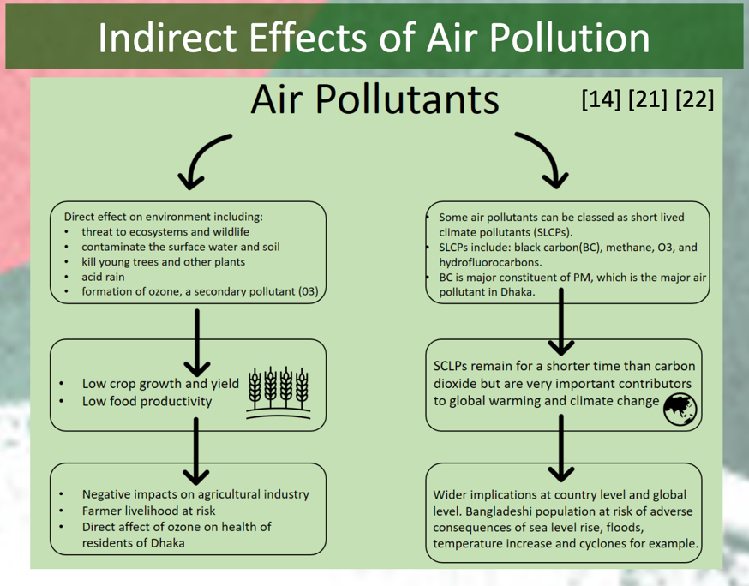
IMAGE

RECENT PUBLICATIONS
- Rahman M, Mahamud S, Thurston G. Recent spatial gradients and time trends in Dhaka, Bangladesh, air pollution and their human health implications. Journal of the Air & Waste Management Association. 2019;69(4):478-501. Available from: https://doi.org/10.1080/10962247.2018.1548388.
- Begum, B.A. and Hopke, P.K. Ambient Air Quality in Dhaka Bangladesh over Two Decades: Impacts of Policy on Air Quality. Aerosol Air Qual. Res. 2018;18: 1910-1920. Available from: https://doi.org/10.4209/aaqr.2017.11.0465.
- Hasan S, Mulamoottil G. Environmental problems of Dhaka city. A study of mismanagement. Cities. 1994 Jun 1;11(3):195–200.
- Alam, M. Z., Armin, E., Haque, M. M., Halsey, J., & Qayum, M. A. (2018). Air pollutants and their possible health effects at different locations in Dhaka city. In Journal of Current Chemical and Pharmaceutical Sciences Research | (Vol. 8, Issue 1). www.tsijournals.com
- Alam, D. S. Chowdhury, M. A. H. Siddiquee, A.T, Ahmed, S. Hossain, M. D. Pervin, S. Streatfield, K. Cravioto, A. Niessen, L. W. (2012) Adult Cardiopulmonary Mortality and Indoor Air Pollution: A 10-Year Retrospective Cohort Study in a Low-Income Rural Setting, Global Heart, Volume 7, Issue 3, Pages 215-221, ISSN 2211-8160, https://doi.org/10.1016/j.gheart.2012.06.008.

BIOGRAPHY (first author)
Ifrah Farooq is a medical student at University College London Medical School. She recently completed her intercalated BSc in Global Health along-side the co-authors of this poster and will go on to complete her MB, BS by 2024. She is passionate about improving population health through policy and intervention and reducing health inequalities that exist across the world.
Email: ifrah.farooq.18@ucl.ac.uk

