The influence of urban green spaces and social environment on preschool-age children overweight

Sandra Andrusaityte Dr, Department of Environmental Sciences, Vytauto Didžiojo universitetas, Kaunas, Lithuania

Regina Grazuleviciene MD, Department of Environmental Sciences, Vytauto Didžiojo universitetas, Kaunas, Lithuania

Inga Petraviciene MSc, Department of Environmental Sciences, Vytauto Didžiojo universitetas, Kaunas, Lithuania

Abstract

Background. Recent research has found that residential environment can have impacts on child development and body mass index (1-3), however, the available evidence of simultaneous investigating the associations of low socioeconomic status and residential green spaces with childhood obesity is scarce (4-6). The aim of this study was to assess the associations between urban green spaces, social environment and risk for overweight/obesity among 4−6 year old children. Methods. This epidemiological study included 1,489 Kaunas children followed-up from birth. Body mass index (BMI) was evaluated according to International Obesity Task Force (IOTF) criteria for children. We compared two child’s BMI groups – the overweight/obesity group (BMI ≥18 kg/m2) and the reference group (BMI <18 kg/m2). Individual exposure to greenness levels was assigned as the average of satellite-derived Normalized Difference Vegetation Index (NDVI) of each participant home, and residential distance to nearest City Park was assessed by GIS. We used logistic regression models to estimate associations as odds ratios (OR). Results. About 7.5% of the 4–6 aged children were overweight/obese. The lower neighborhood greenness exposure (NDVI-100 m< median) during pregnancy and over 4 years was associated with increased children’s overweight/obesity risk. Low maternal education, smoking, and sedentary behavior were also statistically significant risk factors associated with children’s overweight/obesity in the univariate and multivariate models. Children from lower SES families residing in low greenness exposure area had 3-fold increased risk of overweight/obesity (Figure 1: adjusted OR 3.05; 95% CI 1.60–5.82). Data were adjusted for: maternal age, education, maternal active and passive smoking, the child’s sex, birth weight, siblings, and sedentary behavior.

Conclusion. Low residential greenness exposure of low SES families is associated with increase the risk of overweight/obesity in preschool-age children. The usage of city green spaces for increasing physical activity has been recommended as a measure to prevent overweight/obesity among children.

Image
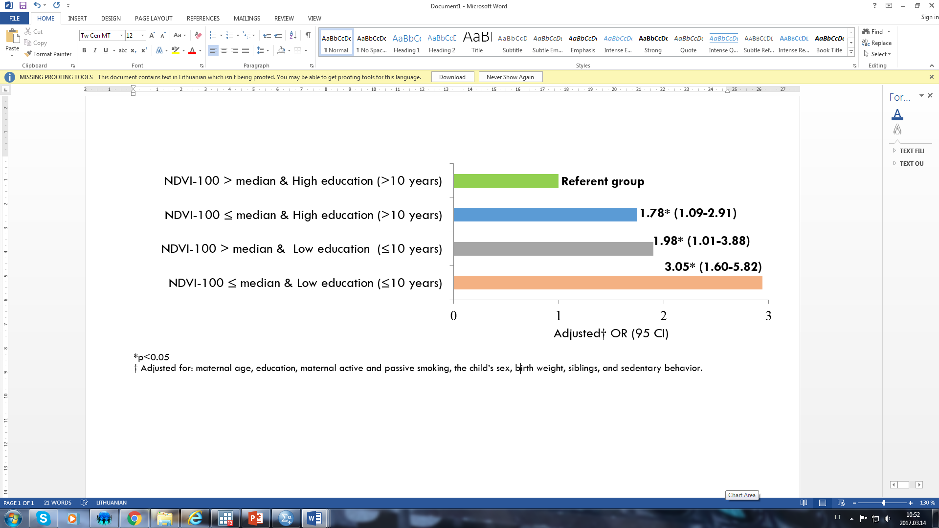
Figure 1: Effect of common SES and greenness exposure on the risk of children overweight/obesity.

Recent Publications
- Dadvand P, Villanueva CM, Font-Ribera L, et al. (2014) Risks and Benefits of Green Spaces for Children: A Cross-sectional Study of Associations with Sedentary Behaviour, Obesity, Asthma, and Allergy. Environmental Health Perspectives 122(12):1329-1335.
- Lovasi GS, Schawartz-Soicher O, Quinn JM, et al. (2013) Neighborhood safety and green space as predictors of obesity among preschool children from low-income families in New York City. Preventive medicine 57(3):189-193.
- Muthuri SK, Onywera VO, Tremblay MS, et al. (2016) Relationships between Parental Education and Overweight with Childhood Overweight and Physical Activity in 9–11 Year Old Children: Results from a 12-Country Study. PLoS ONE 11(8) article ID e0147746.
- Wolch J, Jerrett M, Reynolds K, et al. (2011) Childhood obesity and proximity to urban parks and recreational resources: A longitudinal cohort study. Health & Place 17(1):207-214.
- Halliday JA, Palma CL, Mellor D, et al. (2013) The relationship between family functioning and child and adolescent overweight and obesity: a systematic review. International Journal of Obesity 38(4):480-493
- Stamatakis E, Wardle J, Cole TJ (2010) Childhood obesity and overweight prevalence trends in England: evidence for growing socioeconomic disparities. International Journal of Obesity 34(1):41-47.

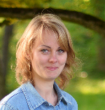Biography
Dr. Sandra Andrusaityte position: researcher, lecturer, Department of Environmental Sciences Vytauto Didziojo Universitetas (VDU), Kaunas, Lithuania. For the last 5 years she has been involved in the epidemiological research of studding environmental exposure impacts on human health. In 2015 she gained a Doctor’s degree in Biomedical sciences, Ecology and Environmental sciences. She is trained as an Epidemiologist and Biostatistician in the Emory Health and Exposome Research Center in Atlanta, USA. Areas of research: Biomedical Sciences; Environmental Epidemiology, Public Health, focusing on impact of natural environment and social environment on children health. She has been involved in the EC 7FP projects: PHENOTYPE and HELIX.
Email: sandra.andrusaityte@vdu.lt

Notes/Comments:

