Children’s Environmental Rights and Age Discrimination
Refia Kadayifci, PhD student, Louvain University, Belgium

Abstract (300 word limit)

It is a well proved fact that environmental hazards produce more significant harms when children are affected. The main objective of this paper is to demonstrate that the ‘right to equality and non-discrimination’ offers an appropriate, meaningful and effective basis to protect children’s environmental health. Doing so requires answering whether there is a strong connection between being children and being vulnerable to environmental degradation and if there is, whether anti-age discrimination law opens a possible avenue to challenge this health disparity. I will refer to two different sources of children’s environmental vulnerability: the disadvantaged situation of children in comparison with adults (as an age group) (this is also true for elders) and particular disadvantage of the children who are recently born (as a birth cohort). I will argue that the ECtHR and the ECJ anti-age discrimination case law reveal that children can be protected as an age group. And there are at least two legal strategies to avoid birth cohort discrimination toward children: 2012 Commission v Hungary ECJ case strategy and 2014 Kaltoft v Municipality of Billund ECJ case strategy. I will then demonstrate the environmental implications of these cases by giving details about why this approach is significant and how it can be legally successful.

Image

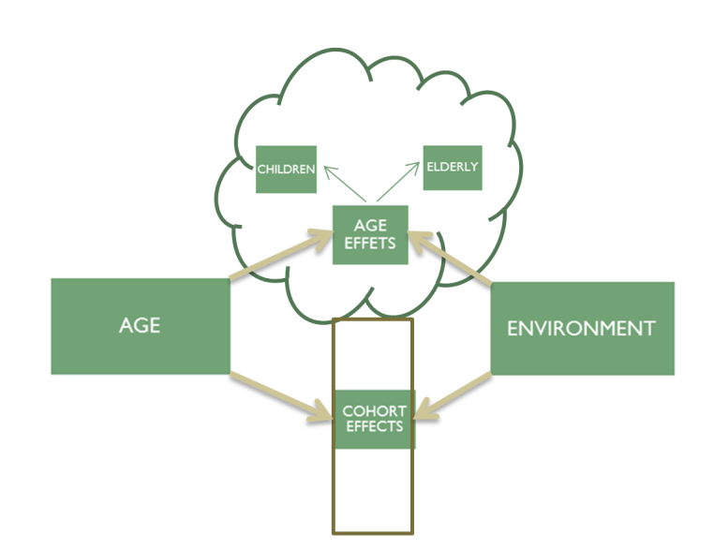



Biography (150 word limit)
Refia Kadayifci has a bachelor degree in law and a LLM degree on Legal Theory as a Jean Monnet Scholar in the field of Environment. Currently she is doing her PhD in Louvain University. Her expertise is in the European Environmental Law and Anti- Discrimination Law. She is trying to explore the potential use of anti-discrimination law in environmental litigation.
Email: rkadayifci@gmail.com

Notes/Comments:

