Plastic Pollution, Effects of plastic wastes on Marine Environment: A study on people’s perception.

Abstract
Plastic pollution is a global issue, affecting all the major water bodies on our planet earth from deep seas (sea-bottom) to the surface of the water bodies. It has negative impacts to the wildlife and their respective habitats, health and burden of coastal communities and maritime activities but also become an issue of public safety, considering the emerging concerns over ingestion of micro plastics by marine particle feeders. Some marine mammals get entangled and severely injured by the plastics which can even be proved by human observation. Marine mammals mistake their food from the plastics which at the end can affect human health as it enters the food chain. The study focused on assessing the knowledge gap on how people perception, behavior and levels of understanding are on the environmental and health effects of plastic wastes. A significant correlation was observed between people’s perception, behaviors on handling plastics and the extent of plastic pollution to the marine environment, and it implied that peoples behavior in handling plastics has a great impact on polluting our environment, affecting the marine ecosystems which at the end affecting our health. Measures within a strategy to close the largest loopholes in the plastic packaging cycle should target plastic bottles and plastic bags, and should specifically address the actors who are responsible in the production, consumption and waste management stage of plastic packaging which could
bring about improvements by changing their behavior and implementing practical actions to do so.
Image:

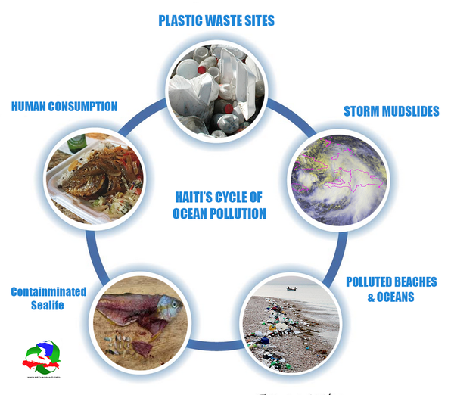

Recent Publications (minimum 5)
1.Arcadis (2010). Analysis of the evolution of waste reduction and the scope of waste prevention. European Commission DG Environment Framework contract ENV.G.4/FRA/2008/0112. , 2010.
2. Ospar (2007). Pilot Project on Monitoring Marine Beach Litter. 74 pp.

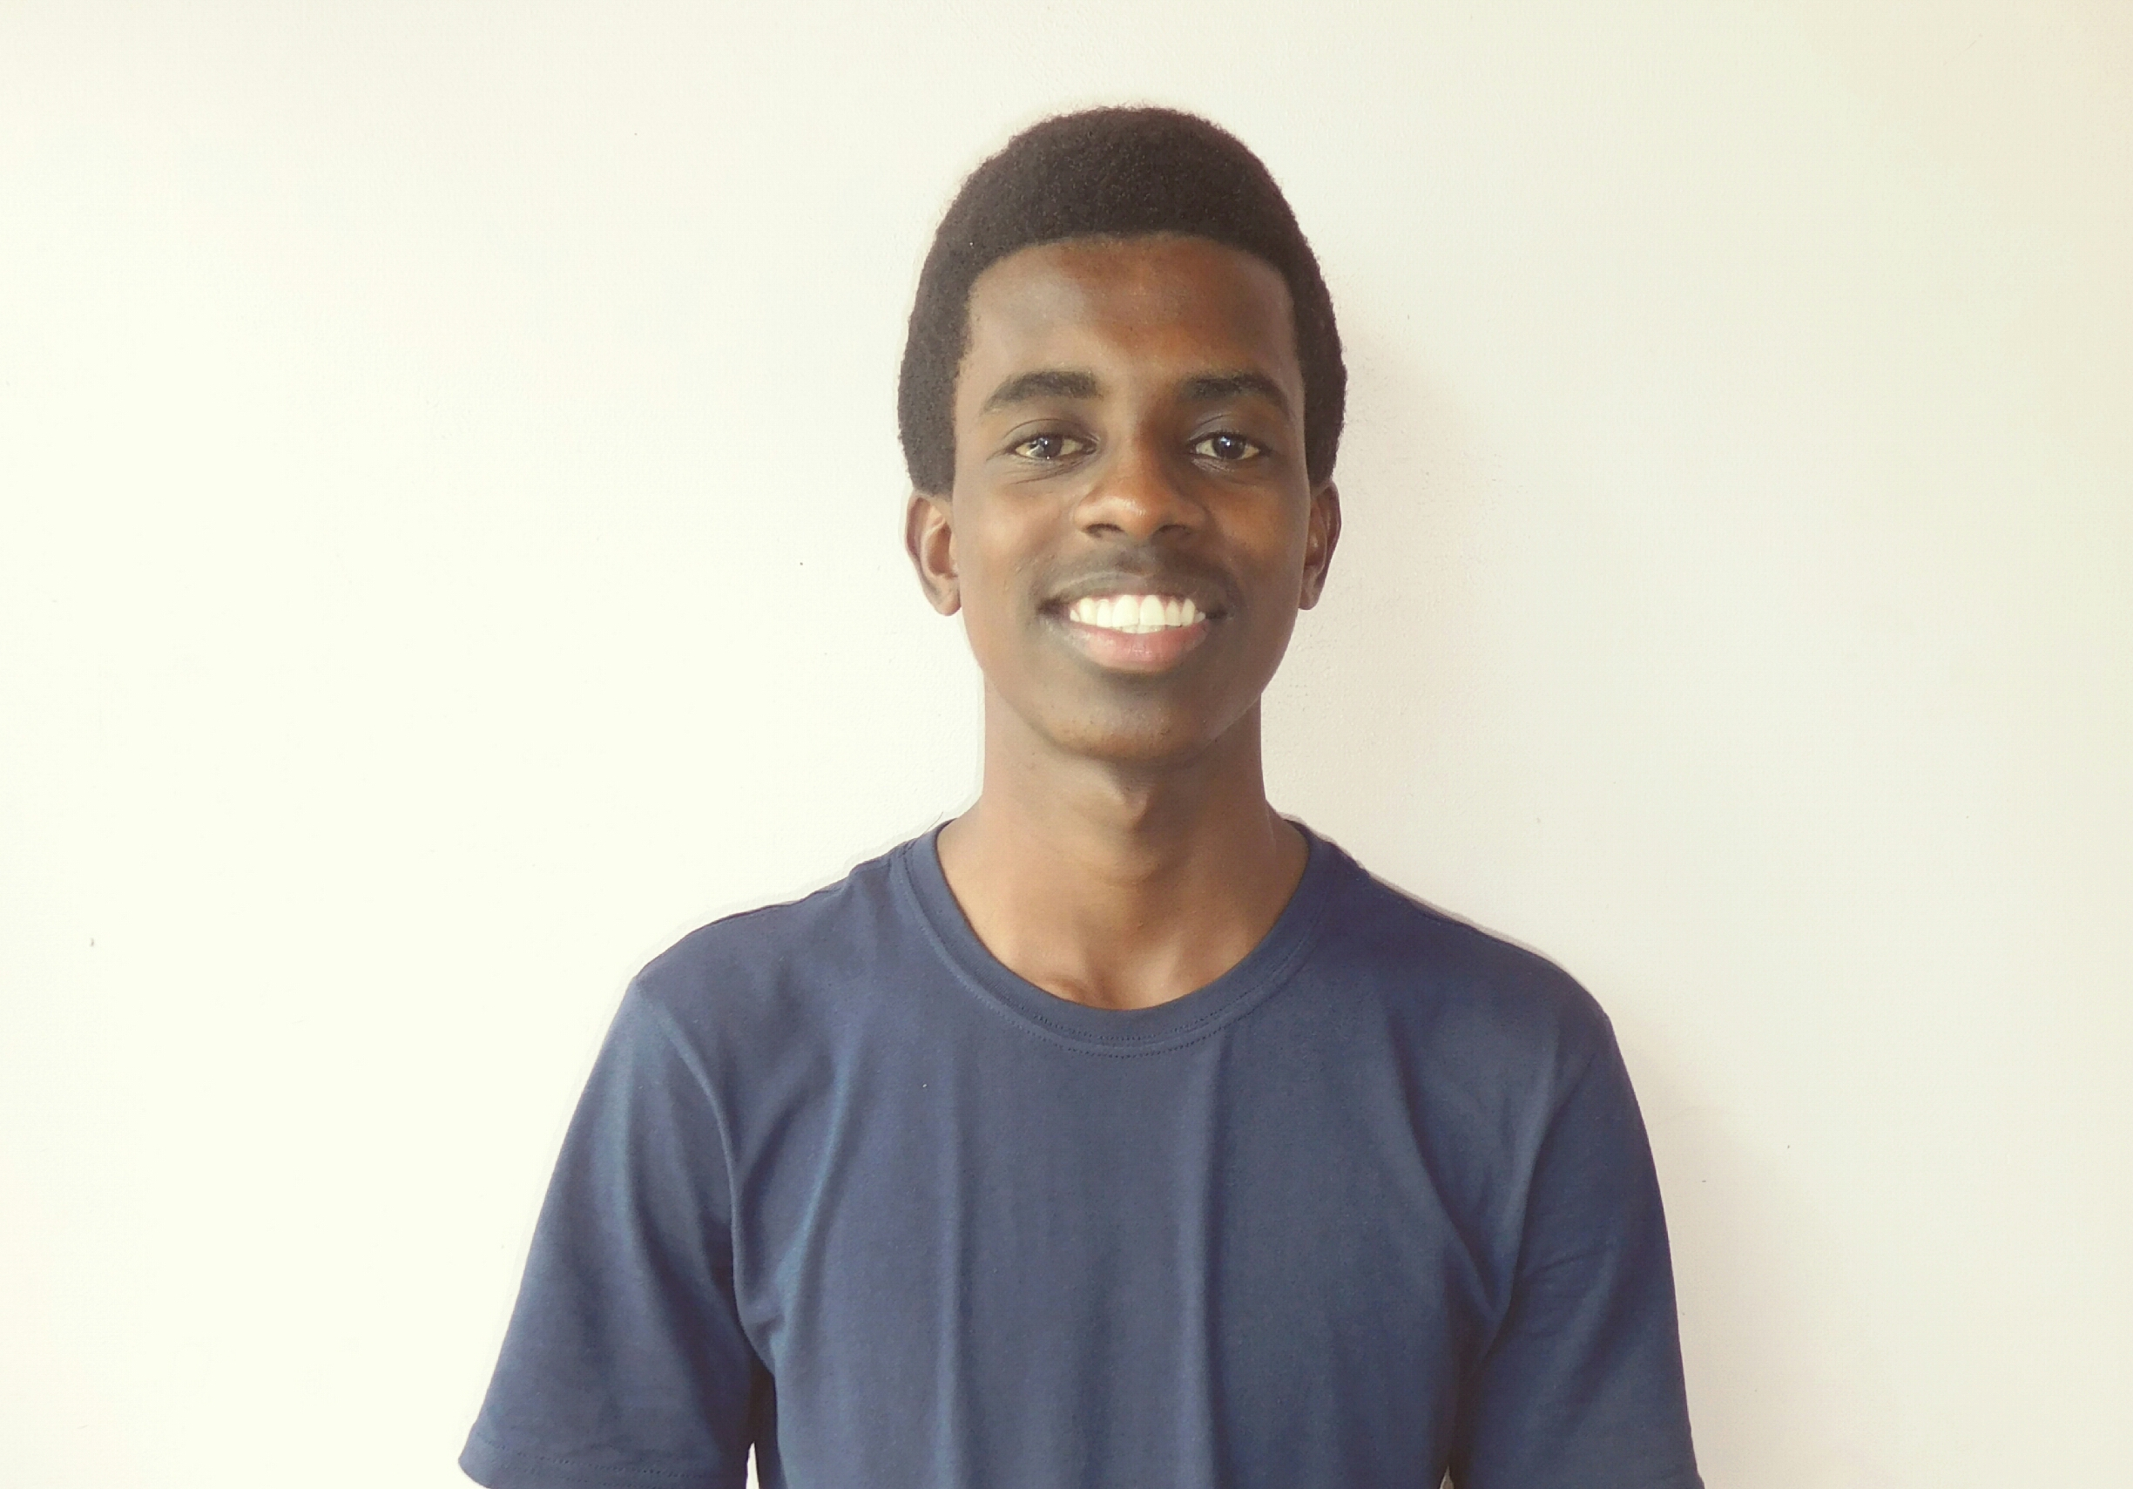

Biography
Ghaamid Abdulbasat Hatibu is a Tanzanian by nationality, he is an environmentalist and geospatial enthusiast. Working in communities to bring change and achieve sustainable development. He believes that environment and development are two sides of the same coin and therefore development must go together with environmental conservation and thereby attaining development with environmental sustainability for the benefits of the current and the future generation as well.

Ghaamid Abdulbasat
Tel: +255653949306
Category: (Oral presentation)
Email: ghamidbasat@gmail.com

