Activated carbons preparation from olive stones for Bisphenol A and Diuron adsorption

Nadia El Ouahedy^{1,2}, Satu Ojala³, Laurence Pirault-Roy¹, Rachid Brahmi²

¹University of Poitiers, IC2MP UMR CNRS 7285, Poitiers, France.
²Laboratory of Catalysis and Corrosion of Materials, University of Chouaib Doukkali El Jadida, Morocco.
³University of Oulu, Faculty of Technology in the Environmental and Chemical Engineering research unit.,90014 Oulu, Finland.

Abstract
Olive stones are an agricultural waste from the olive oil industry and represent one of the most abundant renewable resources in Mediterranean areas. In addition, many attentions is paid to water quality and removal of persistent organic pollutants as the well-known endocrine disruptor Bisphenol A (BPA) or the herbicides such as Diuron. So, the aim of this study was to explore the possibility of using this biomass for the preparation of activated carbon (AC) for BPA and Diuron adsorption from polluted waters. The AC was prepared according to the method of chemical activation and pyrolysis. To optimize the performances of the obtained materials (expressed in terms of adsorption capacity), the effect of main preparation parameters was studied, such as pyrolysis temperature, activating agent and mass ratio.
The prepared AC were characterized by DRX, FTIR, SEM, N₂ adsorption-desorption and CHNS. Simultaneously, a study was performed on the effects of temperature, pH solution, and initial concentration on the removal efficiency for our targeted pollutants. Further, simplified kinetic models (pseudo-First-order and pseudo-Second-order) were tested to investigate the adsorption behaviors and Freundlich and Langmuir models to analyze the adsorption equilibrium. Promising performances were pointed out as 70% of Diuron and 92% of BPA can be removed from aqueous solution for an initial concentration respectively 35 mg/L and 20 mg/L, when the usual concentrations of BPA in environmental waters are in the range of 10 ng/L to 400 μg/L and Diuron is around 1600 ng/L.
Adsorption on AC has many advantages because it converts agricultural waste to useful added-value adsorbent and proposes a low operating cost, easy use, simple design but efficient technique. To achieve a complete process of remediation, we check the possibility to desorb pollutants from AC and to oxidize them through VOC’s catalytic treatment.
Image
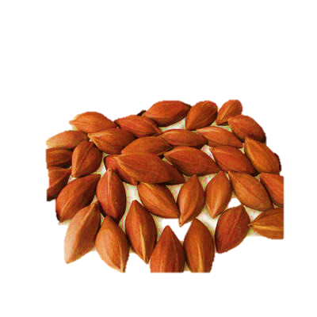

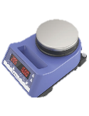
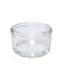
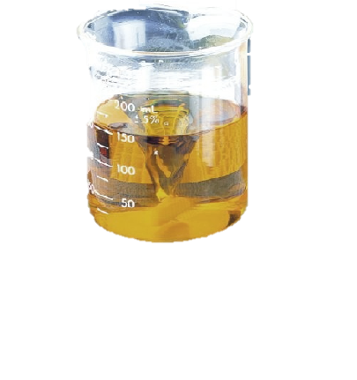
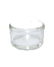
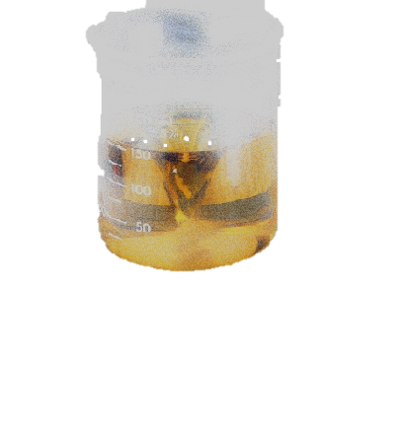
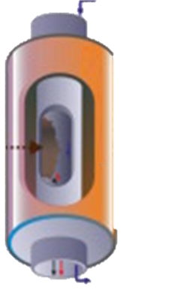
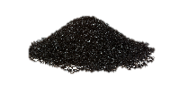
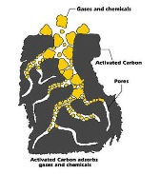
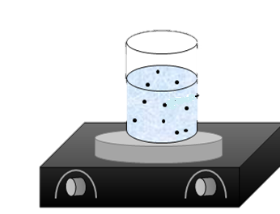
Figure 1: Preparation of activated carbon and adsorption of BPA and Diuron.

Figure 2: SEM pictures of activated carbon prepared

Recent Publications
1.Preparation of activated carbon from olive waste: Study the influence of some factors by the factorial design.
2.Adsorptive removal of Bisphenol A from Aqueous solution by activated carbon.
3.Diuron adsorption from aqueous solution by activated carbon: effect of some parameters on the efficiency of adsorption

 Biography
Nadia El Ouahedy is a 2nd year PhD student in University of Chouaib Doukkali in Morocco and University of Poitiers in France working on depollution of water by hybrid system as a part of the project PHC Maghreb 2016. She is doing the preparation of adsorbents from olive waste providing from Morocco, such as the charcoal prepared by the hydrothermal carbonization process at Triers University in Germany, and activated carbon at University of Poitiers in France and Oulu University in Finland in order to apply them for the adsorption of Bisphenol A and Diuron followed by a catalytic oxidation of those pollutants.
Email:nadiaelouahedy@gmail.com/ nadia.el.ouahedy@univ-poitiers.fr

