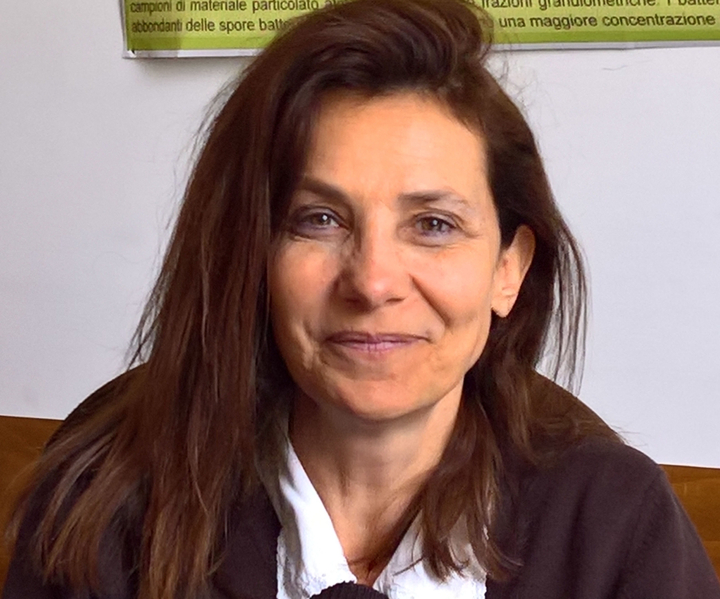Chemical markers for the characterization of bioaerosol 

Francesca Buiarelli^{1*}, Patrizia Di Filippo^{1,2}, Donatella Pomata^{1,2}, Carmela Riccardi^{1,2}

1 Chemistry Department, University of Rome “La Sapienza”, P.le Aldo Moro, 5 -00185 Rome,-Italy
2 DIT, INAIL, Via Ferruzzi, 38 -00143 Rome- Italy

Bioaerosol is commonly defined as aerosolized particles, with a biological origin, spread into the air by a variety of abiotic and biotic mechanisms. The size of bioaerosol can range from several nanometers to a few hundred micrometres in aerodynamic diameter. Examples of bioaerosols include fungal and bacterial spores/cells, fungal hyphae, pollen, viruses and amoebae, algae, lichen, archaea, aggregates of these particles, and fragments of larger organisms including leaf litter, skin scales, animal and plant debris. Metabolites and excreta are also included in this topic. In these last years the knowledge about indoor and occupational bioaerosol exposure and related diseases has significantly increased. Biological particles have been linked to mucous membrane irritation, allergy, asthma, inflammatory lung diseases, hypersensitivity pneumonitis and so on . The use of biomarkers as a tool for the determination of bioaerosol has often been suggested. The basis of this approach is that bioaerosol components contain chemical compounds that can be used as markers of larger and/or bioactive structures. The main objective of our research is the identification and quantitation of dipicolinic and muramic acids, ergosterol, poliols, amino acids and proteins as markers of bacterial, fungal spores/cells and generic bioaerosol, in both indoor and outdoor airborne particulate matter. To achieve this purpose, methods of extraction and analysis by chromatographic techniques coupled to mass spectrometry of different classes of compounds from particulate matter of different size (ultrafine, fine and coarse), collected in proper sampling campaigns, have been developed.

Biography

Francesca Buiarelli completed her Ph.D. in Chemical Science in 1992 and, after several working experiences, became a researcher in the field of Analytical Chemistry at Chemistry Department of Rome University “ La Sapienza” in 1999. She has been teaching Separative Chemistry since 2002 and she has published more than 45 papers in reputed journals. Her research activity involves three main topics:
1) Characterization of polluting agents in airborne particulate matter, water and soil.
2) Excretion study and metabolism of doping agents in sports and veterinary field.
3) Separation and characterization of natural organic compounds in complex matrix such as food.

Presenting author details
Full name: Francesca Buiarelli
Contact number: +39-0649913645
E-mail: francesca.buiarelli@uniroma1.it
Session name/ number: Application of Environmental Chemistry/ Chemical markers
Category: Oral presentation poster presentation

