A system for safe and Eco-friendly Wastewater Treatment to create Soil, Grass and Water (EWT)
Joy Manglani, Only Nature Endures, NGO (OneNature.com), India
Abstract
Problem; "Human activity has had a negative impact on the environment because it has caused deforestation, ocean acidification, and the extinction of important biodiversity." [1]
“Current Sanitation methods convert pollution to disaster; They lead to major problems faced by society today, such as; water pollution, water scarcity, loss of soil fertility, global warming, poor economy, poor health and loss of life”. [2]
These methods decompose (break-up) valuable organic elements, found in the so-called waste, into foul gases & acids, even now! The gases badly pollute the air and acids badly pollute the land and sub soil water.
Methodology; Based on intensive field research, field experiments and application of fundamental science, a system for treatment, using wastewater, unutilized solar energy, building debris as resources to produce; soil with vegetation (say grass) and clean water. Community wastewater includes sullage, kitchen sink food waste pulverized wastewater, wash water, bath water, sewage, polluted rivers, lakes and sea, etc. It is about 99% water and 1% organic matter primarily made up of natural elements such as carbon, oxygen, hydrogen, nitrogen, sulfur and other trace elements found in all healthy biology, these are nutrients and in EWT are converted to healthy vegetation such as grass. Clean highly aerated water is filtered out, wherein there is no odour, no mosquitoes, no colour. The system is occupationally safe and eco-friendly.
Conclusion: EWT helps recycling of material and energy; enhancement of environment, energy conservation, enhancement of air, soil, water, plants and animals feeding on these plants, bio-energy generation, reduction in global warming and climate change, development of havens for wildlife including flora and fauna, enhanced quantity, quality and distribution of rainfall, enhanced dissolved oxygen in water, watershed development, enhanced aquaculture and fisheries development, flood control. EWT is at least 10 times economical, efficient, safer, sustainable and ecological compared to alternatives.

Photos and Brief of EWT;
The treatment primarily includes a Collection and Seeding Tank (CST) for pre-treatment, a Sieve Cage (SC) to sieve out plastic bags and other solids, a Solar Bio-Reactor (SBR) for further treatment using soil formation, nutrient conversion, water filtration as it seeps down and a Clean Water Tank (CWT) from where treated clean water is pumped out for usage. Inorganic waste (building debris) is used to make the media for the bioreactor. Soil is not consumed but produced by mixing organics and inorganics. The fresh sewage is collected in the CST, 10% of treated clean water is recycled here to initiate the treatment. This helps to remove the bad odour. This pre-treated sewage is then churned and pumped using a submersible pump in the CST which also distributes it on the Bioreactor as shown and converted to grass and clean water. SBR comprises a 1.5 mtr deep tank, with a slightly inclined bottom and with a specially designed bio-media which allows fast percolation. The water flows through an underground pipe in the far corner end of the bioreactor to the underground tank (CWT) whose surface is seen behind. In about 25 minutes the sewage gets treated and clean water is automatically pumped out of the underground tank seen behind the Bioreactor. The pumps use automatic level controls.
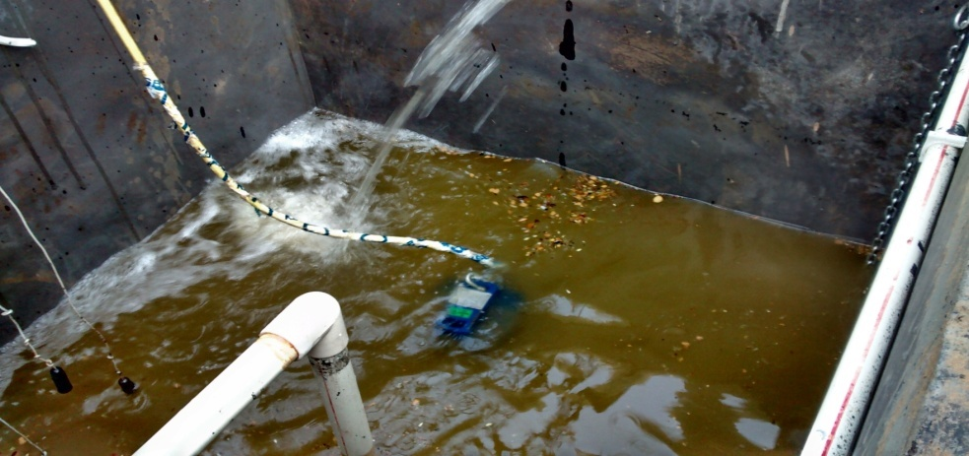
Sewage Collection tank (CST)

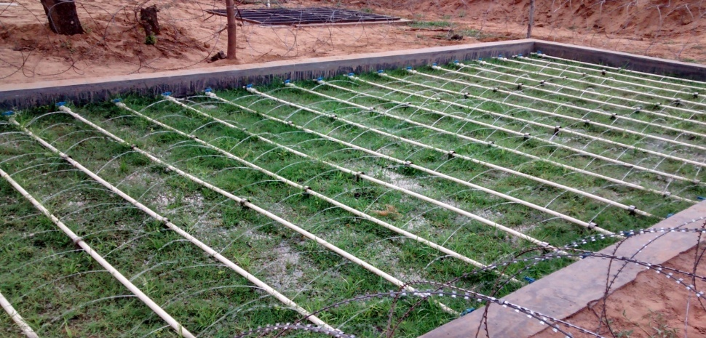
Bioreactor (SBR)

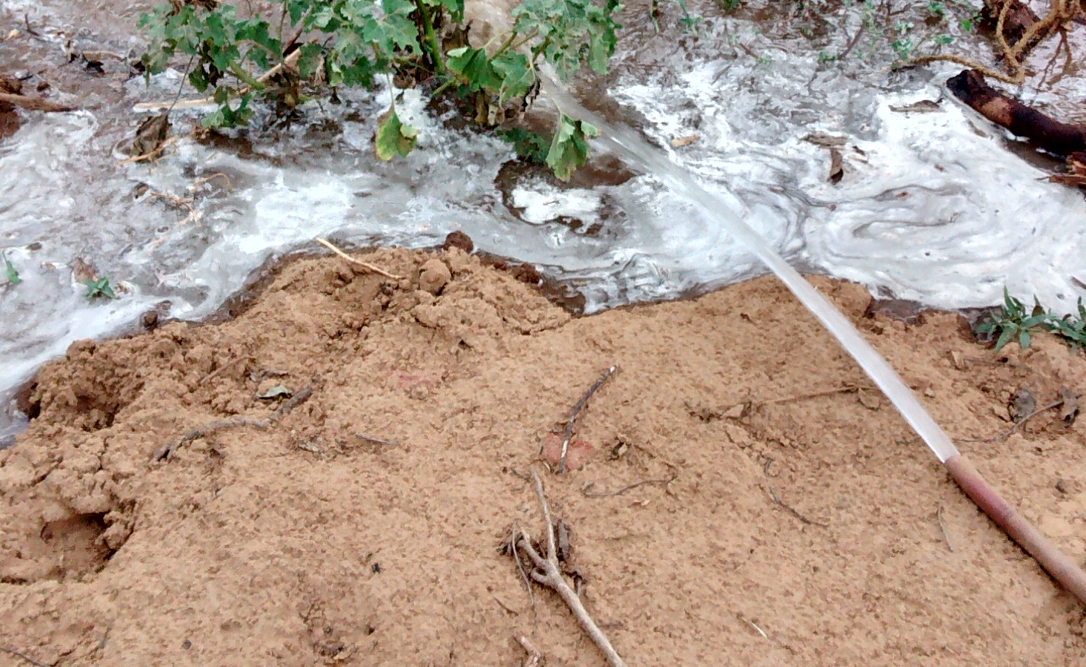
Clean Water from Clean Water Tank (CWT)
Reference
- https://www.wikihow.com/Write-a-Paper
- (Dr Steven Esrey & Ingvar Anderson, Water & Sanitation Council, WHO in 1999)
Publications
The work is new and there are no publications till now.

Joy Manglani is an Environment Scientist & Inventor. He holds the prestigious B. Tech. degree from the premier IIT Delhi in Chemical Engineering. He is a founder (since 1983) and President of NGO - Only Nature Endures (ONE) also called OneNature where he trains interns and seniors. He invents and promotes Sustainable Technologies for Joyful Life and Healthy Environment. Has experience of successfully inventing and applying technologies in the fields of Water and Sanitation, Eco-friendly Handcrafted Textiles & Clothing, Organic Farming, Eco-friendly Asbestos Cement, Business revival, Thermal Engineering, Awareness and Justice. His breakthrough invention above can help in solving the Water and Sanitation problem.
He was an Advisor to Government of Maharashtra (India) on Water and Sanitation Technologies. He was also an Advisor to Government of India for Safe Industrial Technology.
His ancestors and current family are social workers.

joymanglani2@gmail.com , +919869402067

