

Toxicology of air pollutants & its impact on human beings
Vijay Chaudhry
Consultant & Author

Author while discussing the epidemiology of fluoride in the research paper (accepted by American Dentistry 2018), analyzed the impact of high ionic load including fluoride on teeth of human teeth by means of electrodes incorporated in a tooth brush. The results have been depicted in the said paper. So far author has discussed the water as the pathway in the environmental toxicological route. Apart from water, air is one of the widest pathways through which various toxicological pollutants travel long distances to be absorbed by vegetation. Although vegetative belts act as sinks for the toxic pollutants, yet various pollutants viz. Ozone, Sulfur Oxide, Hydrogen Fluoride find their receptors in vegetation especially leaf and stems. Historically leafs of vegetative world have been used as a diagnostic tool. The most important fluoride problem in agriculture other than direct effects on plants is the effects on grazing animals that have ingested forage containing elevated concentrations of fluoride. Hydrofluosilicic acid dissociates in solution virtually 100%.This acid has low pH and causes a delayed burn on skin tissues. The analysis as proposed should be read along with author’s complete research paper titled “Hydrological Cycle By Using Dental Model”, Soil & Rock 2003, Massachusetts Institute of Technology, Boston,Verlag Gluckauf, GMBH, Germany, pp : 2633-2637( As the title .”Restoration” suggests, tooth should be restored by non-corrosive materials as reflection co-efficient in quoted paper which plays a major role in osmosis/diffusion has been considered as greater than 0 and less than 1) and accepted abstract titled “Tooth Decay and Its Analysis” accepted by American Dentistry 2018.Although lime spraying protects peaches against fluoride –induced soft tissues, yet they should be monitored for excess fluoride level. This again can be done by electrical resistivity method, as both leaf and tooth undergo mottling (voltage 1x 3Volts). The “Electrical Resistance Method” (Bovankovich.1973) analysis is shown in the following graph:

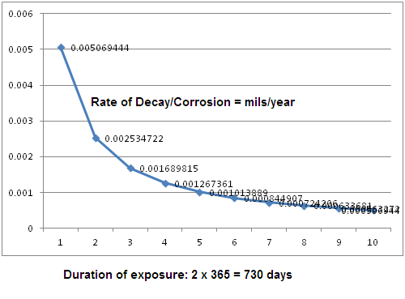

Author’s Publications:

- Chauadhry V.K., “Restoration of Hydrological Cycle By Using Dental Model”, Soil and Rock America 2003, 12th Pan-American Conference on Soil and Geotechnical Engineering and 39th U.S. Rock Mechanics Symposium, June 22-26, Massachusetts Institute of Technology , Cambridge, Boston, Verlag Gluckauf GmbH, pp: 2633-2637.
- Chaudhry V.K., Elimination of HAV and HEV By “Restoration of Hydrological Cycle By Using Dental Model”, PhD thesis, Geotechnical News, Volume 2( No.2), Canada, June 2003, p: 67.
- Chaudhry V.K. Natural Reverse Osmosis in Riparian Areas, Summer Specialty Conference 2004, American Water Resources Association, Olympic, California, AWRA, June 2004( CD).
- Chaudhry V.K., et al, Groundwater Manual (AWWA-21), American Water Works Association, 2003.
- Chaudhry V.K., et al, Dual Water Supply Manual (AWWA-24), American Water Works Association, 2003.
Biography
Vijay Chaudhry has completed his PhD at the age of 48 years from IOU Foundation, The Netherlands. PhD degree was awarded on the basis of his published research work. He worked in the field of water/environmental science for Thermax Ltd (Pune), a joint venture of Thermax and Permutit,USA, Nuchem Weir Ltd, a joint venture of Nuchem Ltd. and Weir Westgarth Ltd.( UK), Cement Corporation of India Ltd.( A Govt. of India Enterprises) and many other environmental organizations as consultant. Since he worked in Research & Development, his research interests are environmental/water management. He has published more than 30 papers in reputed journals and magazines.
Presenting author details
Full name: Vijay Chaudhry.
Contact number: 91-9873415654
Twitter account: Not Applicable.
Linked In account: Not Applicable.
Session name/ number: Not Applicable
Category: (Oral presentation/ Poster presentation): Poster.

