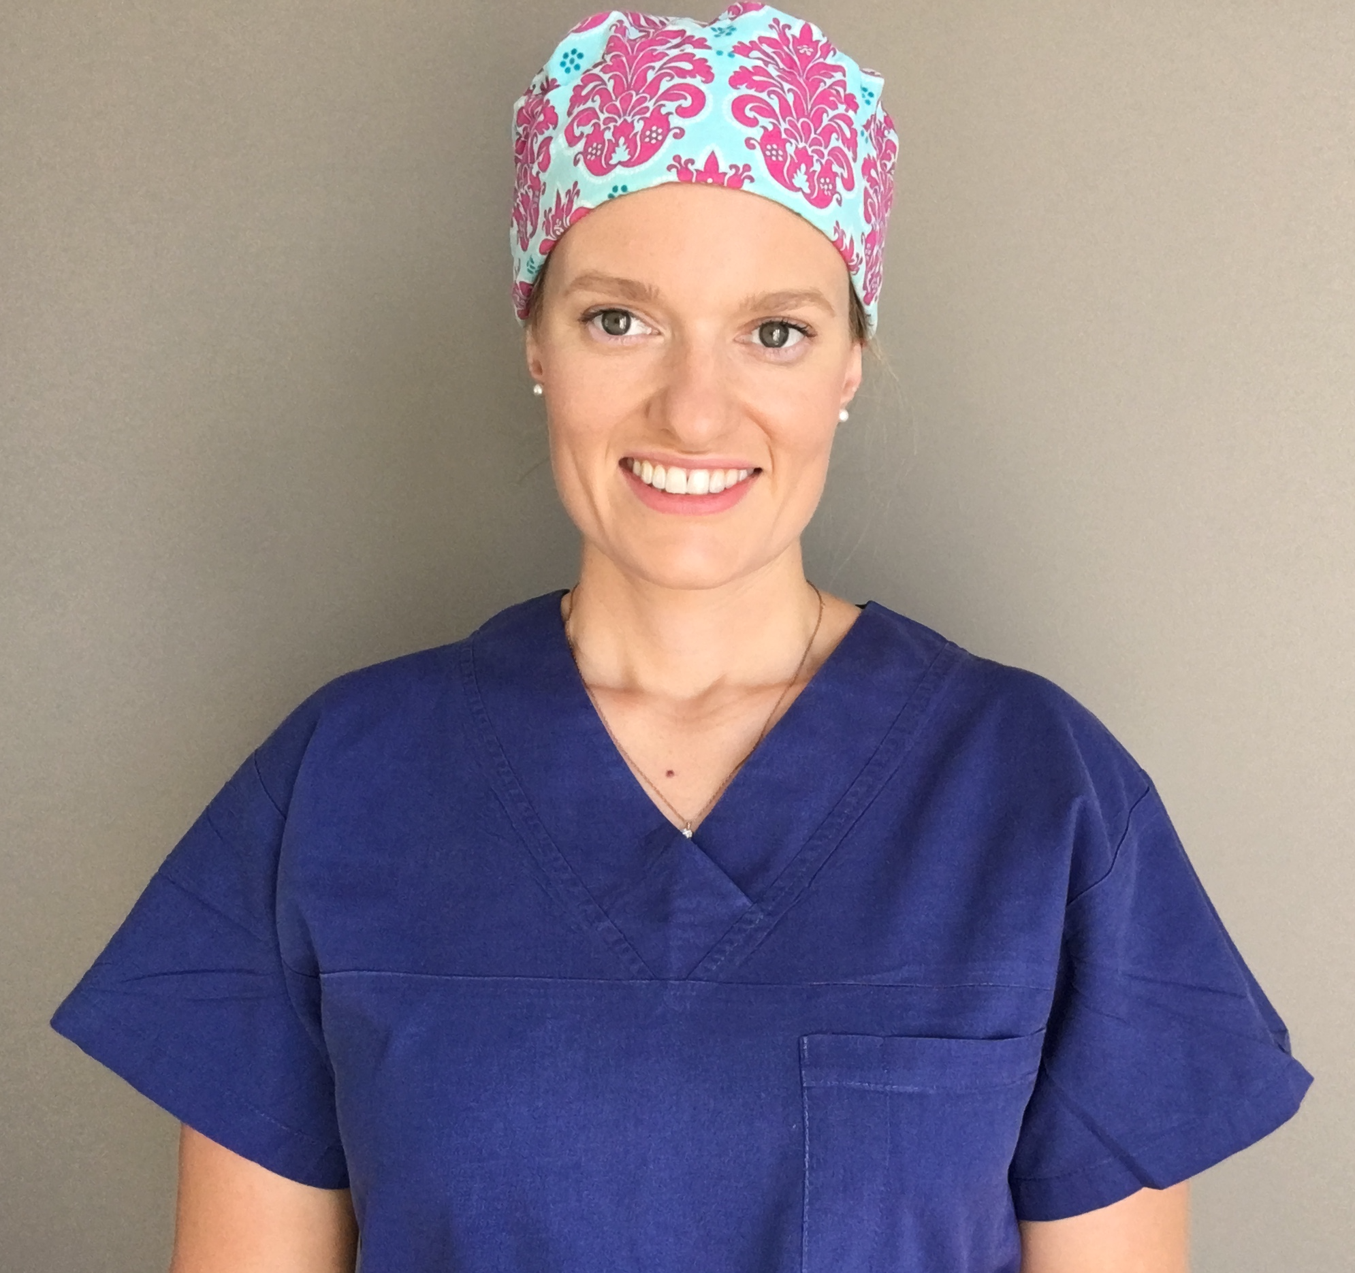

Title: Melioidosis of the Head and Neck
Name: Dr Laura O’Connor
ENT Registrar, Royal Darwin Hospital, Northern Territory, Australia

Melioidosis is an infectious disease of the tropics, caused by Burkholderia pseudomallei and is endemic to Southeast Asia and Northern Australia. The rarity of this disease and its variabilty in severity and mode of presentation, often leads to misdiagnosis. Despite its relative rarity, it is not an infrequent presentation to our Tertiary Institution in the Northern Territory of Australia. A retrospective review of a 10 year period at our hospital, identified sepsis in almost half of the presentations, with a mortality rate of 19%. B. pseudomallei is typically resistant to emperic sepsis antibiotic management and despite intensive, appropriate antibiotic treatment, mortality rate was 86% in those with sepsis, thus a delay in treatment is often fatal. 50% of patients present with pneumonia, however it can manifest in the genitourinary, skin, bone and neurologic systems. Presentation of the Head and Neck region, is exceedingly uncommon. We present this retrospective review of 20 patients who presented over a 22 year period (Jan 1994 – April 2016), with their primary manifestation of meiliodosis in the head and neck region.

Biography

Laura O’Connor is a registrar in ENT at Royal Darwin Hospital.

Presenting author details
Full name: Dr Laura O’Connor
Contact number: +614170055548
Twitter account: N/A
Linked In account: N/A
Session name/ number: Pathophysiology of ear, nose and throat disorders
Category: (Oral presentation)

