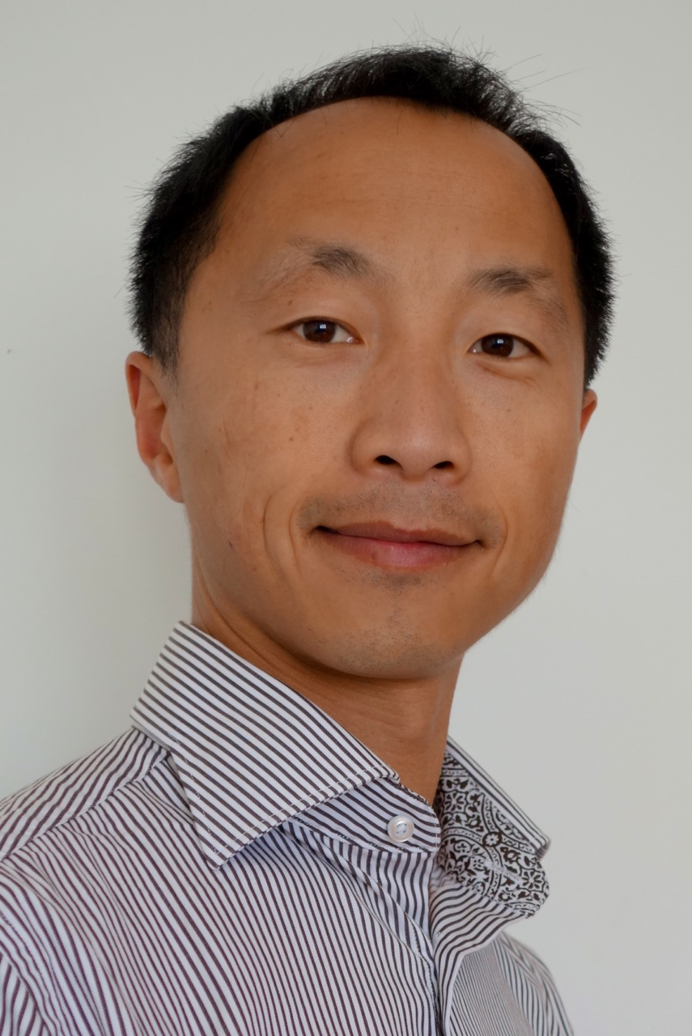  Photo: | University logo:  

Title: Nasal Breathing, Sleep-Related Breathing Disorders and Craniofacial Pain

Name: Louis Chan
TMJ & Sleep Therapy Centre of Sydney
Country: Australia

One of the reasons why so many people suffering from chronic diseases is due to our lifestyles and sleep problems. Sleep is vital for our brain function, emotional well-being as well as physical health. Children requires adequate airway to allow good sleep for growth and development, adults with sleep and airway disorders often suffers from chronic diseases such as cardiovascular disease, diabetes, strokes and Alzheimer disease.

My presentation going to focus on how airway and nasal problems impact on sleep, pain and facial growth.

Biography
Dr Louis Chan graduated in Dentistry in 1998, his interest in craniofacial start after his father start to have Trigeminal Neuralgia. Since graduation he hasn’t stop learning from leaders in orthodontics, sleep dentistry & craniofacial pain. He has been treating patients with a holistic approach for over 18 years, from tongue tie and lip tie release for new born babies, orthopaedic orthodontics for young children and teens as well as pain and sleep therapy for adults.

He is now studying for Master of Acupuncture and Chinese Medicine, and planning to integrate Chinese acupuncture with dental therapy for pain and sleep.

Presenting author details
Full name: Dr Louis Chan
Age: 46
E-mail ID: louis@mydentalcare.net.au
Contact number: 0416206216
Linked In account: http://linkedin.com/in/louis-chan-38493829
Facebook Account: https://www.facebook.com/louis.chan.5209
Session name/number:
Category: (Oral presentation):

Note: Mention all the abbreviation in the abstract.

