Short Term Management of Vocal Fold Paralysis
Dr Matthew S Broadhurst, MBBS, FRACS(ENT), Laryngology, Sleep Medicine

Abstract
Vocal cord paralysis is commonly encountered by ENT surgeons. The standard management usually involves waiting for 6-12 months to assess for recovery or reinnervation. During this time, the patient usually experiences poor quality voice, ineffective cough, and aspiration which may result in pneumonia. Management of these patients includes a search for the aetiology and often requires speech therapy. In addition to this, a reversible, office-based early injection laryngoplasty can minimize the patient morbidity of impaired vocal fold mobility while maximizing glottal function and improving phonatory quality.

Methods:
A retrospective study was conducted on consecutive patients with unilateral vocal cord paralysis. Voice handicap index, basic and aerodynamic/acoustic data were collected at the initial assessment and following intervention. Intervention consisted of an office-based, unsedated, paraglottic injection of hyaluronic acid to the effected side. All patients underwent videostroboscopy before, during and after office intervention and subjective assessment of these recordings was made. Patients also completed the voice related quality of life.

Results:
All 185 patients tolerated office-based injection well with no adverse events. All patients experienced an improvement in glottal competency and this was reflected in the aerodynamic and acoustic data. Analysis of videostroboscopy before and after showed a similar outcome, as did patient questionnaire data.

Discussion:
Office-based, unsedated paraglottic injection of hyaluronic acid is a safe and effective treatment option in the short term management of impaired vocal fold mobility. It improves glottal competency and vocal function while minimizing the risks associated with impaired vocal fold mobility. It allows rapid return to work/social functioning compared to the wait and see approach.

Image
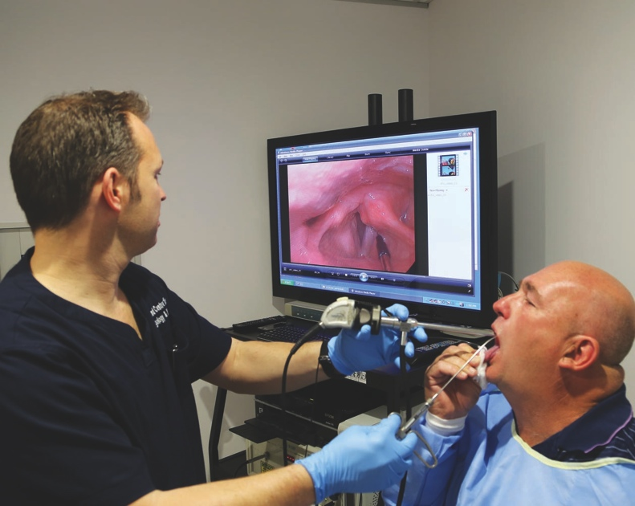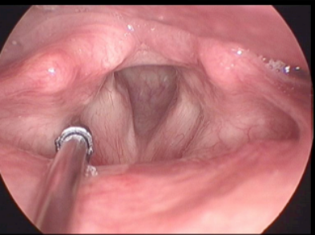
Recent Publications
Predictors for Permanent Medialization Laryngoplasty in Unilateral Vocal Fold Paralysis.
Mor N, Wu G, Aylward A, Christos PJ, Sulica L.
Otolaryngol Head Neck Surg. 2016 Sep;155(3):443-53.

Types and timing of therapy for vocal fold paresis/paralysis after thyroidectomy: a systematic review and meta-analysis.
Chen X, Wan P, Yu Y, Li M, Xu Y, Huang P, Huang Z.
J Voice. 2014 Nov;28(6):799-808.

Effect of injection augmentation on need for framework surgery in unilateral vocal fold paralysis.
Francis DO, Williamson K, Hovis K, Gelbard A, Merati AL, Penson DF, Netterville JL, Garrett CG.
Laryngoscope. 2016 Jan;126(1):128-34.

Change to earlier surgical interventions: contemporary management of unilateral vocal fold paralysis.
Costello D.
Curr Opin Otolaryngol Head Neck Surg. 2015 Jun;23(3):181-4.

Early hyaluronate injection improves quality of life but not neural recovery in unilateral vocal fold paralysis: an open-label randomized controlled study.
Pei YC, Fang TJ, Hsin LJ, Li HY, Wong AM.
Restor Neurol Neurosci. 2015;33(2):121-30.

Early versus late injection medialization for unilateral vocal cord paralysis.
Friedman AD, Burns JA, Heaton JT, Zeitels SM.
Laryngoscope. 2010 Oct;120(10):2042-6.

Biography
Dr Matthew Broadhurst is a fellowship trained laryngeal and upper airway surgeon specialising in laryngeal surgery, voice restoration and obstructive sleep apnoea. He returned to Brisbane, Australia from Boston, Massachusetts in 2007 having worked for 2 years at Harvard Medical School and Massachusetts General Hospital. He was the first fellowship trained laryngeal surgeon in Australia and now has a large tertiary referral practice in voice and larynx disorders and sleep apnoea. In his practice, he utilises state of the art techniques in surgery to the airway and is actively involved in clinical research and education both nationally and internationally. His areas of special interest and research include KTP laser for dysplasia and glottic cancer, short and long term management of vocal fold paralysis, phonotraumatic lesions in professional voice users and laryngeal papilloma.

Email: mattbroadhurst@mac.com
Website: entdoctor.com.au

