Anterior Neck Mass as a presentation of Laryngeal Solitary Fibrous Tumor
Author: Guinevere S. Pabayos, MD, Armando Chiong Jr., MD

Abstract: Solitary fibrous tumor is initially discovered as a pleural tumor, however, several reports have shown the presence of extrathoracic SFT. A 35-year old male was diagnosed as a case of Solitary fibrous tumor of the larynx which presented initially as slow-growing anterior neck mass progressing to presence of dyspnea. Initial biopsy revealed a spindle-cell mesenchymal proliferation and diagnosed by strong positive reactivity to CD34 immunostaining, and weakly positive to S-100.

Objectives:
To document, report, and explore the origin-causality, diagnostics, and eventual management of a patient with rare case of solitary fibrous tumor of the larynx and anterior neck.

Study Design: Case Report
Setting: Tertiary Hospital
Patient: one patient
Results: A 35-year old male was diagnosed as a case of Solitary fibrous tumor, presenting as anterior neck mass, and sought consult due to difficulty of breathing. Rigid endoscopy revealed a mass lesion at the right supraglottic area, with bulge at the glottis and supraglottic area. Solitary fibrous tumor is a rare neoplasm with mesenchymal origin, usually located in the pleura. Head and neck SFT’s comprise 6% of all SFT’s. There were no reported case/cases of laryngeal SFT with extension to the anterior neck or an anterior neck SFT with invasion into the laryngeal inlet.

Conclusion: Solitary fibrous tumor (SFT) of the head and neck especially in the larynx is very uncommon. There are no reported cases as of yet of laryngeal SFT with extension to the anterior neck, or an anterior neck SFT invading the laryngeal inlet, hence this is considered as the first case reported. It cannot be diagnosed merely by clinical presentation, radiologic imaging, and histopathologic picture, since it mimics other soft tissue lesions. The diagnosis of the lesion largely depends on the histopathologic and CD34-reactive immuhistochemical staining combined. The implicated cause is the fusion of the NAB2-STAT6 gene causing proliferation of stroma of SFT. Hence additional stain such as the STAT6 may be useful for an inconclusive immunoreactivity result. Conservative management may be proposed, but largely depends on the size and extent of the tumor. Wide resection of the lesion is significant and prudent since there is a high recurrence rate of both the benign and malignant types of solitary fibrous tumor.

Key words: Solitary Fibrous Tumor; anterior neck mass, laryngeal mass, benign tumor of the neck

Introduction:
Solitary fibrous tumor (SFT) is a rare mesenchymal neoplasm. Its usual location, as reported by Klemperer and Rabin in 1931, is in the pleura. In the head and neck, there are reported cases of benign neoplasm in the orbit, scalp, sinonasal, oral cavity, and some reported cases of laryngeal and thyroid SFT. SFT’s can be appreciated pathologically as bland spindle-shaped cells with nondescript growth pattern. However, definitive pathological diagnosis cannot be gained by histology alone and immunohistochemical staining is required to differentiate it from other tumor of mesenchymal origin. SFT’s are mainly immunoreactively positive for CD34. Furthermore, there is a more specific marker for SFT, which can be used for inconclusively CD34 positive mesenchymal tumor.

The Case
A 35-year old, male, Filipino, Muslim, from Cotabato City sought consult at our institution due to difficulty of breathing. Patient presented with a six-year history of progressively enlarging anterior neck mass, with three-month history of intermittent dyspnea, foreign body sensation, progressive dysphagia and hoarseness. Physical examination revealed a 5x6cm, smooth, well-defined mass, firm, nontender, and moves with deglutition on the anterior neck. Rigid endoscopy revealed a mass lesion on the right supraglottic area, bulge on the right glottic and subglottic area, with less than 10% airway opening, both arytenoids visibly mobile, however, with impaired glottic closure. Tracheostomy was mandatory to secure the airway. A subsequent suspension laryngoscopy with biopsy was done, however, the result was inconclusive, revealing fragment of fibromuscular tissue. A fine needle aspiration cytology (FNAC) of the anterior neck mass was simultaneously done intraoperatively, which revealed blood and colloid. The neck computed tomography scan with contrast studies done showed a well-marginated, hypodense, thick-walled, heterogeneously enhancing mass seen on the right laryngeal fossa measuring 2.86x1.78cm with a larger extension anteriorly measuring 4.66x2.52cm. There was noted effacement of the epiglottis and aryepiglottic fold. The hyoid and thyroid cartilage were intact, as well as normal thyroid gland without any masses seen.
Due to vagueness of histopathological and cytological result of the mass, an incision biopsy on the anterior neck mass was then subsequently performed. Histopathological result of the incision biopsy retrieved from the anterior neck revealed spindle cell mesenchymal proliferation. Immunohistochemistry studies of CD34, S-100 and smooth muscle actin (SMA) was then recommended. The final immunohistochemistry revealed positive CD34, with weakly positive S-100 and negative SMA, favoring a Solitary Fibrous Tumor.

Discussion:
Solitary Fibrous tumor is a rare spindle-cell neoplasm, first described and reported by Klemperer and Rabin in 1931, and called it “localized fibrous mesothelioma”. It was first mentioned and regarded solely as a pleural tumor. The general incidence of SFT favors female over male predominance, and all age groups are equally affected.
Extrathroracic SFT’s, are also documented, and are extremely uncommon. According to Girardi, et. Al (2014), only 6% of SFT develop in the head and neck, and the oral cavity was reported to be the most commonly affected area. SFT’s of the upper respiratory tract comprise of about <0.1% of all SFT’s. It can be seen in the paranasal sinuses, nasopharynx, and nasal cavity. Anterior neck SFT are also extremely uncommon, with only 1 known reported case, and 2 associated with perithyroidal SFT.
Laryngeal SFT’s was noted to have a male over female predominance. The subsites commonly affected are the epiglottis, ventricular fold, aryepiglottic fold, vocal fold, or the commissure. Common clinical presentation of SFT originating in this area is the foreign body sensation, “hot potato” voice as in supraglottic masses and dysphagia. There could also be hoarseness once the glottis is affected, and in late stages, there is difficulty of breathing due to obstruction. Separate entities of the thyroidal, perithyroidal, or larynx was previously reported. However, there were no noted case of laryngeal SFT with extension to the anterior neck or an anterior neck SFT invading the laryngeal inlet. Our patient presented with a progressively enlarging neck mass and presented with difficulty of breathing. There was noted mass on the laryngeal area causing obstruction.
SFT can be seen as a painless mass that is slow-growing, ranging from months to years. It is difficult to diagnose clinically, and other soft tissue tumors should be included as differential diagnsosis, which would include sarcoma, benign fibrous histiocytoma, schwannoma, neurofibroma and fibroma.
A computed tomography scan of a dense, well-defined enhancing lesion, indicating expansile growth pattern, no bony erosion or lytic changes, are common description of benign tumors of the head and neck, and should include SFT as differential. However, other soft tissue tumors should not be ruled out. SFT’s are generally benign lesions with indolent course. It is an expansile lesion that leads to remodeling of adjacent bony structures. However, the features of a benign SFT on a bone window can be misleading and may disregard any consideration of malignancy. A malignant SFT can appear to have benign features in CT scan, such as remodeling, and only a small foci of bone destruction or lytic changes may be overlooked. In our patient, the scan showed a heterogeneously, well-defined enhancing lesion, with effacement of the arytenoids and epiglottis, and favors the features of a benign soft tissue tumor. However, there should be note of the extension of the lesion to adjacent structure of the anterior neck, and importantly, the thyroid and muscles were not invaded. Additionally, there are no noted lytic changes of the thyroid cartilage were revealed in our case. A benign lesion is highly regarded at this point, however, a malignant lesion should still not be overlooked. It is also proposed that the continuous expansion of the lesion caused the cricothyroid cartilage to efface and allow the access of the mass into the right laryngeal mucosa, thus causing expansion of the mass into the inlet, and subsequently, obstruction of the airway.
A Magnetic Resonance Imaging can also be requested for an inconclusive CT scan finding. This will show a densely well-circumscribed mass with expansile character and low to moderate enhancement on both T1 and T2-weighted imaging. However, variable contrast enhancement in imaging a lesion in an identified SFT should include malignant potentiality of the tumor.
Gross pathological description of usual SFT is a whitish to grayish, smooth, well-defined lesion. According to Geramizadeh, et. Al, (2016), histological description shows wide variability of cellularity, composed of bland, round to spindle-shaped cells with scanty cytoplasm. It is more often associated with stromal hyalinization. The cells are arranged in a haphazard manner, or often in a “patternless pattern”, or otherwise, no specific cellular pattern. In WHO Pathology and Genetics, Head and Neck tumors (2003), the histologic description of SFT favors bland, spindle-shaped cells, with variable cellular proliferation, nondescript growth pattern, and no cytologic atypia. It has collagen bundles with interlaced thin-walled vascular spaces. Other important feature of SFT is that its vascularity can form a hemangiopericytoma-like pattern hence, previously, SFT was considered as a component of hemangiopericytoma. Malignant SFT’s were also reported, and differentiated histologically with malignant differentiation, such as hypercellularity, cytologic atypia, increased nuclear to cytoplasmic ratio, mitotically active cells of more than 4 mitosis per 10 HPF. There can also be note of tumor necrosis or infiltrative margins in cut sections.
However, the histologic description of benign SFT could also be used to describe other soft tissue tumors, hence, there is no definitive histopathologic picture to an SFT that may clearly differentiate it from other benign mesenchymal tumors. Immunohistochemistry reactivity stain is essential to identify SFT from other benign mesenchymal tumor. SFT’s are discovered to contain the CD34 transmembrane glycoprotein found on the surface of hematopeietic progenitor cells, or otherwise as an antibody which produces consistently positive reactivity and is a sensitive marker to SFT’s.
CD34 is previously discovered as a hematopoietic stem cell and progenitor cell marker (Sidney, et.al 2014). However, it was also then established as a marker for other mesenchymal stromal cells and epithelial tumors, hence is a non-specific marker for SFT. Conversely though, 95% of SFT’s is consistent and stain strongly for CD34 (LA Doyle et.al, 2014). There are other reported cases of diagnosed SFT to also have positive reactivity to bcl-2 markers, and commonly lacks reactivity for desmin, cytokeratin, and generally negative for actin/smooth muscle actin (SMA). This could help in the histological differentiation of other soft tissue tumors such as benign fibrous histiocytoma, fibroma, and neurogenic tumors.
In our case, the tumor had a strong reactivity to CD34, hence favored a diagnosis of SFT. However, there is also noted weak reactivity to SMA. A positive reactivity to CD34 could be a misleading diagnosis since some other soft tissue tumor may be positive to both CD34 and SMA. However, an intensely positive CD34 immunostaining demonstrations a strong focus into the diagnosis of SFT, since around 85-100% of SFT is reactive to CD34 (Geramizadeh, et.al, 2016). In recent studies, CD34 immunostaining could have weakly positive reactivity to other soft tissue tumors such as leiomyosarcoma and schwannoma. However, in this lesions, a strong reactivity to SMA should be noted and is used to differentiate the lesions.
To further implicate the diagnosis of SFT, the exploration of other immuhistochemistry reactivity staining was contemplated. In a study by Geramizadeh, et.al (2016), they have related the consistently positive immunoreactivity of SFT cells to STAT6 immunohistochemistry stains, and is therefore helpful to use as a marker for inconclusive SFT.
The etiology of SFT is still unknown. But according to Robinson, et.al (2012), there is evidence of recurrent NAB2-STAT6 gene fusions integrative sequence due to translocations of the STAT6 gene to NAB2 in SFT’s. Expression of this fusion, causes the activation of EGR1 gene, which is a repressor of transcription pathways, thus activating the mitogenic pathways of neoplasia. Thusly, detection of NAB2-STAT6 fusions in tumors is strongly associated in the proliferation of SFT’s, and is an important marker to be considered for an inconclusive immunohistochemical staining result.
About eighty-seven percent of SFT’s are benign, and conservative treatment can be considered. A study conducted by Alobid, et.al (2003), noted the use of conservative surgical procedure for laryngeal SFT by use of CO2 laser excision could be a treatment option. Significantly, there was no complications or recurrence noted. However, it is important to consider that this type of surgical excision will largely depend on the size of the lesion. Furthermore, since studies have implicated that both benign and malignant SFT have a relatively high local recurrence of about 21% to 47%, surgical treatment that should be considered includes radical resection or wide resection with clear margins. A patient diagnosed with SFT of the larynx may be subjected to laryngectomy, Total and Partial, which will depend mostly on the affected subsites of the larynx. A clear margin is advised to prevent the recurrence. For a malignant SFT who underwent complete resection with clear margins, the 10-year survival rate reported is around 54% to 89%. The use of adjuvant chemotherapy is not recommended since most patient will not be responsive. Conversely, radiotherapy can be used for locally recurring or for local control, as well as an option for unresectable tumor, however, it could not affect overall survival rate.
In our case, the incision biopsy result of the lesion was considered to be benign, however, there are minute evidence of possible malignancy by imaging studies due to the effacement and invasion of the mass into another compartment. Hence, a wide excision of the tumor is considered. Total laryngectomy was highly considered since the mass has already encompassed the laryngeal inlet, causing obstruction. Also, frequent follow-up is necessary to note possible recurrence of the lesion to other adjacent subsites. The use of radiotherapy could be also be considered if the final histopathologic result would yield malignant potentiality of the lesion.

Acknowledgements:
Dr. Francisco A. Victoria, Chairman of the Department of ENT-Head and Neck Surgery of Ospital ng Maynila Medical Center; The Consultant and Resident Staff, especially the Research Committee, of the Department of ENT-Head and Neck Surgery, Ospital ng Maynila Medical Center; the Pathology Department, Ospital ng Maynila Medical Center

References:
- Alobid I, Alos L., et. Al; (2004) Laryngeal Solitary Fibrous Tumor treated with CO₂ laser excision: case report. Ear Arch Otorhinolaryngology. 262: 286-288.
DOI 10.1007/s00405-004-0805-1
- DeVito N, Henderson E, Han G, Reed D, Bui MM, Lavey R, et al. (2015) Clinical Characteristics and Outcomes for Solitary Fibrous Tumor (SFT): A Single Center Experience. PLoS ONE 10(10): e0140362. doi:10.1371/journal.pone.0140362
- Cohe J. and Clayman G. (2011) Atlas of Head and Neck. Saunder. Chapter 37.
- Fletcher C. and Path F. (2002) Distinctive Soft Tissue Tumors of the Head and Neck. Modern Pathology 2002; 15(3):324-330
- Kunzel J, Hainz M, Ziebart T, et.al. (2016). Head and Neck solitary fibrous tumors: a rare and challenging entity. European Archives of Oto-Rhino-Laryngology. 273: 1589-1598. DOI: 10.1007/s00405-015-3670-1
- Ganly I, Patel S, et. Al; (2006) Solitary Fibrous Tumor of the Head and Neck: A Clinicopathologic and Radiologic Review; Archives of Otolaryngology Head Neck Surg. 2006;132(5):517-525. doi:10.1001/archotol.132.5.517
- Geramizadeh B, Marzban M, Churg A. Role of Immunohistochemistry in the Diagnosis of Solitary Fibrous Tumor, a Review. Iran J Pathol. 2016; 11(3):195-293
- Girardi F, Marinez B, Girardi M. (2014). Solitary Fibrous Tumor of the Larynx: report of two new cases. Jornal Brasileiro de Patologia e Medicina Laboratorial. 50:3 http://dx.doi.org/10.5935/1676-2444.20140020
- Langman G. (2011). Solitary Fibrous tumor: A pathological and clinical dilemma. Journal of Thoracic Disease. 2011 Jun; 3(2): 86-87. doi: 10.3978/j.issn.2072-1439.2011.03.04
- Robinson DR, Wu YM, et. Al. (2012) Identification of recurrent NAB2-STAT6 gene fusions in solitary fibrous tumor. Nature Genetics. 45, 180-185 (2013) doi:10.1038/ng.2509
- Sidney L, Branch M, Dunphy S, Dua H, Hopkinson A. (2014). Concise Review: Evidence for CD34 as a common marker for diverse progenitors. Stem Cells. 2014 Jun; 32(6): 1380–1389. doi: 10.1002/stem.1661
- Topaloglu O, Ucan, Bekir, Demirci, Taner., et.al. (2013). Solitary Fibrous Tumor of Neck Mimicking Cold Thyroid Nodule in 99m Tc Thyroid Scintigraphy. Case Reports in Endocrinology. 2013. http://dx.doi.org/10.1155/2013/805745

Figures:
Figure 1. PATIENT PROFILE: S/P Tracheostomy
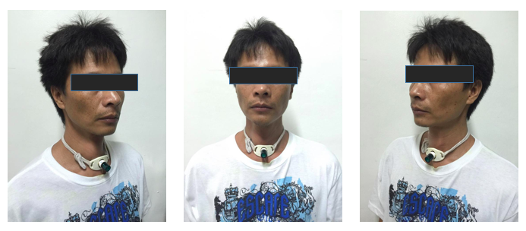

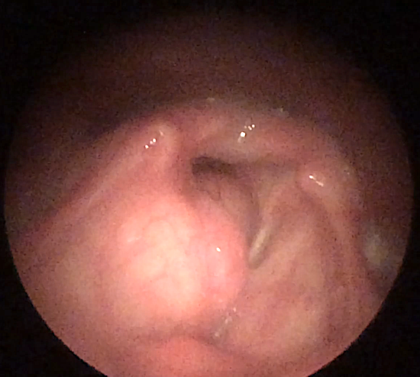
Figure 2: ENDOSCOPIC FINDINGS
Figure 2a (right). Rigid Endoscopy upon first consult, revealed a well-defined mass on the right supraglottis, with bulge on the glottis and subglottic area causing airway obstruction, with noted less than 10% of airway opening.
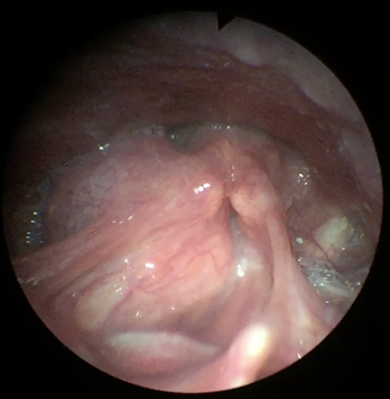

Figure 2b (left). Impaired glottic closure, with bilaterally mobile arytenoids.

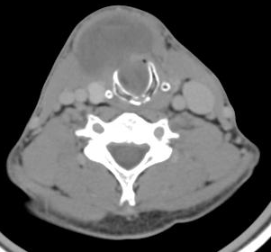
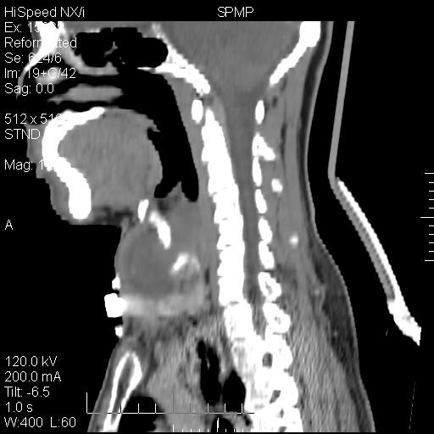
Figure 3: RADIOGRAPHIC FINDINGS

Figure 3a (left): Axial view. Figure 3b (right): Sagittal view
Neck Computed tomography scan with contrast studies: Reveals a well-marginated, hypodense, thick-walled heterogeneously enhancing mass seen in the right laryngeal fossa measuring about 2.86x1.78cm with large extension anteriorly measuring 4.66 x 2.52cm. There is resulting narrowing of the laryngeal airway about 70% and to a lesser extent the retropharyngeal space. The epiglottis and aryepiglottic fold are effaced. Intact hyroid and thyroid cartilage.

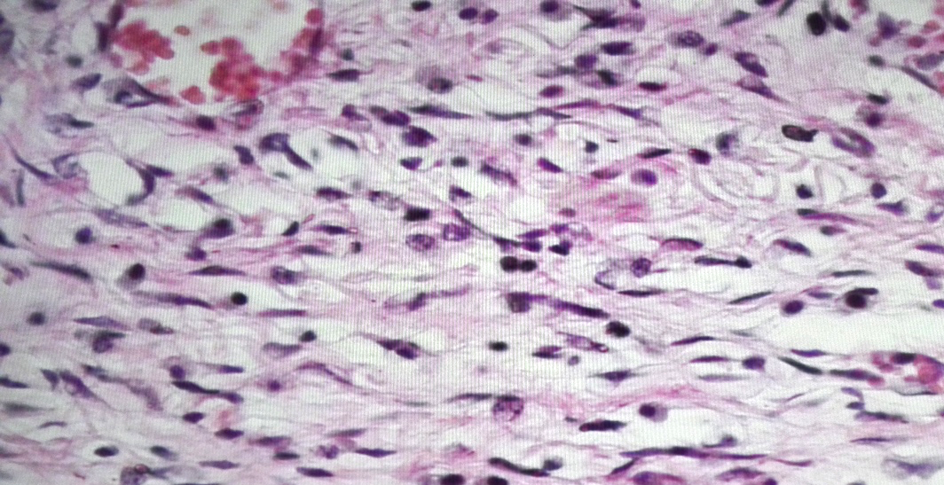
Figure 4: HISTOPATHOLOGIC. Incision biopsy of the anterior neck mass revealed a spindle-cells arranged in a haphazard pattern.

