Application of a lightweight Encryption Algorithm to a quantized speech image for Secure IoT
Mourad Talbi¹, Faouzi Maddouri², Ben Fatima Sira, Mohamed Salim Bouhlel³
¹Center of Researches and Technologies of Energy of Borj Cedria, Tunis, Tunis
²College of Business Administration-Prince Sattam bin Abdulaziz University
³Sciences Electroniques, Technologie de l'Information et Télécommunications
(SETIT)
¹mouradtalbi196@yahoo.fr, ²F.Maddouri@psau.edu.sa, ³mbouhlel@gmail.com
Abstract—The IoT Internet of Things being a promising technology of the future. It is expected to connect billions of devices. The increased communication number is expected to generate data mountain and the data security can be a threat. The devices in the architecture are fundamentally smaller in size and low powered. In general, classical encryption algorithms are computationally expensive and this due to their complexity and needs numerous rounds for encrypting, basically wasting the constrained energy of the gadgets. Less complex algorithm, though, may compromise the desired integrity. In this paper we apply a lightweight encryption algorithm named as Secure IoT (SIT) to a quantized speech image for Secure IoT. It is a 64-bit block cipher and requires 64-bit key to encrypt the data. This quantized speech image is constructed by first quantizing a speech signal and then splitting the quantized signal into frames. Then each of these frames is transposed for obtaining the different columns of this quantized speech image. Simulations result shows the algorithm provides substantial security in just five encryption rounds.
Keywords—IoT, Security, Encryption, quantized speech image, SNR, PESQ, Histogram, Entropy, Correlation.

- The proposed Algorithm
In this paper we propose to apply a lightweight Encryption Algorithm to a quantized speech image for Secure Internet of Things. This application is justified by the following arguments:

- We need to send confidential data between many devices with high level security,

- A lightweight Encryption Algorithm can be implemented in simple devices which don’t require powerful processors,

The construction of a quantized speech image is illustrated in Figure 1. According to this figure, the different steps of this construction are given as follow:

- Quantization of the input speech signal,
- Splitting the obtained quantized speech signal into frames where each of them is of length $N$. These frames are in number of $N$ and are noted as follow: $F_{i}, 1≤i≤N$,
- Transpose each of these frames $F_{i}, 1≤i≤N$ in order to obtain the different columns $V_{i}, 1≤i≤N$ of this quantized speech image, $V=\left[V_{1}V_{2}{…V}_{N-1}V_{N}\right]$,

In figure 2 is illustrated the block diagram of the proposed encryption/decryption technique applied to the quantized speech image for Secure Internet of Things.
As shown in Figure 2, a lightweight encryption algorithm proposed in [5], is applied to the quantized speech image in order to obtain the encrypted image. After that, the lightweight decryption algorithm [5] is applied to the encrypted image in order to have the decrypted image. Then, the reconstruction of the quantized speech signal is performed and finally the de-quantization is applied to this signal in order to obtain the output speech signal which represents the confidential data.
- Experimental Setup

To test the security strength of the proposed technique, it is evaluated on the basis of the following criterion:
- effect of cipher on the entropy
- Key sensitivity
- Histogram and correlation of the image.

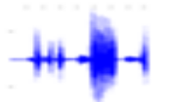
Input
Speech Signal

Quantization

Splitting the obtained Quantized speech signal into frames

Frame number
N-1 (of length N): $F_{N-1}$
Frame number N (of length N): $F_{N}$
1st Frame of length N: $F_{1}$
2nd Frame of length N: $F_{2}$

Transpose each frame, $F_{i}, 1≤i≤N$

Transposed Frame number N: $V_{N}$

Transposed Frame number N-1: $V_{N-1}$
2nd transposed Frame: $V_{2}$
1st transposed Frame: $V_{1}$

Quantized Speech Image :
$$V=\left[V_{1}V_{2}{…V}_{N-1}V_{N}\right]$$

Figure 1. The block diagram of the construction of a quantized speech image.

Input
Speech Signal
Splitting the obtained Quantized speech signal
Into frames

Quantized Speech Image
Quantization

Lightweight Encryption
Algorithm [5]

Output
Speech Signal

Encrypted Image

Lightweight Decryption
Algorithm [5]
Reconstruction
of the quantized speech signal
Decrypted Image
De-quantization

Figure 2. the block diagram of the proposed encryption technique applied to the quantized speech image for Secure Internet of Things.

- Results and Discussion
According to [5] the algorithm simulation is made in order to perform the standard tests including Avalanche and image entropy and histogram on Intel Core i7-3770@3.40 GHz processor employing MATLAB®. For evaluating the performance in the real IoT environment, Muhammad Usman et al. Implemented the algorithm on ATmega 328 based Arduino Uno board as well. The memory utilization and execution time of their proposed algorithm [5] was observed. In [5], the execution time was found to be respectively 0.188 millisconds for encryption and 0.187 milliseconds for decryption, the algorithm proposed in [5] employs the 22 bytes of memory on ATmega 328 platform. As previously mentioned, in this work, we use the same encryption/decryption algorithms proposed in [5]. The encryption algorithm proposed in [5] was compared with other algorithms implemented on hardware as shown in table 1 [5].

Table 1. Results for Hardware implementations [5].
CIPHER | DEVICE | Block Size | Key Size | Code Size | RAM | Cycles  (ene) | Cycles  (dec)
AES | AVR | 64 | 128 | 1570 | - | 2739 | 3579
HIGHT | AVR | 64 | 128 | 5672 | - | 2964 | 2964
IDEA | AVR | 64 | 80 | 596 | - | 2700 | 15393
KATAN | AVR | 64 | 80 | 338 | 18 | 72063 | 88525
KLEIN | AVR | 64 | 80 | 1268 | 18 | 6095 | 7658
PRESENT | AVR | 64 | 128 | 1000 | 18 | 11342 | 13599
TEA | AVR | 64 | 128 | 648 | 24 | 7408 | 7539
PRINCE | AVR | 64 | 128 | 1574 | 24 | 3253 | 3293
SKIPJACK | Power TOSSIM | 64 | 80 | 5230 | 328 | 17390 | -
RC5 | Power TOSSIM | 64 | 128 | 3288 | 72 | 70700 | -
SIT | ATmega328 | 64 | 64 | 826 | 22 | 3006 | 2984

Key and Block sizes are in bits whereas RAM and code size are in bytes. The cycles include key expansions along with both encryption and decryption [5].

The Avalanche test of the algorithm shows that a single bit change in key or plain text brings around $49\%$ change in the cipher bits, which is close to the ideal $50\%$ change. The results in [5] show that the precise decryption is possible merely when the correct key is employed for decrypting the encrypted image. When the incorrect key is employed, the image remains non recognizable. For a visual demonstration of Avalanche test, compared to the original key, the wrong key has a difference of just a bit, the algorithm strength can be perceived from this result.

To perform histogram and entropy tests, in this work we have used a speech signal ‘‘original1.wav’’ represented in Figure 4. From results in Table 2, it can be remarked that the entropy of the encrypted image is greater than the original image. The correlation comparison in Figure 9 illustrates the contrast between the encrypted and the original data. The original data which is in our work the quantized speech image. This image is highly correlated and detaining a high value for the correlation coefficient. However, the encrypted image does not seem to have any correlation.

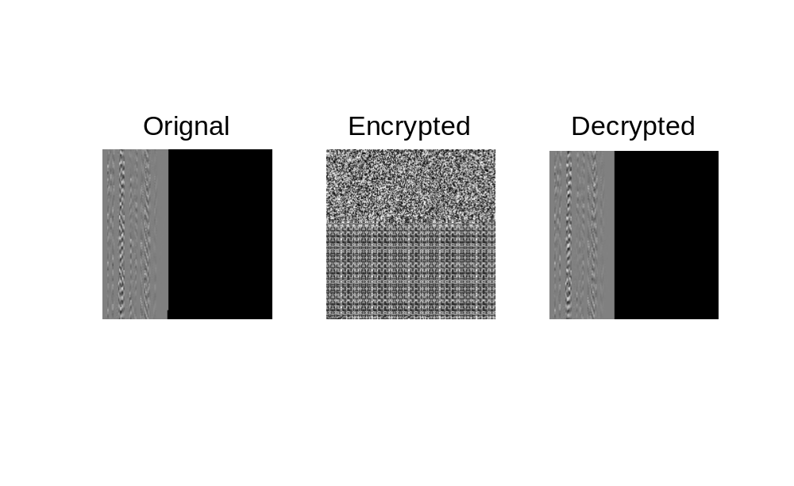
Figure 3. Image Encrypted/Decrypted

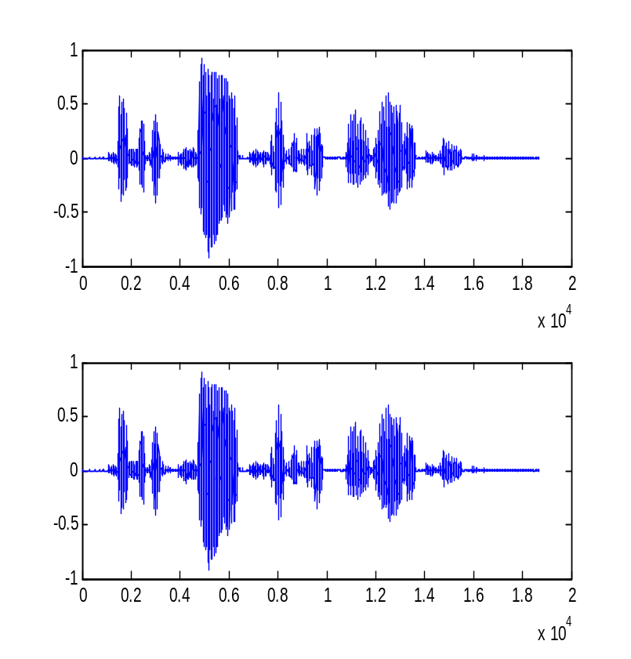
Figure 4. Original Speech Signal.

Figure 5. Reconstructed Speech Signal after Decrypted and Dequantization.

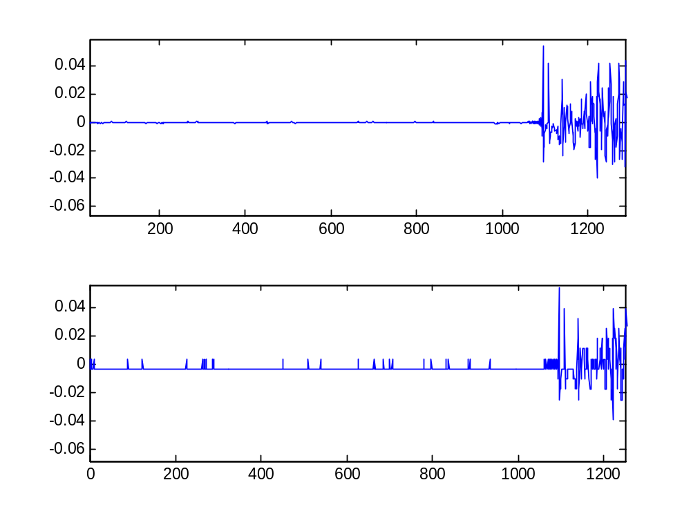
(a)
(b)

Figure 6. (a) The beguining of the original speech signal (Zoomed ), (b) the same region of the reconstructed speech signal after Decrypted and Dequantization (Zoomed).
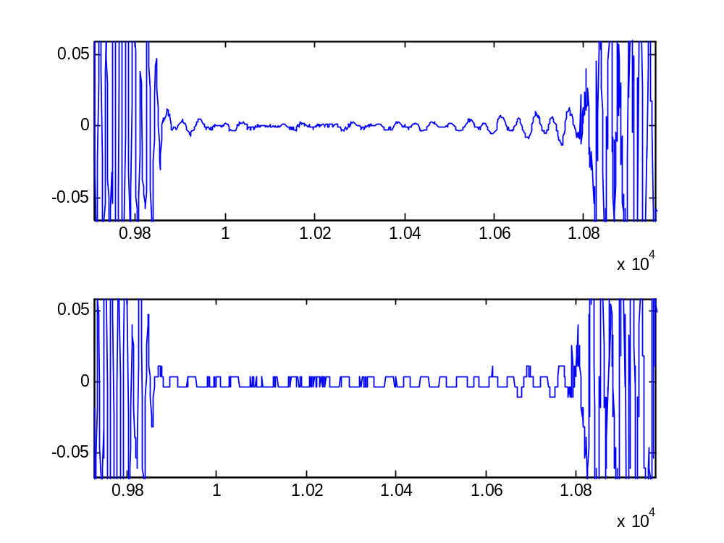

(b)
Figure 7. The middle of the original speech signal (Zoomed), (b) the same region of the reconstructed speech signal after Decrypted and Dequantization (Zoomed).

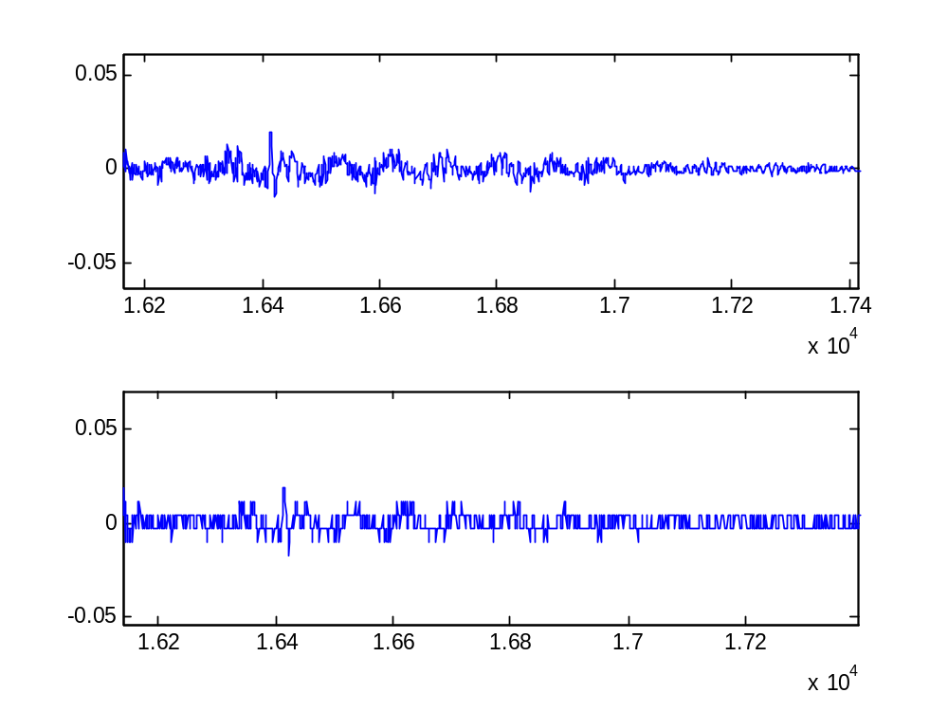
(a)
(b)
Figure 8. The end of the original speech signal (Zoomed), (b) the same region of the reconstructed speech signal after Decrypted and Dequantization (Zoomed).

Figures 6 to 8 show clearly the difference between the original speech signal and the reconstructed speech one obtained after decryption and dequantization. This difference is due to quantization/dequantization.

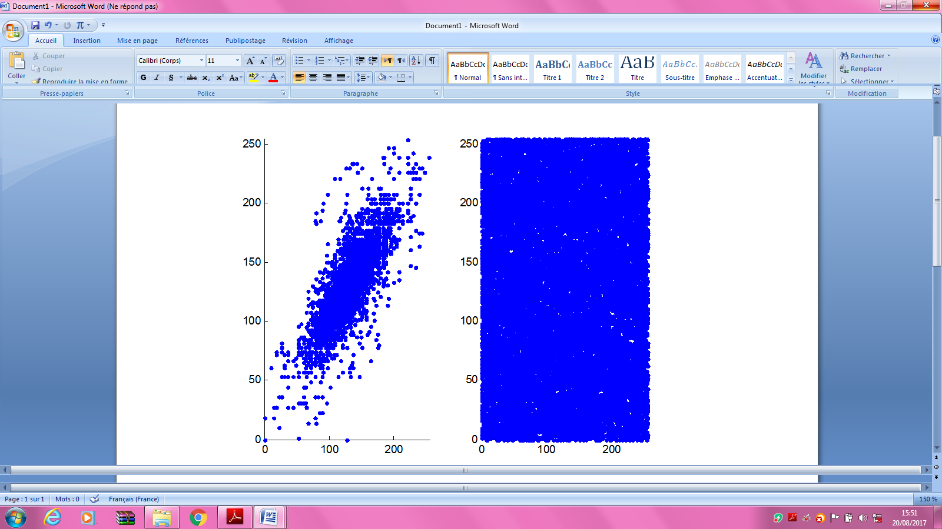
Encrypted quantized speech image
Original quantized speech image

Figure 9. Correlation comparison.

Table 2. Results for Correlation and Entropy.

Speech Signal | Size of the Quantized Speech Image | Correlation |  | Entropy |  | SNR (dB) | PESQ
Speech Signal | Size of the Quantized Speech Image | Original Quantized Speech Image | Encrypted  Quantized Speech Image | Original Quantized Speech Image | Encrypted  Quantized Speech Image | SNR of the Reconstructed Speech signal | PESQ of the Reconst-ructed Speech signal
‘original1.wav’ | $$220×220$$ | 0.9952 | 0.0255 | 2.7560 | 6.4783 | 33.9532 | 3.9794
Total encryption time (in Second)
27.753251

According to the results obtained from SNR and PESQ computations (Table 2), the reconstructed speech signal is with very good perceptual quality.

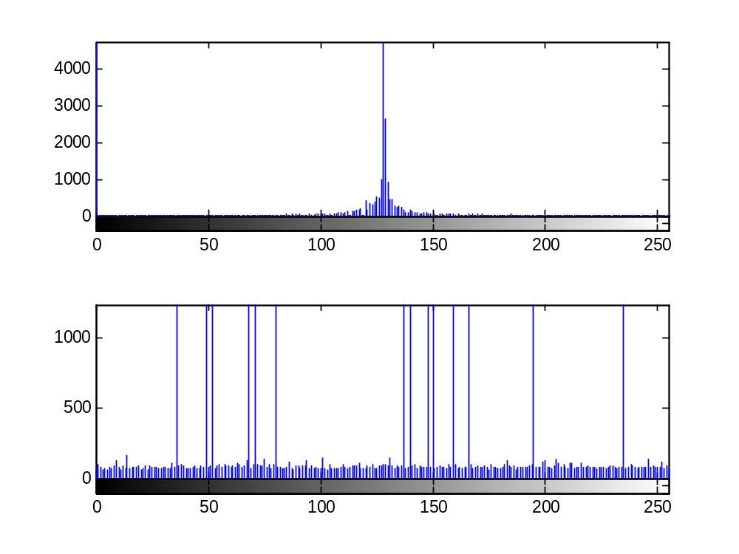
(a)
(b)
Figure 10. (a) Histogram of the original Speech quantized Image,
(b) Histogram of the Encrypted Speech quantized Image

In the results of histogram in Figure 10 for the original and encrypted image, the almost uniform distribution of intensities after the encryption is an indication of desired security.

- Conclusion
In the near future Internet of Things will be an important element of our daily lives. Many energy constrained devices and sensors will continuously be communicating with each other and the security of which must not be compromised. For this reasonn a lightweight security algorithm is to a quantized speech image for Secure IoT. This quantized speech image is constructed by first quantizing a speech signal and then splitting the quantized signal into frames. Then each of these frames is transposed for obtaining the different columns of this quantized speech image. The simulations show promising results making the algorithm a suitable candidate to be adopted in IoT applications.
References
[1] J. Gubbi, R. Buyya, S. Marusic, and M. Palaniswami, “Internet of things (iot): A vision, architectural elements, and future directions,” Future Generation Computer Systems, vol. 29, no. 7, pp. 1645–1660, 2013.
[2] R. Want and S. Dustdar, “Activating the internet of things [guest editors’introduction],” Computer, vol. 48, no. 9, pp. 16–20, 2015.
[3] J. Romero-Mariona, R. Hallman, M. Kline, J. San Miguel, M. Major, and L. Kerr, “Security in the industrial internet of things,” 2016.
[4] H. Suo, J. Wan, C. Zou, and J. Liu, “Security in the internet of things: a review,” in Computer Science and Electronics Engineering (ICCSEE), 2012 International Conference on, vol. 3. IEEE, 2012, pp. 648–651.
[5] Muhammad Usman, Irfan Ahmedy, M. Imran Aslamy, Shujaat Khan and Usman Ali Shahy, ‘‘SIT: A Lightweight Encryption Algorithm for Secure Internet of Things,’’ International Journal of Advanced Computer Science and Applications, Vol. 8, No. 1, 2017.
[6] D. Airehrour, J. Gutierrez, and S. K. Ray, “Secure routing for internet of things: A survey,” Journal of Network and Computer Applications, vol. 66, pp. 198–213, 2016.
[7] D. Miorandi, S. Sicari, F. De Pellegrini, and I. Chlamtac, “Internet of things: Vision, applications and research challenges,” Ad Hoc Networks, vol. 10, no. 7, pp. 1497–1516, 2012.
[8] L. Da Xu, “Enterprise systems: state-of-the-art and future trends,” IEEE Transactions on Industrial Informatics, vol. 7, no. 4, pp. 630–640, 2011.
[9] P. Zhao, T. Peffer, R. Narayanamurthy, G. Fierro, P. Raftery, S. Kaam, and J. Kim, “Getting into the zone: how the internet of things can improve energy efficiency and demand response in a commercial building,” 2016.

