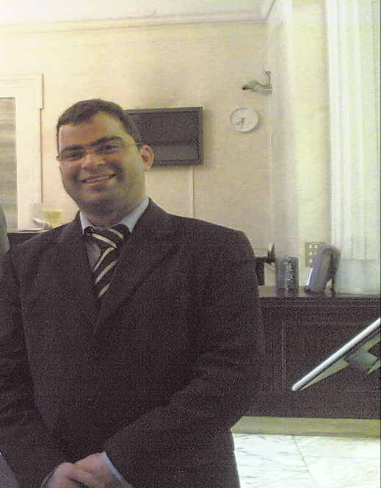

Title of Abstract Airway Foreign Body Removal , in Childhood, with a Rigid Bronchoscope
Name: Fadi Bitar
IDLIB -SYRIA

Abstract: (250 words minimum)
Suffocation, due to a foreign body in the airway, is the most
common cause of accidental death in toddlers and children under
5 years of age.
My study started in November 1996 and was conducted both at Aleppo University Hospital and during my subsequent private practice
It includes 2840 patients, the majority aged less than 6 years old
I will present the development of bronchoscopy, since first described in 1896 by
Killian, and then my own practice in the evaluation of patients & operative techniques that I have used.
I will tabulate the complication rates and my results, with statistical analysis, and finally derive
my personal recommendations
Biography: (100 words minimum)

Basic medical qualification (MD), Faculty of Medicine, Aleppo University, Syria 1996.
MS Otolaryngology and Head and Neck surgery, Ministry of Health Syria 2000.
Arabic National Board Otolaryngology council of ARAB Health Ministers ARAB LEAGUE 2001.
DO- HNS RCS Eng 2005 Royal Collage of Surgeon London

Presenting author details
Full name: fadi bitar
Contact number: +963932772628
Twitter account:
Linked In account: fadi bitar
Session name/ number:
Category: Oral/ Poster
Email: fadibitar73@hotmail.com

